4 Colours

Analysis 2

Problem Introduction 2

Stakeholder’s Problem 2

Problem Research 7

Objectives 12

Computational Methods 14

Limitations 14

Requirements 15

Design 16

Programming Languages 16

Programming Approach 19

Abstracted Solution 19

Decomposed Solution 33

Development 38

Success Criteria 1 – Clean UI 39

Success Criteria 2 – Multiplayer 43

Success Criteria 3 – Original Rules 70

Success Criteria 4 – No Advertisements 100

Success Criteria 5 – Free to Play 101

Further Test Data for Post Development 102

Evaluation 103

Post Development Testing 103

Success Criteria 6 – Tutorial 131

Maintenance 131

Limitations 132

Conclusion 133

Appendix 134

Server 134

Client 148

# Analysis

## Problem Introduction

For my A2 project, I would like to create a card game consisting of 4 different colour sets – red, yellow, green, and blue. Within each set, there will be cards numbered from 0 to 9, as well as special abilities cards (action and wild cards) such as changing the colour, making the next player pick up 2 or 4 cards, making the next player miss a turn or changing the direction of play. The aim of the game is to get rid of all 7 cards you begin with. If you forget to say uno when you reach your final card, you must pick up all the cards that have been played! The game will have the option for multiplayer with other real players or could have the option to play against different difficulties of AI. I could use account creation for online play and to store player statistics. A tutorial system may be good to ensure players know how to play the game. There are games like this, but they cost money, require the player to watch advertisements or have poor UI – all of which can ruin the experience of the game.

## Stakeholder’s Problem

My client is Mr Dorrell, a college student, who is a passionate gamer in his spare time. He loves to livestream his game to his audience on social media, as well as critically review videos games. In an email to me, he discussed the problems he faces when finding a card game and would like me to create a card game for him and his fan base. Below is the email I received with a full description of the requirements for the game from my stakeholder, and I will use a questionnaire to ensure I reach the requirements of any parts that I have misunderstood. I will also research games that are similar.

**Contact via Email**

*“Dear Mr Crossley,*

*I am writing to you to express my concerns over a popular card game known as UNO. I love to catch up with my fans all over the world with some light-hearted card games, and when bored in my own company, use a card game to kill some time. However, I do not want to pay the price tag or watch adverts for low quality piece of software that does not meet my standards, or requirements! When I look for a card game, I expect a clear and clean interface, and instructions on how to play would be helpful. The ability to play against other real players would be ideal for me but bots may be good too. I think perhaps some player stats could also be a unique feature that other platforms do not offer. Would you consider creating this card game?*

*I am eager to hear your reply,*

*Mr Dorrell”*

It appears that Mr Dorrell loves playing video games with his fans but does not like paying the price tag or watching vast amounts of advertisements for free alternatives. As a solution, he has asked me to create the card game, but without the hefty price tag or advertisements. Mr Dorrell would like a UI that is easy to use and visibility pleasing. 2 different playing modes could be needed – single player with bots and multiplayer with other real users. To save user statistics, I would need to make use of account creation. Mr Dorrell also mentions how a tutorial would be helpful for those fans who have not previously played the card game, and do not understand the instructions. Below is the questionnaire I sent to Mr Dorrell to ensure I stick to his requirements.

Questionnaire (stakeholder) via Email

1. What types of AI difficulty could be necessary?

*I believe there should be 3 different levels of AI difficulty - an easy mode, normal mode, and hard mode. This will allow my fans of different levels to be able to play against a suitable competitor if online multiplayer is not available.*

1. Should there be a maximum of 4 players?

*Yes. If there are any more players, there will be little cards left to pick up in the deck and less variety of cards available to other players. Especially when it comes to special ability cards which have a major impact on game play.*

1. What statistics could be saved?

*For the online multiplayer, as wins and loses can be verified by the server, there could be a global leader board of the top players perhaps. Statistics for online mode could include the total time spent playing, total games played, total games won and perhaps even match history. I don’t have exact specifics for statistics, but these are some nice ideas that could improve user satisfaction and a goal to play the game!*

1. What should the tutorial contain?

*The tutorial should be optional as some players already know how to play the game. However, for those that don’t it would be useful for some rules at the bare minimum. If possible, it would be cool to have an interactive tutorial where the players can learn about the different types of cards that can be played.*

1. What would happen if a player were to leave?

*If a player where to leave on single player, it would not matter as the game would no longer exist. However, for multiplayer games, the player’s cards should be returned to the deck, and they should not be able to re-join. If an AI took over the player’s cards while they were disconnected, the AI may play at a higher skill level than the player who was in the game. Plus, it would mean that statistics could be inflated if the player kept joining games, leaving and letting the AI take over on their behalf.*

1. 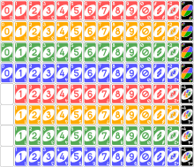How many cards are in the deck?

*There are 108 cards in the deck. 76 are number cards, 24 are action cards and 8 are wild cards. There are 25 cards in each red, blue, yellow and green colour sets, and the 8 wildcards are black. I have attached an image, from Wikipedia, of the different cards that are found within the deck. Each player will start with 7 cards randomly shuffled from the deck.*

1. What are the rules of the game?

*With 2-4 players, they are each given 7 cards. The main objective of the game is to get rid of all your cards. If you can’t play a card, you pick one up instead! A skip card means the next player misses their turn, a reverse card switches the direction of play and a draw 2 means the next player picks up 2 cards and misses their turn. A wild colour change card allows the player to change the colour set in play, whereas the draw 4 wild card does the same, but the next player is required to pick up 4 cards. Wild cards can be played on top of any cards, but the other cards must have the same colour set or symbol on them to be played. If you do not say UNO when you reach 1 card during your turn, you must face a penalty of 2 cards!*

1. What are you expecting from the UI?

*I would expect something clean, modern and user-friendly. It should be visibly pleasing and not overly complicated. There should be a consistent design in use. Good use of “whitespace” will be needed.*

1. Is there anything specific that you require to be added?

*Obviously, I have already listed my requirements, but the most important feature to me is the online multiplayer, as I will need to be able to play with my fans. If I cannot play with them, it defeats the purpose of the game.*

1. Is there anything specific that you don’t want in the game?

*I think it would be hard to add unnecessary things to the game with the time constraints in place. Just make sure you stick to the requirements. Out of everything, I would not like to see your own rules in the game. I feel it is essential the official rules of the card game are stuck to exactly. When it comes to card games, people have the habit to create their own rules.*

**Questionnaire (fans) via Forms**

Upon further discussion with my stakeholder, we agreed that it could also be helpful for his fans to fill out a questionnaire too. As they will also be playing the game, it is essential they have a say in the process too. A total of 47 fans filled out the questionnaire. My first question asked if they care about advertisements in their games.

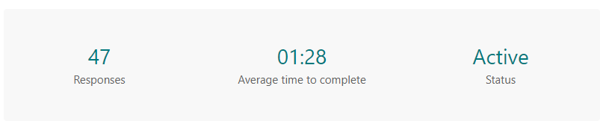

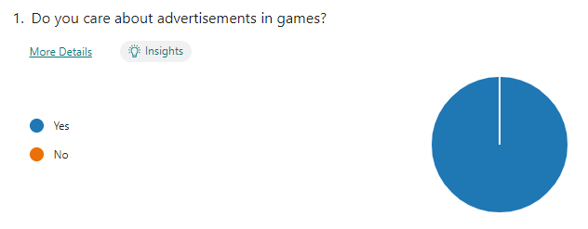

100% of participants answered that they do not like adverts in their game. This matches with my stakeholder’s, Mr Dorrell, requirements about having no adverts in the game. My second question asked if they like paying for games.

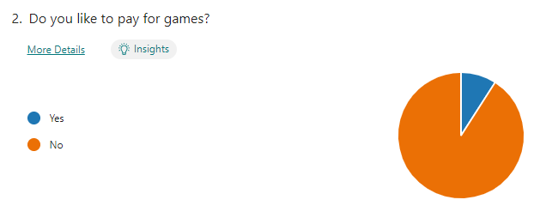

Roughly 9% of students said that they like paying for games. This is likely due to paid games having higher quality, but the goal of this project is to make a high-quality free alternative of a popular card game, so it does not matter. However, most students, roughly 42, agreed with the stakeholder that they do not like paying for games.

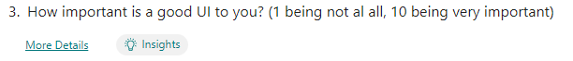

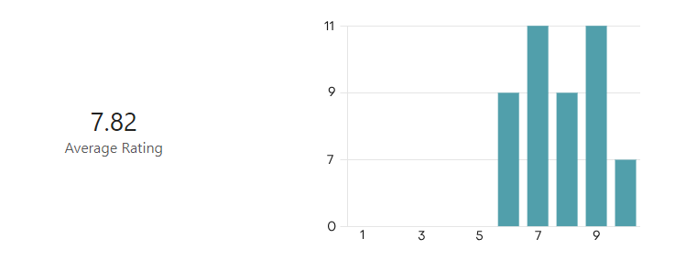

I then proceeded to ask whether users thought a good UI was essential. All 47 students submitted an answer of 6 or above, with 10 being very important and 1 being not important at all. This gave an average of 7.82, showing that all the stakeholder’s fan would like a good UI.

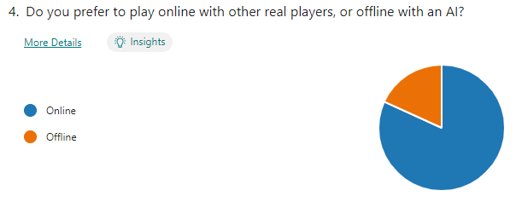

Although roughly 18% of students said that they prefer to play offline, the majority still voted that they prefer to play online with other real players. For this reason, the online multiplayer will take priority over the offline single player mode.

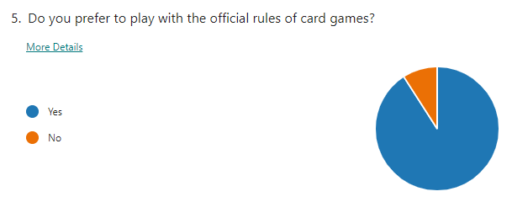

Roughly 91% students said they prefer to play with the official rules of the card game, whereas 9% said that they do not. I will stick with the stakeholder’s requirements to use the official rules as this was the majority decision.

## Problem Research

[**www.crazygames.com/game/uno-online**](https://www.crazygames.com/game/uno-online)

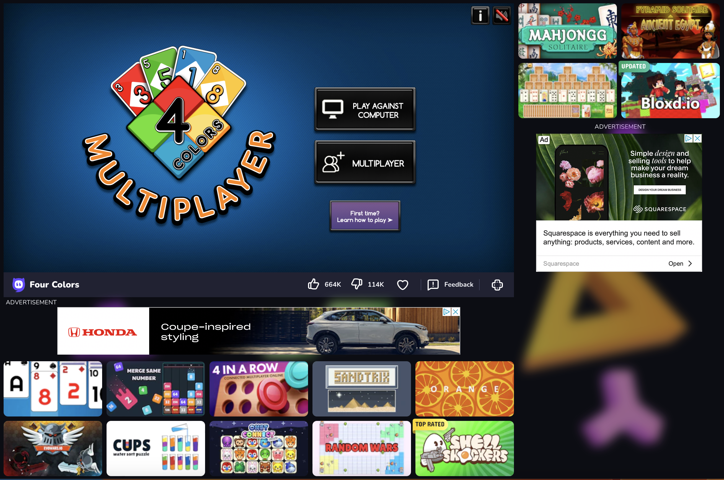

As this is an online game, there is lots of advertisements surrounding this game. This would be an issue for my stakeholder. Initially, the UI does not look too bad, and it does look like other card games like it. This game has 2 options, play against the computer which would be my version of the offline single player, and a multiplayer like I’m planning on including.

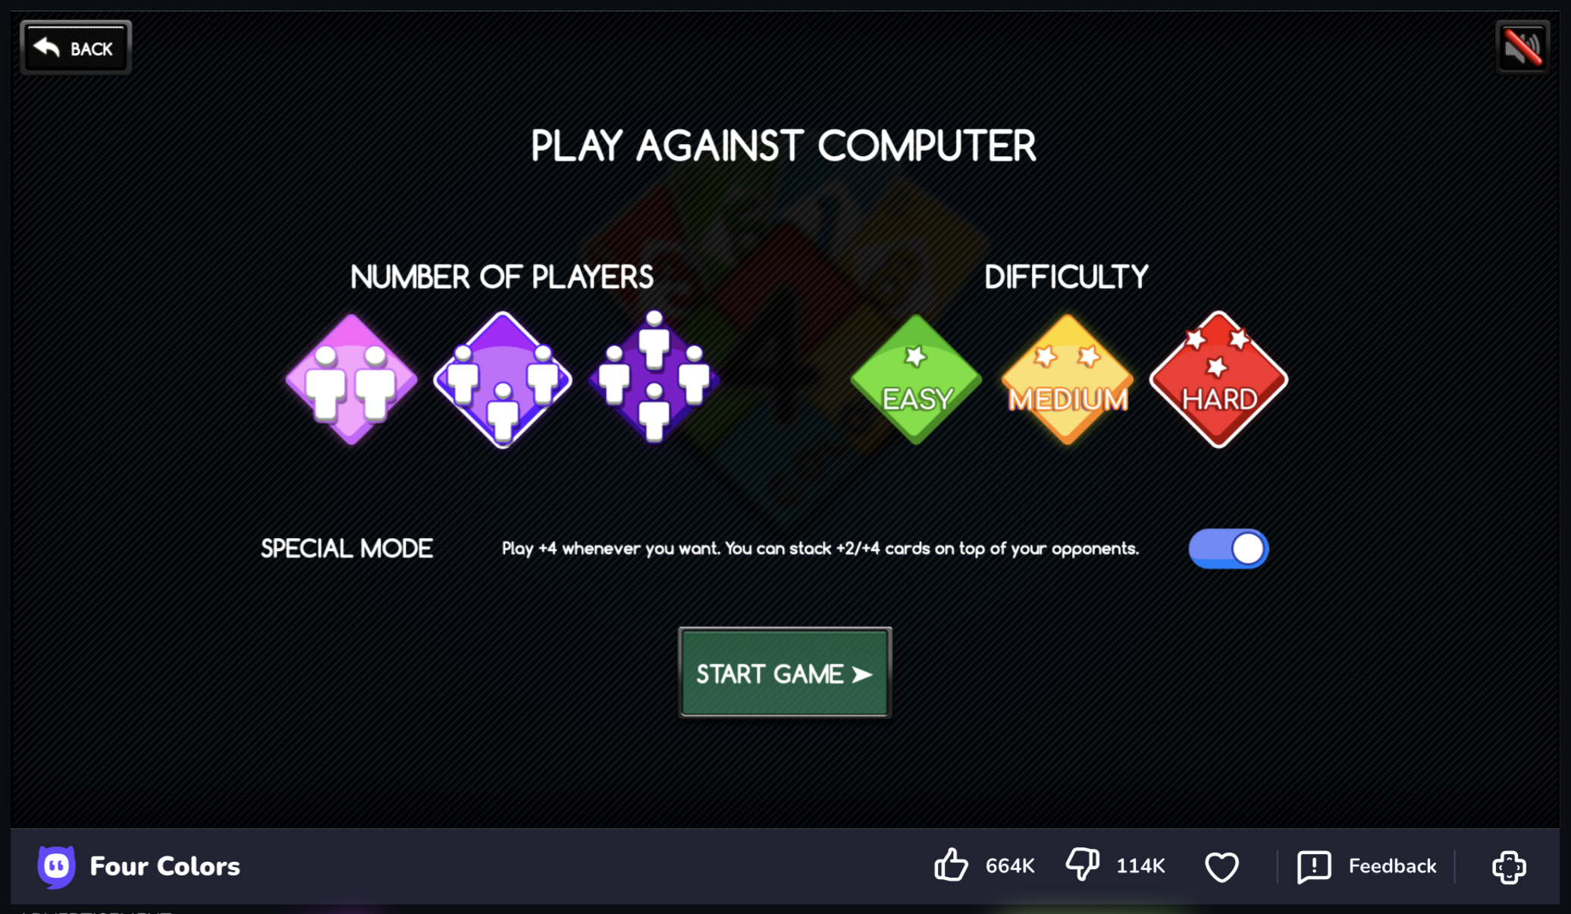

Similarly, I could have 3 AI difficulties too. However, I did not initially think about playing against more than one AI. It would be interesting to see the feasibility of this when I start my project. There is also a special mode, but as per my stakeholder’s request, I will be sticking to the official rules.

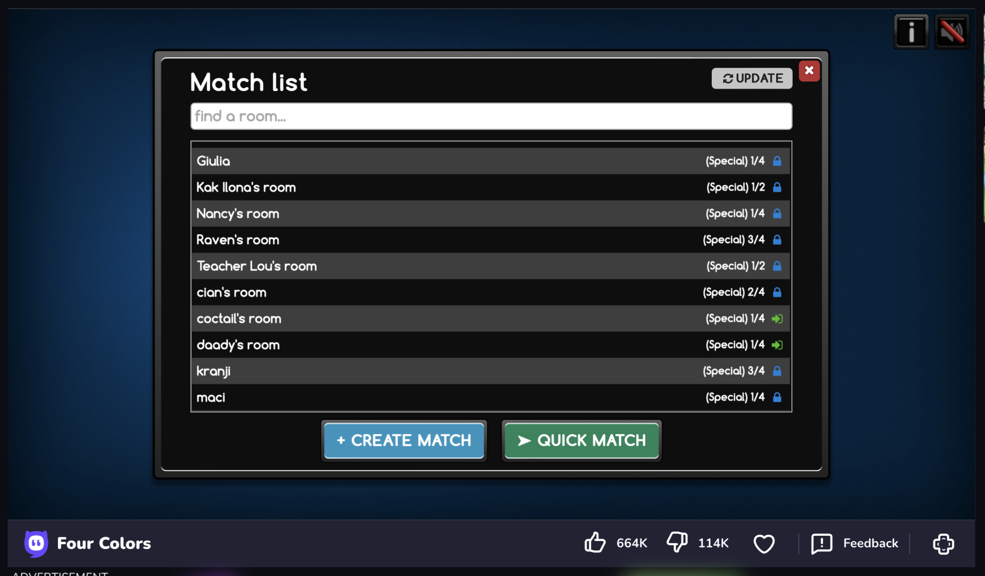

In the online mode, there are “rooms” which up to 4 players can join. Some are public, and some are private. There is no account required, only a nickname. This idea of rooms may be a good idea.

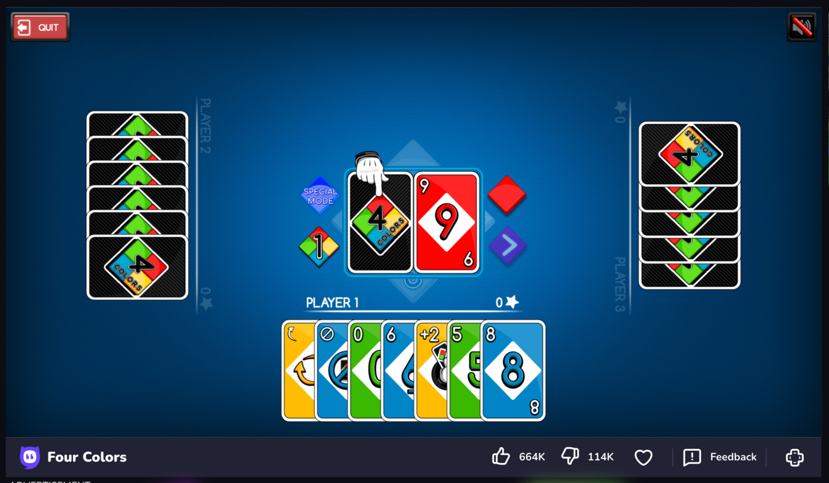

The UI for the game is quite good. It has the option to mute the music and to also leave the game. I think the layout is ideal and I will use a similar one for my game. In this game, there are no stats, but in each session a player earns stars. The person with the most stars at the end of all the rounds is the winner, just like in the Steam version of the game.

**ww.pizz.uno**

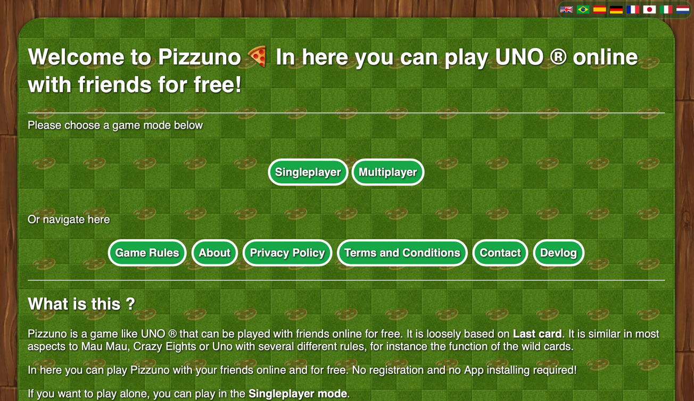

This game has awful UI. There is lots of bulky text, all the buttons blend into the background and feels poorly made. Yet again, this game feature a single player and a multiplayer mode

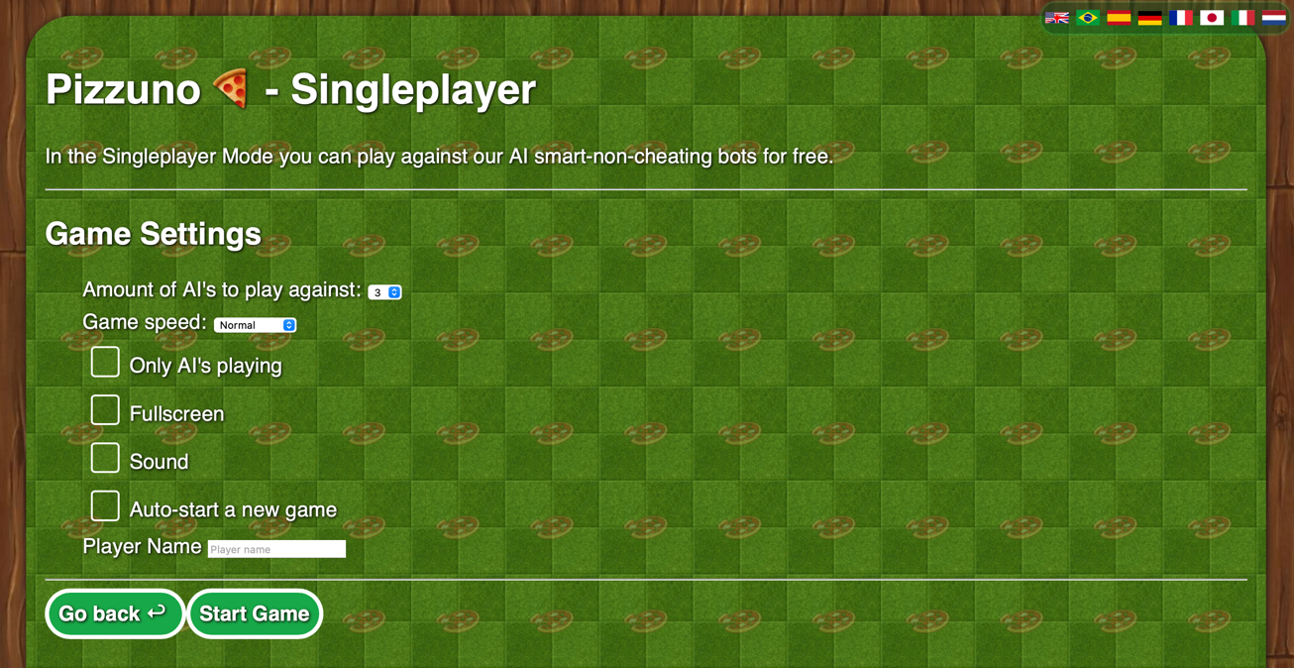

As you enter the single player mode, there is multiple options available. The number of AIs is the first option, like in the previous game I looked at. This seems to be a popular feature that I think would be a great addition to the different AI difficulties. There is an option for full screen which is poorly placed, as should be an option while the game is running, as if you exit full screen once the game has started, there is no way to toggle full screen again. The sound option is to mute the sound, but this is not made clear, and instead creates the intention that it is to enable sound. I can only see the auto-start a new game being useful, if it is only the AIs that are playing, but even so, I don’t see a need to have only AIs playing. There is also an option for a player name, which isn’t necessary for single player, as you would be the only player.

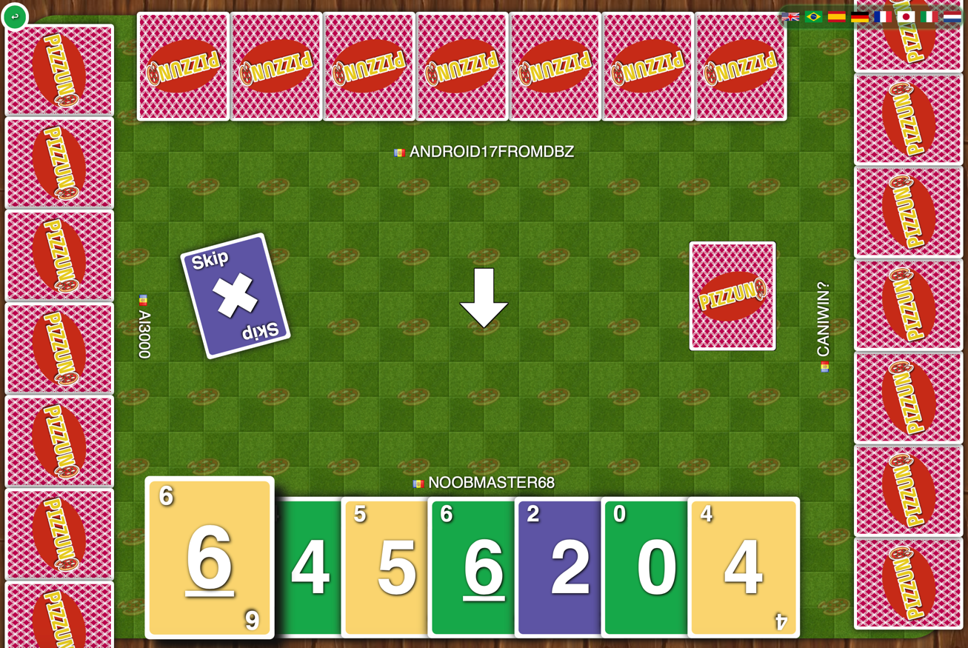

The game interface itself is poorly designed. The cards are too large, so they overflow off the screen and the cards are relatively basic and lack creativity. This game feels poorly made and low quality to play. Adverts also occasionally pop up when you press certain buttons.

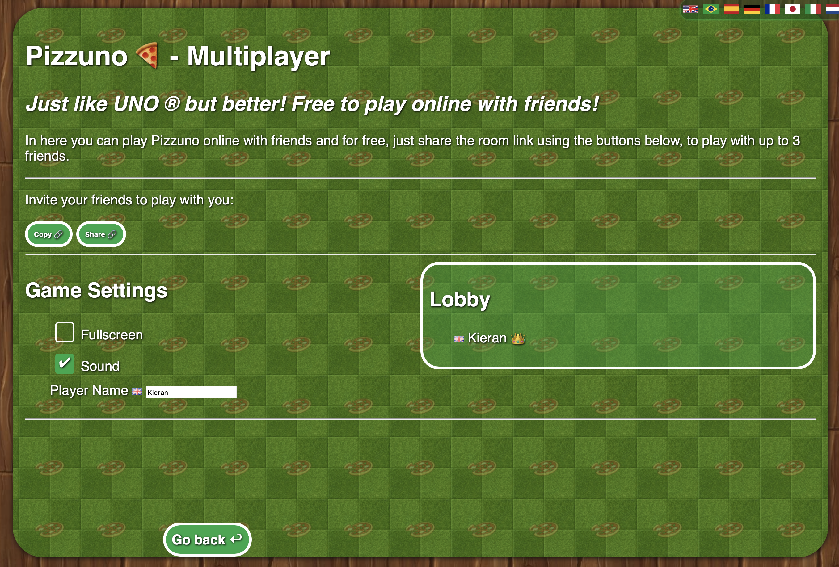

This game makes use of “rooms” like the previous game. The UI here is poor again, the sound button now works the opposite way to the single player mode, the back button is randomly placed at the bottom, and everything blends again. There is no option to browse rooms and instead players join by a link that contains a room code, for example: www.pizz.uno/multiplayer?room=fO8LW

[**www.store.steampowered.com/app/470220/UNO/**](http://www.store.steampowered.com/app/470220/UNO/)

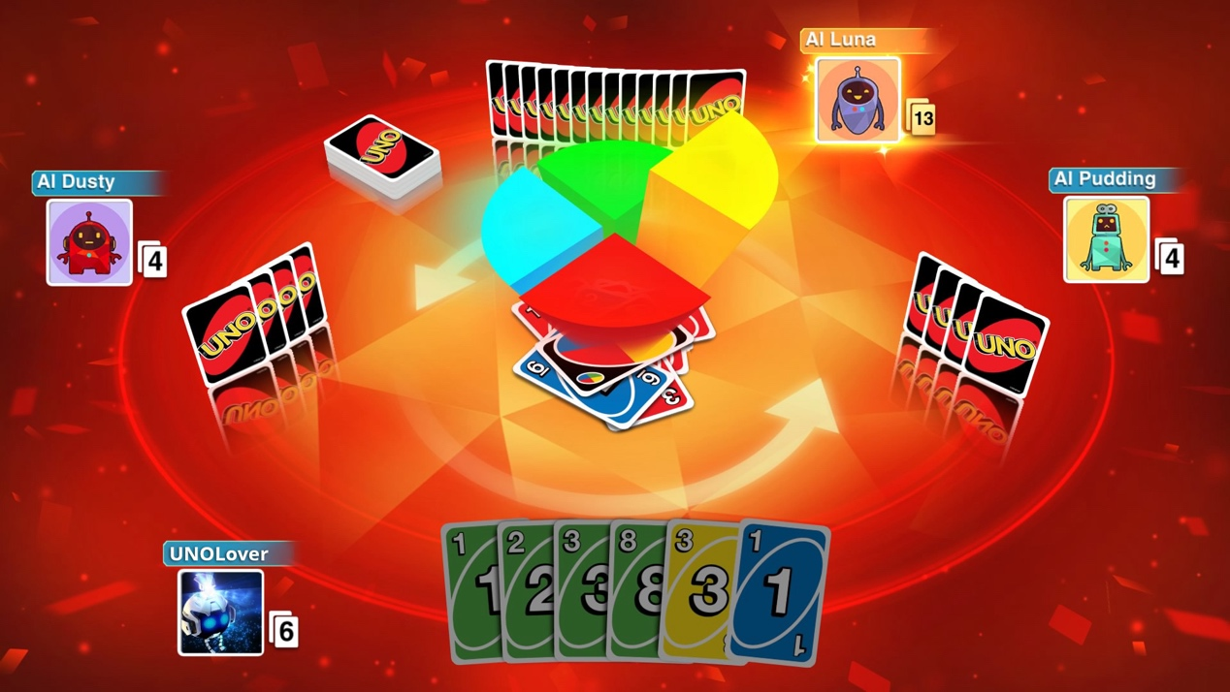

This game costs nearly £10 for a simple card game. It contains over the top animations during the game which take away from the classic feel to the card game. The UI within the game is good, but everything about it does not feel like the card game I loved as a child. There are many different spin-off modes that I would not include in my game, such as a 2v2 mode. However, this game does have accounts as it uses social accounts to log onto the platform. For example, if playing on a computer, Steam would be used, or on a console, perhaps a PlayStation or Xbox account. This allows for cross-platform play, which unfortunately my game would not be able to do. Although I do not own this game, I have watched some YouTube gameplay to review how it works. The game also includes single player and multiplayer modes, with the AIs that can be seen in the photo above. My project will be visually simpler and more abstract, for a more classic feel to the card game.

## Objectives

To measure how successful my project is, the main objectives should all be completed by the end for the project for it to be considered a success. Without them, the system would not work or would not match the criteria given by the stakeholders – Mr Dorrell and his fans. Any additional system features can be considered in the extent of the success that the project has beyond the main objectives, with each additional objective being implemented to improve the project.

**Main Objectives**

1. Clear UI – the game should have a user-friendly UI, that is sleek, clean and modern. A good use of whitespace will be needed, using padding and margins. A consistent colour scheme should be used, as well as a consistent font.
2. Multiplayer – this mode will allow for up to 4 players (minimum 2) with nicknames to join a room together. When a player leaves a game, their cards will be returned to the pile, and they won’t be able to join back. The game will begin when all players have pressed ready.
3. Original rules – the game will use the original rules of UNO as my stakeholder has requested. Both his fans and I agree with Mr Dorrell. The cards and game play must have the correct functionality.
4. No advertisements – as per my stakeholder’s request, the game will contain no adverts to ensure the experience is not ruined, and that classic feel or the card game remains intact.
5. Free to play – yet again, as per my stakeholder’s request, the game will be free to play and there will be no payable DLCs. This allows for more fans to play and does not restrict those younger players who cannot afford expensive games, as this game is family friendly.
6. Tutorial – a simple tutorial system that tells the user how to play the game. Additionally, this can be extended into a playable tutorial, but this depends on whether I have enough time to do so, as I am restricted in that aspect.

**Additional Objectives**

1. Single player – single player could contain the option of 3 AI difficulties (easy, medium, and hard) as well as the option to play with up to 3 AIs. No account will be required to play on single player so this means no internet connection will be required to play this mode.
2. Account creation – account creation will contain a simple username and password system, so players can be uniquely identified. This will allow for access to the multiplayer mode to verify players and for their statistics so be saved into an online database.
3. Statistics – statistics such as games played, games won and games lost can be saved. The total amount of stars collected will also be saved to the database. If I have time, I can extend upon the different statistics that can be saved.
4. Chat-box – the chat box will allow for players in the same multiplayer room to communicate, which will create a friendly sense of community.
5. Star leader board – a global leader board for players who have collected the most stars. This would likely be a top 10, as loading all players would be resource intensive.
6. Account profiles - to allow players to add profile pictures, change their username, add a biography and other features if possible.

## Computational Methods

* **Abstraction** – this is the process of removing unnecessary details from a program to simplify it. A great example of this is card representation. Each card in the deck represents a specific action within the game. The action is abstracted with a simplistic designed card with only key attributes. For example, the card ID is not visible, etc. This simplification allows players to interact with the game without needing to consider every intricate detail and keeps a clear, predictable game flow.
* **Heuristics** – this is approaching a problem by using knowledge from past experiences. I have never coded a game at all but luckily, I can use past coding knowledge to modularly structure my code in a way that is able to be understood easily by any developer. A drawback is my past knowledge is limited in such that I have never coded with the language I will be using. I only have experience with Python, Lua and SQL.
* **Artificial Intelligence** – the card game could be able to perform a task usually requiring human intelligence, such as decision making. I would intend to have 3 levels of AI difficulty which are easy, medium and hard. A positive is the program will be able to play cards strategically based on aspects I will assign values to, to ensure the AI will understand the difference between regular cards, action cards and wild cards. Fans could be able to play offline in single player against the AI to improve their own skills. A negative of using AI is that the hard difficulty may take a longer time to make a move, due to more calculations being required to play a card.

## Limitations

1. Time – this project has very strict deadlines within a limited time. Considering I must analyse, design, develop and evaluate my project, there is not much time to spare. I will try to meet my main objectives to meet my stakeholder’s needs and add some additional features if there is time. Realistically, I have other subjects and commitments that will require my attention, reducing the time I can spend on my project. In an ideal world, I would spend all my time on the project, but as a lone developer, it is a struggle.
2. Cross-platform – not only will my game not be available of other platforms such as Xbox or PlayStation, but it will also only likely work on one platform as it will likely contain commands that are optimised for the platform. This will reduce the number of fans that can play the game but was not one of my stakeholder’s requirements for the project.
3. One developer – as I mentioned above, I am a lone developer. Most software projects often contain large teams, where each person works on different aspects. I do not have access to professional development areas, and simply have my laptop and the school computers. For a project with no budget, there will be a lot to do, with little time.
4. Graphics – my game will not contain cool 3D animations like the Steam version of the card game. I feel these animations are unnecessary anyways as they take away from the classic feel to the card game which I plan to recreate with my project. For this reason, my game will stay 2D. This also allows those with low specification PCs to play my game as my 2D will be less resource intensive.

## Requirements

* **Processor** - minimum i5-3470S @ 2.90GHz for processing the instructions within my program, weaker processers may not have the capability to run my card game smoothly for a decent user satisfaction.
* **Memory** – max 2GB of RAM to load and store my card game while it is running – allowing room for player data and processing.
* **Storage** – max 1GB of storage available to store my card game as RAM is volatile. Both the client and server build are around 200MB.
* **Graphics** – a graphics card is likely not necessary for my card game. There is no high-quality rendering, so integrated graphics are probably suitable. A graphics card may provide a smoother experience and reduce load on the processor.
* **Power** – a power source will be required for the computer to run.
* **Motherboard** – a motherboard that fits the hardware components.
* **Keyboard** – to enter login details for the online multiplayer mode.
* **Mouse** – to click on assets within my game to play different cards and to navigate through the different menus.
* **Screen** – to output the UI to the player.
* **Internet Connection** – ethernet connection via the motherboard or perhaps a NIC for access to the multiplayer mode.
* **OS** – Windows as the programme may not be executable on other platforms.

# Design

## Programming Languages

There are 2 languages that I will be using for my application. I will be using C# as this is most compatible in the Unity game engine, and I could also be using MySQL to save data to my databases for my additional objectives.

**Pros of C#**

* **Object-orientated programming (OOP)** – gathering data into objects, makes it easier to deconstruct the programme into smaller pieces that are faster to create, manage and combine. For example, each card or player in my game are the same, but they just have different attributes or slightly different methods.
* **High-level language** – the syntax of C# resembles the English language as it is highly abstracted from machine code. This means it will be easier to understand and manage in the short time frame of my project. Languages like C are lower-level languages that may take longer to learn or understand.
* **Part of the .NET platform** – by itself C# would have a narrow focus for Windows applications only. With the .NET support, this allows for cross-platform. Although not necessary for my stakeholder’s requirements, it would extend the number of fans that can play the game with him.
* **In-built garbage collector** – managing the memory allocation is crucial to any applications performance and C# has a garbage collector for this purpose. It tracks unused objects and automatically frees memory. Saving me time writing extra code to manage memory for my short time frame.
* **Type-safe language** – variable types do not change across the code. A variable defined as an integer would not accept string values. Variables will behave in a predictable manner and operations cannot only be carried out if they are of the same type. This means errors will be pointed out before they reach the execution environment, saving me time fixing “bugs” in the short time frame of my project.
* **Documentation** – C# is very well documented, which will make it easier for me to understand and troubleshoot. As C# has a large community it means there will be support available too.

**Cons of C#**

* **Performance** – we can measure performance in terms of compilation time. C# alone has similar performance to Java, but C# .NET comes out on top faster. However, when compared to C++, it is much slower. This is because of it is compiled differently, but with all the pros that C++ does not offer, it is worth it. My stakeholder does not have system requirements.

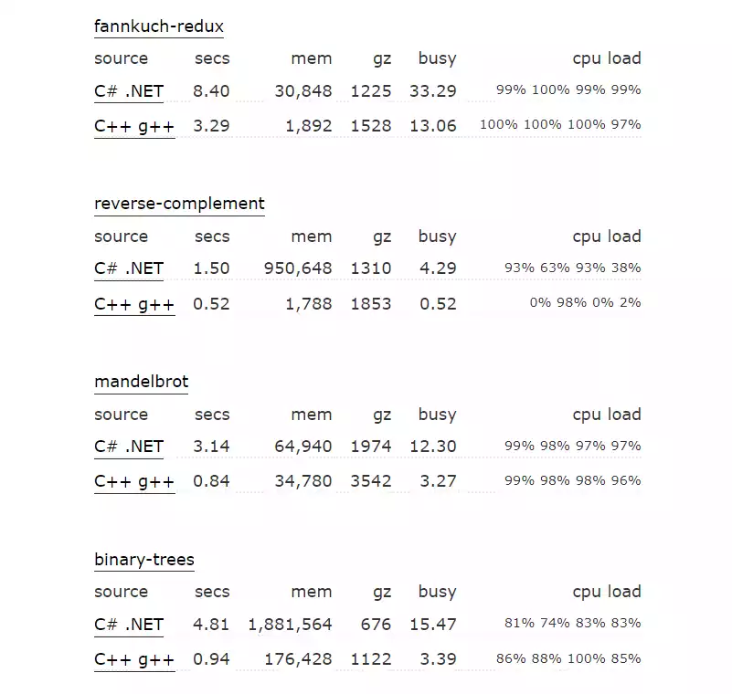

* **Dependence on .NET** – C# alone is not very flexible and relies heavily on the .NET platform. Compared to a language like Java that can run on any platform with Java Virtual Machine, C# uses different runtimes for different platforms. While .NET supplies the resources for the different runtimes, bare C# cannot be used easily. My stakeholder does not care about flexibility of the language.
* **Complexity** – although C# itself is relatively simple, .NET libraries add more layers to the problem. In a short time, frame, this may be an issue, but I feel that I would be able to learn relatively fast.

**Pros of MySQL**

* **Fast query processing** – large amounts of data can be easily retrieved quickly and efficiently using operations. This means that data can rapidly be returned from the large database of users.
* **Little coding skills** – for data retrieval, large numbers of code are not required, and it simply uses basic keywords and simple syntax. This means it will be quick to learn in the short time frame of my project.
* **Documentation** – like C#, MySQL is heavily documented as it is a standardized language. As a result, if I do become stuck, there is a large community that I can ask for help with a short time frame.
* **Cross-platform** – MySQL works irrespective of the platform, meaning it will work well with C# and the .NET platform that can be compiled onto any platform. This extends the number of fans who can play with my stakeholder Mr Dorrell.
* **Scalability** – MySQL databases can hold an immense number of data that can be scaled up or down due to requirements of the application. For example, if Mr Dorrell goes viral and gains loads of new fans, the database can easily be scaled up.
* **Security** – MySQL databases have built-in security features such as user authentication, encryption, and access control which all help protect user data from unauthorised access. Mr Dorrell’s fans will have their data kept securely.

**Cons of MySQL**

* **Compatibility** – older versions of MySQL do not support ROLE, COMMIT or stored procedure. MySQL also does not support check constraints. I will have to ensure I used the latest version of MySQL to have the most features available to my project. If I have to use an earlier version, I may have to find work arounds which will consume part of my short time frame.
* **Large Databases** – MySQL does not handle large databases efficiently. Luckily, Mr Dorrell only has a small following, but even if his fan base does grow, it should be scalable enough to still be efficient.
* **Transactions** – MySQL also struggles with handling transactions efficiently, which is why it is more prone to data corruption. This should not be too much of an issue, as it’s small amounts of data in each transaction. If some data is lost, it is not the end of the world, unlike bank account information being lost. After all, it is only a game.
* **Debugging** – MySQL has misleading errors which may consume my time. There are little debugging tools, so if an error occurs, it will mean I have to spend further time finding the bug.

Both C# and MySQL have some cons, but all languages have their own. Either way, the pros outweigh the cons, so I believe both languages to be suitable for the development of my project, with C# being the major language.

## Programming Approach

C# is a language that supports many programming paradigms. C# has the ability to support concurrent, functional, meta, generic, object-orientated and reflection programming. As C# is a multi-paradigm language, it would be waste not to take advantage of all the features, so I believe the best approach would be to use all a mixture of all of them. As a result, I will evaluate some major paradigms.

Concurrent programming is useful as it will allow the programme to run faster on multiprocessor machines by reducing idle time. This paradigm allows for many different types of multitasking including working on the same problem, simultaneous execution of programs, and background execution. As a result, performance is improved. For computers with less cores, the program may in fact be slower. The minimum requirement for my game is a quad-core processor. Anything less would likely struggle to process the game sufficiently anyway. If code is written extremely poorly, it can lead to a deadlock. This is where resources are all in use, and the computer can no longer continue to process data. My code will be good quality and planned to prevent this.

Functional programming is essentially using function to build a programme. This allows code to be clearly split into sections that are easier to read and understand. Additionally, code does not need to be repeated, and can be placed into a function to be recalled, leading to shorter and more accurate code. Functions are much easier to debug and test, rather than entire programs, as they are smaller immutable chunks. For all this reasons, time will be saved for my short time frame. In some scenarios, functional programming can have lower performance if code has been written poorly. Functional programming also takes up more memory as instead of updating existing variables, variables are being created and deleted upon and after function calls. The game is not large in size like Mario Kart for example, and will not use up tons of memory, so this should not be too much of an issue.

Object-orientated programming has very similar advantages to functional programming in the aspect that it makes code clearer and easier to understand. OOP allows for reusable classes, like a function that would be reusable. Although the classes are easier to write, yet again, they do take up more space in memory, meaning they may hinder performance. With my hardware specifications, this should be fine. Plus, this will save my lots of time creating objects of classes instead of individual items for my short timeframe. To summarise, I believe OOP to be the most important paradigm, as I will have lots of players and cards, that can be created as classes and objects. However, all the paradigms are useful to some degree.

## Abstracted Solution

I have begun to explore my design on paper before digitalising it. I have considered what methods classes, and tables I may need for my programme, considering I meet all main objectives and the additional ones. I have designed the key aspects of my program. Below is a flowchart of the entire programme in an ideal world.

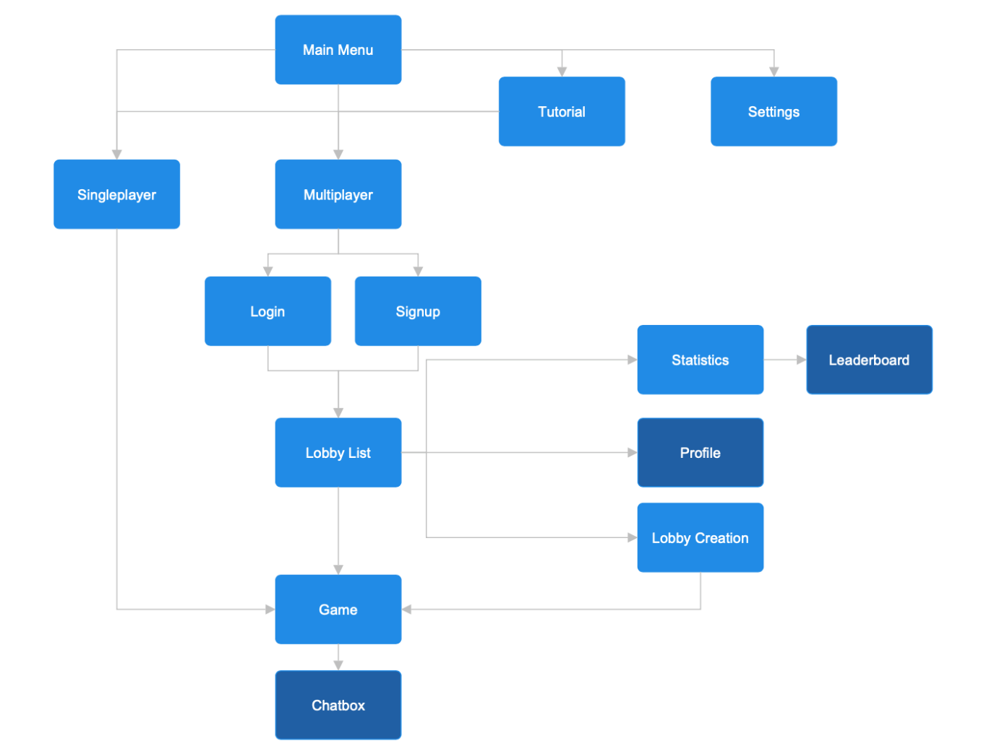

Again, this assumes that all objectives are met, but are not all required for my success criteria. The game load up into the main menu where the user would have the option to enter single player, multiplayer, a tutorial or the settings menu. Whilst the single player flows straight to the game, and does not have a chat box, multiplayer is a little more advanced. If a user has an account, they can login on the multiplayer menu, or can sign up for an account if they do not have one. Next, there will be a lobby list menu where they can join a game, create a game, view their profile, or view statistics, including a leader board.

**Classes**

|  |
| --- |
| **Player** |
| username (string)  cards (array)  uno (Boolean)  stars (integer)  bot (Boolean) |
| getUsername()  setCards()  getCards()  addCards()  removeCard()  setUno()  getUno()  getStars()  addStars() |
| class player  private username  private cards  private uno  private stars  private bot  public procedure new(theUsername)  username = theUsername  cards = []  uno = False  stars = accounts.query(SELECT stars_won WHERE username = username) or 0 # get stars from database or set to 0 if null  bot = False  end procedure  public function getUsername()  return username  end function  public procedure setCards(theCards)  cards = theCards  end procedure  public function getCards()  return cards  end function  public procedure addCards(theCards)  cards.append(theCards)  end procedure  public procedure removeCard(theCard)  index = cards.FindIndex(theCard) # find card position  cards.pop(index) # remove card  end procedure  public procedure setUno(theUno)  uno = theUno  end procedure  public function getUno()  return uno  end function  public procedure getStars()  return stars  end procedure  public procedure addStars(theStars)  accounts.query(SET stars_won = stars_won + theStars WHERE username = username) # add stars onto existing database value  end procedure  public function getBot()  return bot  end function  public procedure setBot(theBot)  bot = theBot  end procedure  end class |

The player class contains 5 attributes which are assigned in the constructor method. It has many get and set methods which allows for encapsulation. Encapsulation allows for validation, reduces complexity, and prevents unintended manipulation of the object’s data. This will help with debugging as it I know where the specific issue is, which will help with my strict time frame.

|  |
| --- |
| **Bot** *inherits* Player |
| difficulty (string) |
| getDifficulty()  setDifficulty() |
| class Bot inherits Player  private difficulty  public procedure new(theDifficulty, ID)  super.new(“Bot “ + str(ID)) # calls the parent constructor method  super.setBot(True)  difficulty = theDifficulty  end procedure  public function getDifficulty()  return difficulty  end function  public procedure setDifficulty(theDifficulty)  difficulty = theDifficulty  end procedure  end class |

As highlighted by the diagram below, the bot class inherits from the player class. As it inherits from the player class, we use a super constructor to set the attributes of the player object, as well as new attributes exclusive to the bot class. Inheritance allows rewriting code for efficiency and to save time for my strict time frame. I continue to use encapsulation in this class too and continue to comment any longer methods that require more of an explanation.



|  |
| --- |
| **Card** |
| asset (string)  colour (string)  type (string) |
| getAsset()  getColour()  getType() |
| class card  private asset  private colour  private type  public procedure new(theAsset, theColour, theType)  asset = theAsset  colour = theColour  type = theType  end procedure  # no need for set methods as they are constants, not variables  public function getAsset()  return asset  end function  public function getColour()  return colour  end function  public function getType()  return type  end function  end class |

Unlike the player class, card objects ideally would only be initialised once by the constructor method. As a result, there would be no need for set methods for the attributes, as highlighted by the comment in the pseudocode. I have continued to use encapsulation, comments and use appropriate variable and method names.

|  |
| --- |
| **Board** |
| players (array)  playerCount (integer)  turn (string)  deckCards (array)  playedCards (array) |
| getPlayers()  addPlayer()  removePlayer()  getPlayerCount()  getTurn()  nextTurn()  getNextDeckCard()  setDeckCards()  addPlayedCard()  getLastPlayedCard()  getPlayedCards() |
| class Board  private players  private playerCount  private turn  private deckCards  private playedCards  public procedure new()  players = []  playerCount = 0  turn = 0  deckCards = []  playerCards = []  end procedure  public function getPlayers()  return players  end function  public procedure addPlayer(thePlayer)  playerCount += 1  players.append(thePlayer)  end procedure  public procedure removePlayer(thePlayer)  playerCount -= 1  index = players.FindIndex(thePlayer) # find player position  players.pop(index) # remove player  end procedure  public function getPlayerCount()  return playerCount  end function  public function getTurn()  return turn  end function  public procedure nextTurn()  # if turn number exceeds player count, then back to 1st player  if turns < (playerCount – 1) then  turns += 1  else  turns = 0  end if  end procedure  public function getNextDeckCard()  # the next card will be in index position 0, store temp and remove  nextCard = deckCards[0]  deckCards.pop(0)  return nextCard  end function  public procedure setDeckCards(theCards)  deckCards = theCards  end procedure  public procedure addPlayedCard(theCard)  playedCards.append(theCard)  end procedure  public function getLastPlayedCard()  deckLength = len(playedCards)  return playedCards[deckLength – 1] # index starts at 0  end function  public function getPlayedCards()  return playedCards  end function  end class |

The board class is a longer class that contains the data of the game itself. It essentially controls the players, bots, and cards. The methods in this class and the diagram below reflect this. Like before, the attributes are set in the constructor class, and allow for encapsulation by get and set methods. Unlike cards, player and bots, there will only be 1 object of the board class per game. Therefore, this is likely to act more statically, but I will look into this further when reaching development.

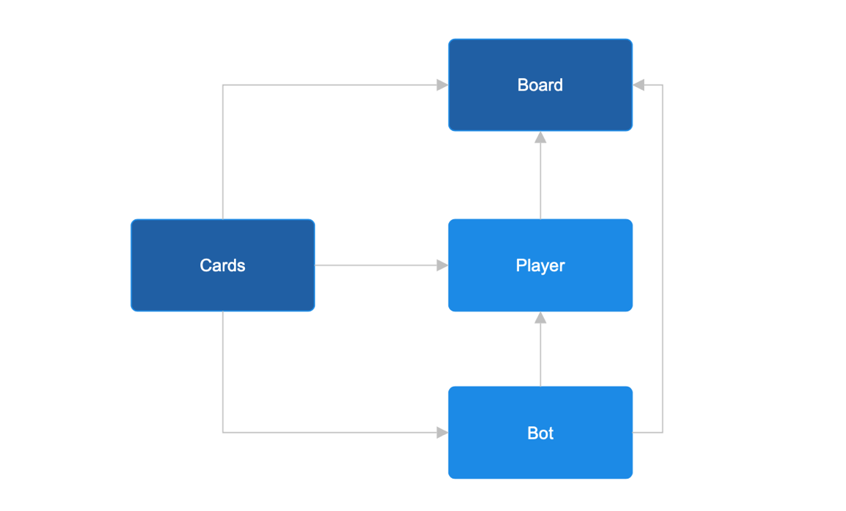

|  |
| --- |
| **Room** |
| host (string)  players (array)  playerCount (integer)  password (string) |
| getHost()  getPlayers()  addPlayer()  removePlayer()  getPlayerCount()  getPassword()  setPassword() |
| class Room  private host  private players  private playerCount  private password  public procedure new(theHost)  host = theHost  players = [theHost]  playerCount = 1  password = “”  end procedure  public procedure getHost()  return host  end procedure  public function getPlayers()  return players  end function  public procedure addPlayer(thePlayer)  playerCount += 1  players.append(thePlayer)  end procedure  public procedure removePlayer(thePlayer)  playerCount -= 1  index = players.FindIndex(thePlayer) # find player position  players.pop(index) # remove player  end procedure  public function getPlayerCount()  return playerCount  end function  public function getPassword()  return password  end function  public procedure setPassword (thePasswird)  password = thePassword  end procedure  end class |

The room class would be implemented for the multiplayer mode. Each room would be a different game that could have up to 4 players. Validation can be implemented into the methods if required but can also be added before calling the method elsewhere if a different condition is needed each time. Again, encapsulation is used.

**Naming Conventions**

Consistent syntax is important to reduce errors and mistakes in my code. For example, variables are case sensitive meaning if I had a method named shoeSize, then used SHOESIZE to call it, it would return an error as it does not exist. I will be using camelCase for variables and methods. This is where the first letter is lowercase, and first letter of following words are uppercase. For classes, I will be using PascalCase, where every first letter of words are uppercase. For databases, I will be using snake_case where everything is lowercase, and words are separated with underscores. Using different naming conventions for different parts of code allows for me or third parties to easily distinguish each type of code.

**GUI Design**

Although my GUI designs will be higher quality upon development, it is a good procedure to have a rough idea of the layout. This will help when it comes to coding the front-end and back-end of the project. To create my designs, I used Microsoft PowerPoint.

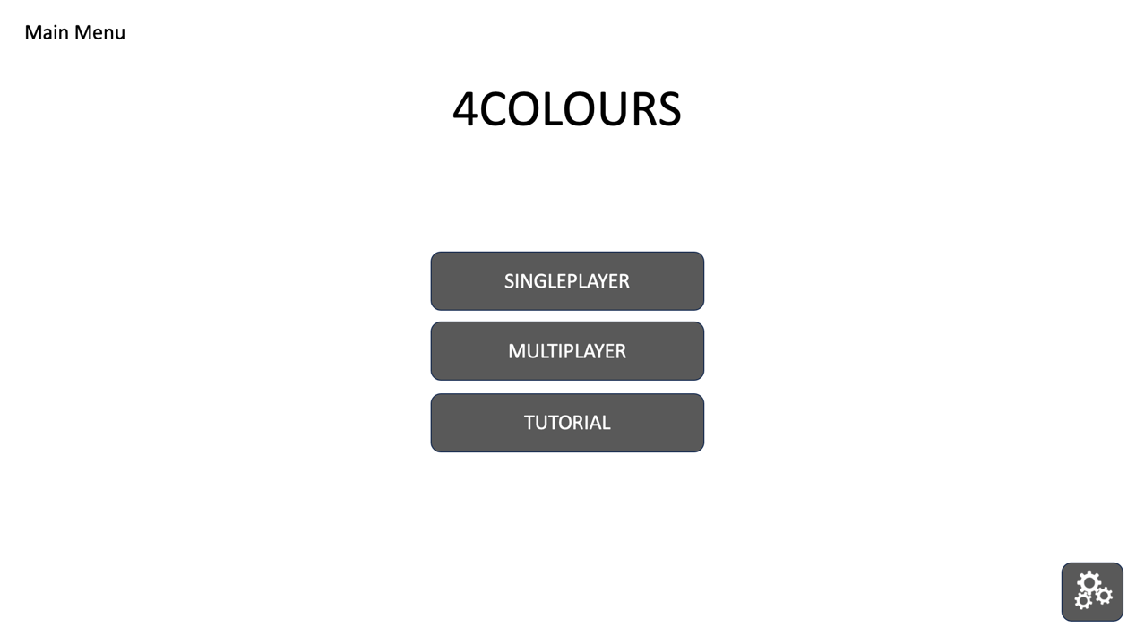

This is the main menu where the user will have 3 options. Enter single player mode, enter multiplayer mode, or to enter the tutorial. The tutorial will use the gameboard design and just hint the player.

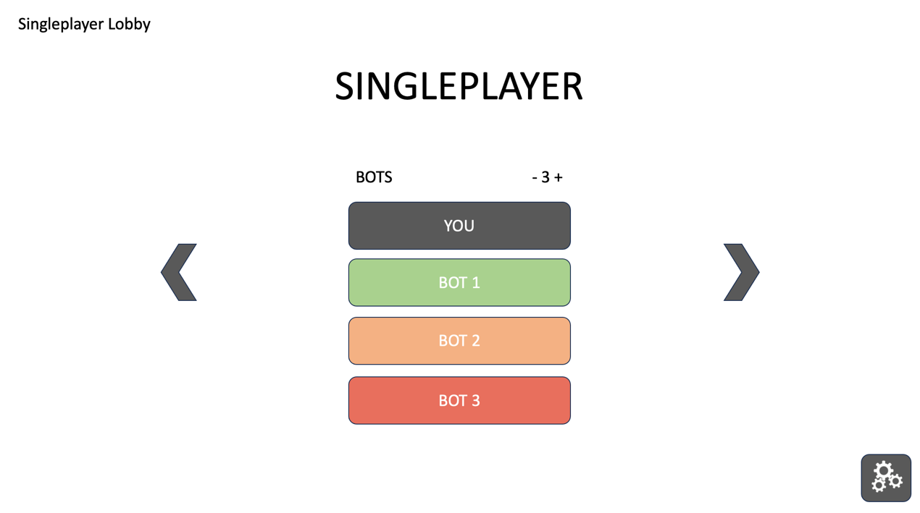

If the player selects single player, they will be presented with this screen. The have 2 arrows, one to return to the main menu and one to start the game. There will be the ability to add up to 3 bots, and clicking on each bot will rotate the difficulty indicated by the colours. Bot 1 would be easy, bot 2 would be medium and bot 3 would be hard.

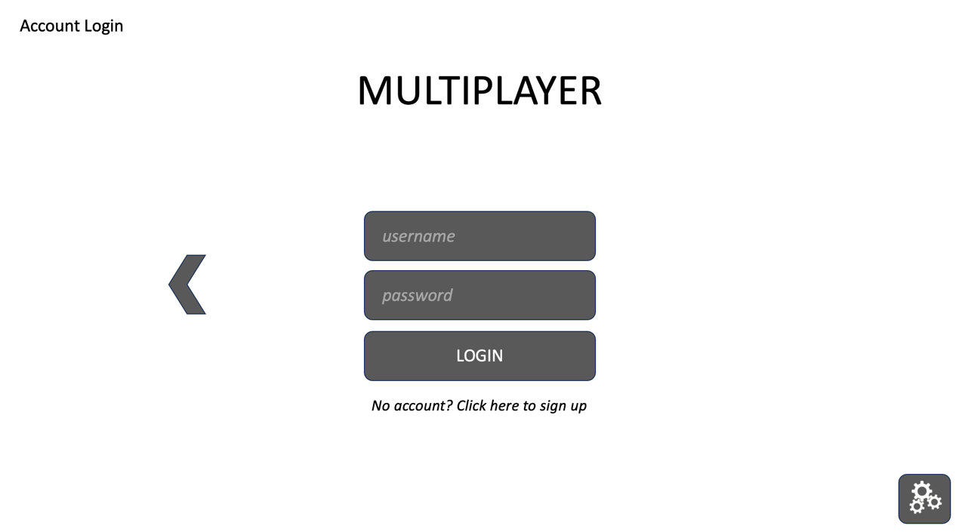

Alternatively, if the player selects multiplayer, and aren’t already logged in, they will be presented with the login page. The have an arrow to return to the main menu. If they don’t have an account, they can press the button to sign up. In the actual project, I may change the login button to a forwards arrow to fit the theme.

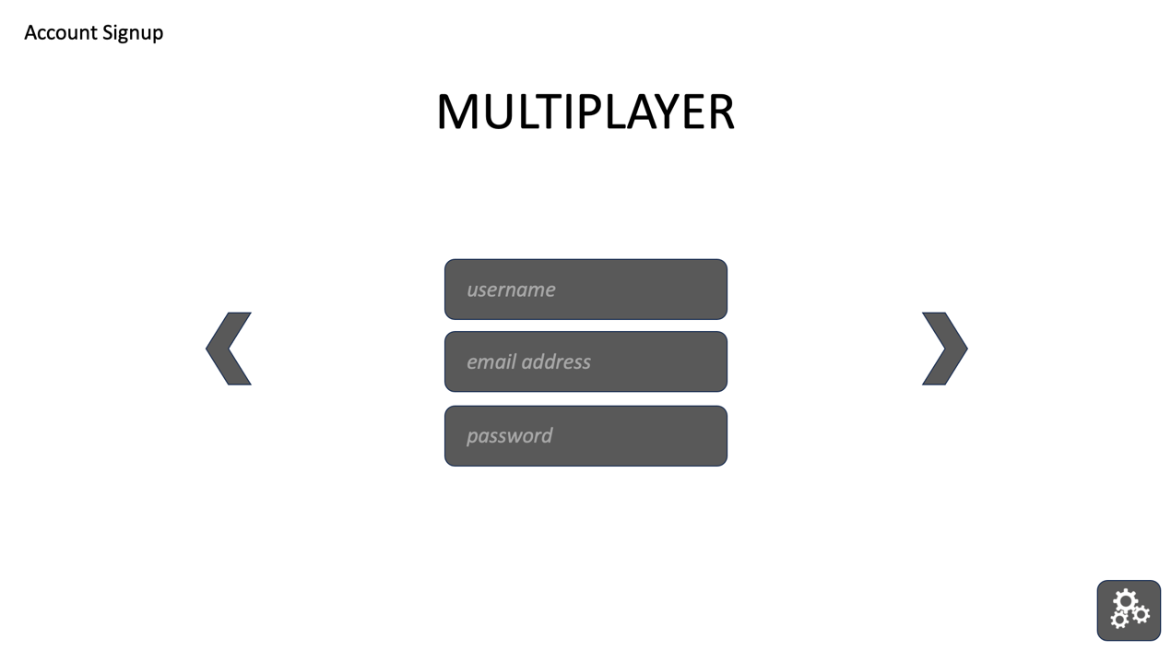

As the player does not have a login, they will be shown this page to create an account. An email address that does not already have an account is required to prove their identity, and a unique username will be created alongside their password. Once all fields are filled out, they can continue with the arrow. The data is be validated to ensure they are correct, and if not, an error will be returned to stop them from proceeding. If all is correct, they will be required to verify their email address.

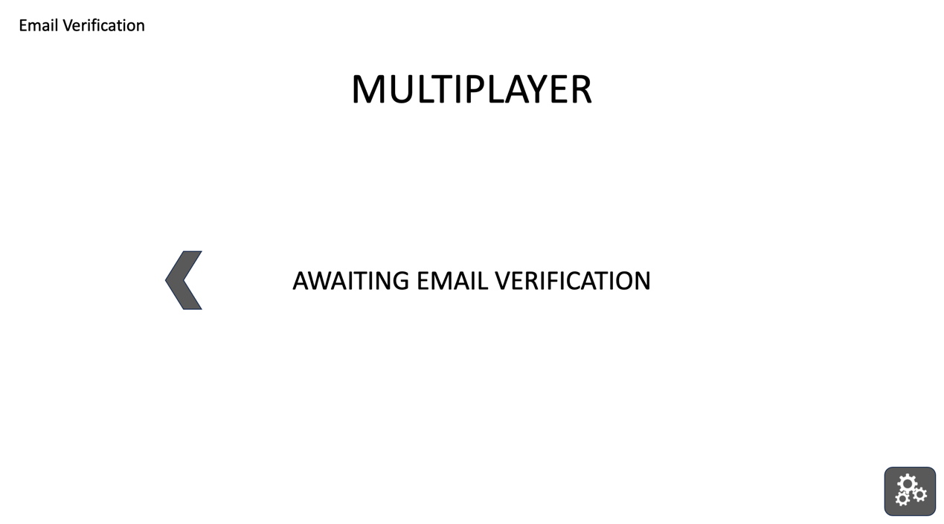

They have an arrow to go back encase they typed an incorrect email. The program will automatically check if they have verified their email address, allowing them to continue into the multiplayer lobby.

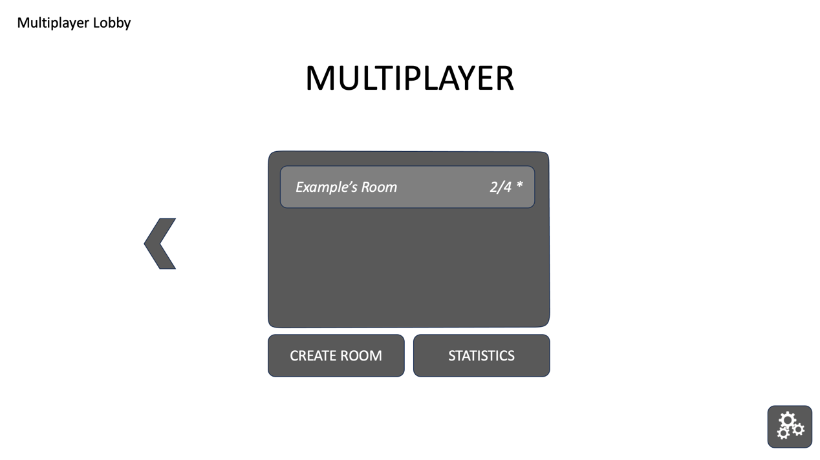

In the multiplayer lobby, the player can join a room, create a room, or view their statistics. Some rooms will have passwords such as the example room, which has been marked with an Asterix in this case. There is a back arrow to return to the main menu. I could also include the account profile here too if I have time.

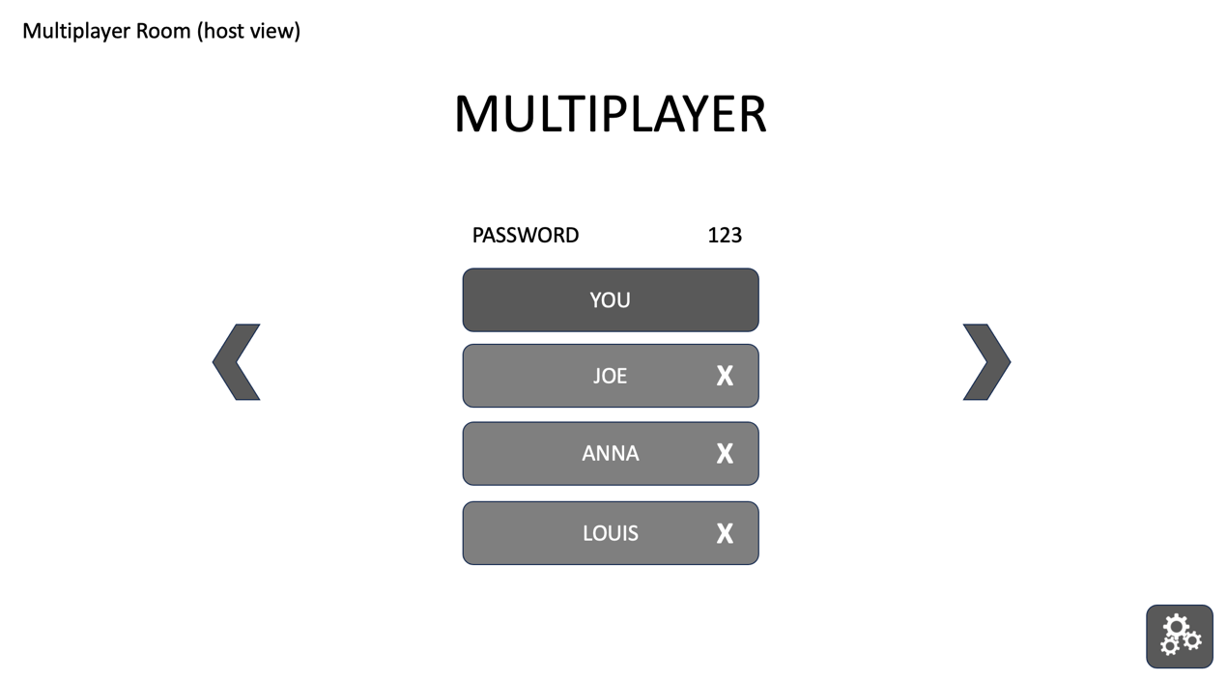

Once a player is in the room, it will display the other plays. The host has access to remove players and change the room password. There is a back arrow to leave/delete the room and a forward arrow to begin the game for the host.

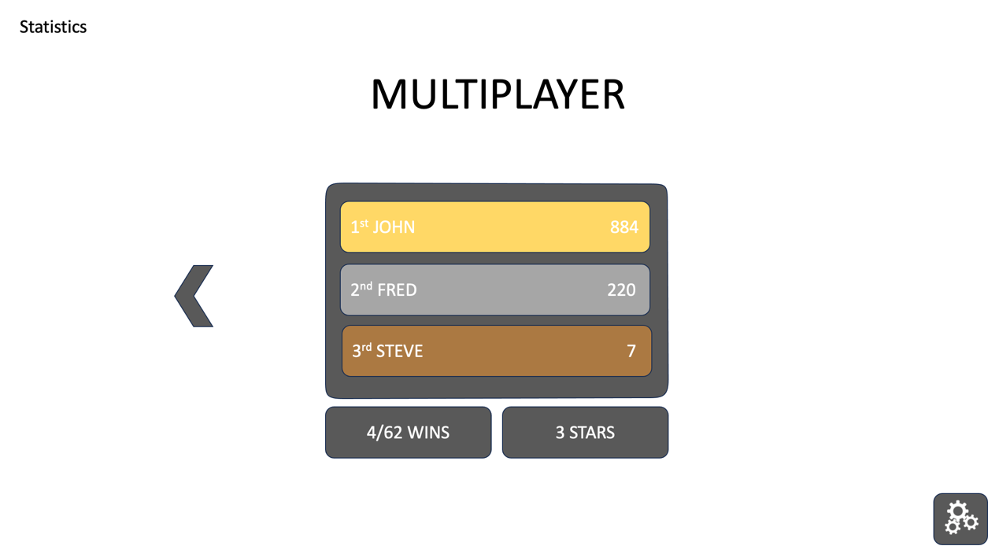

On the statistic page, there would be the win to loss ratio and the number of stars they have earnt. If I have time, I will meet the additional objective of the star leader board. There is a back button to return to the multiplayer lobby.

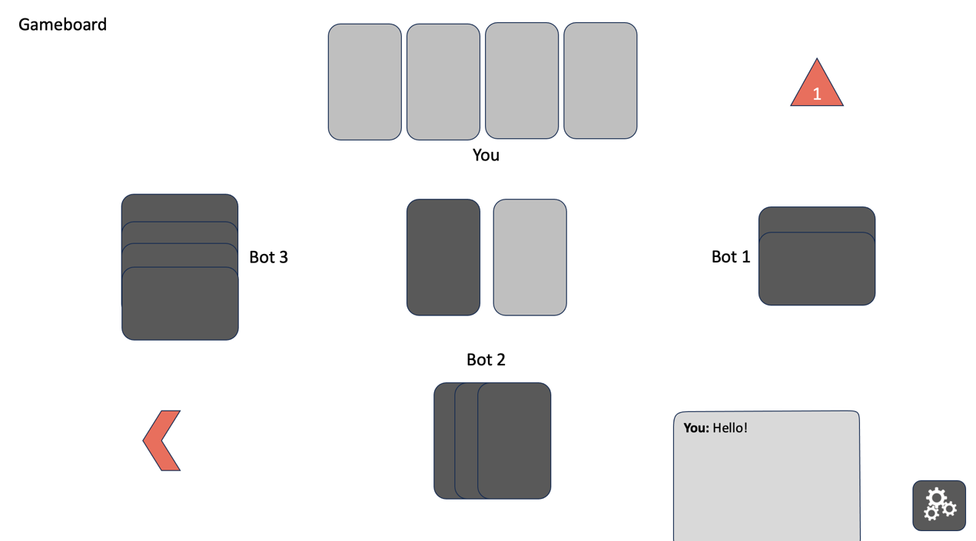

This shows the gameboard itself. It displays the number of cards each player has and shows the player what cards they have. The is a hidden deck for the cards and a visible deck for the played cards. The triangle button is to announce Uno and the back arrow leaves the game. The box in the bottom right represents the additional objective of the chat box.

It is important to remember that these are only initial designs to help with the actual creation and implementation of the project. They allow a visual of the items and assets that need to be included in the project itself. The settings button could be available on every menu for easy access.

## Decomposed Solution

**Data Dictionary**

Validation will occur within my methods before there are entered into the classes. Variables and methods may change during develop, and I will plan accordingly if required. These could be the key variables and methods in my project.

|  |  |  |  |  |
| --- | --- | --- | --- | --- |
| **Name** | **Type** | **Data** | **Example** | **Scope** |
| username | Constant | String | “kieran12” | Player Class |
| cards | Variable | Array | [“R7”, “RR”] | Player Class |
| uno | Variable | String | True | Player Class |
| stars | Variable | Integer | 120 | Player Class |
| difficulty | Variable | String | “Easy” | Bot Class |
| players | Variable | Array | [“kieran12”, “steve”] | Board/Room Class |
| playerCount | Variable | Integer | 3 | Board/Room Class |
| turn | Variable | Integer | 1 | Board Class |
| deckCards | Variable | Array | [“R7”, “RR”] | Board Class |
| playedCards | Variable | Array | [“R7”, “RR”] | Board Class |
| host | Constant | String | “kieran12” | Board Class |
| password | Variable | String | “123” | Room Class |

|  |  |  |
| --- | --- | --- |
| **Method** | **Purpose** | **Validation** |
| getUsername | Return username | None |
| setCards | Set player’s starting cards | None |
| getCards | Return player’s card | None |
| addCards | Add a card to player’s deck | None |
| removeCard | Remove a card from player | Check if the player actually has the card in their deck before |
| setUno | Change Boolean Uno status | None |
| getUno | Return player’s Uno status | None |
| getStars | Return’s player’s stars from DB | None |
| addStars | Add stars to player in DB | Check if negative as there is no need to add a negative value |
| getDifficulty | Return bot’s difficulty level | None |
| setDifficulty | Set bot’s difficulty level | Only 3 difficulties so check it is either “Easy”, “Medium” or “Hard as other values won’t be recognised |
| getPlayers | Returns players in room/board | None |
| addPlayer | Add player to room/board | Check if player count does not exceed the maximum of 4 |
| removePlayer | Kick player from room/board | Check if the player is still in the room or board first |
| getPlayerCount | Return number of players | None |
| getTurn | Return the ID of next turn | None |
| nextTurn | Increment the turn count | Check it does not exceed the player count as it would be no-one’s turn |
| getNextDeckCard | Return the next card on pile | None |
| setDeckCards | Remaining undistributed cards | Check 1 of each card to play by the rules for the stakeholder |
| addPlayedCard | Place card onto played deck | Check player had the card in their deck when they play it |
| getLastPlayedCard | Return the card last played | None |
| getPlayedCards | Returns all played cards | None |
| getHost | Return the room host | None |
| getPassword | Return the room password | None |
| setPassword | Set the room password | Check if host to prevent another user changing the password and >9 characters |
| setupGame | Create objects for the game | None |
| shuffleCards | Randomly shuffle cards | Check correct frequency of cards in pack for stakeholder’s rules |
| login | Login to account from DB | Check if correct details in database to prevent fake accounts |
| signup | Create account into DB | Check valid email, alphanumeric 2<x<17 characters username and secure password with at least one number, symbol and upper/lower case and >= 8 characters |
| joinRoom | Join player into a room | Check correct password if required and the room is not full. Should also ensure player is not already in a game, except bots, to prevent playing more than 1 game at once |
| leaveRoom | Kick player from a room/board | Check if still in the room or board to prevent calling twice |
| createRoom | Create new room | Check player is not already in a room to prevent playing more than 1 game at once |
| fetchStats | Fetch stats from the DB | Check player is logged into their accounts to prevent obtaining other player’s stats |
| playCard | Play card in the game | Check type of card to carry out the different types and check player has the card in their deck to prevent them using whatever card they wish |

**Database**

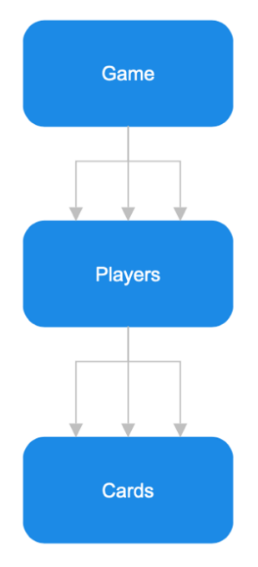

My database will be to 3NF. No single cell will hold more than one value, there will be primary keys, no duplicated rows/columns and each column will only have one value for each row. Additionally, there will be no partial dependence and no transitive partial dependence.

* id – integer, primary key, auto-increment
* username – string, unique, not null
* email – string, unique, not null
* password – string, not null
* games_played – integer, not null, default 0
* games_won – integer, not null, default 0
* stars_won – integer, not null, default 0

**Iterative and Post Test Plan**

Below are the tests I will conduct as I construct this part of the solution. I, the programmer, will complete these tests. These will be referred to during my development section. I will use the tests as both my iterative and post-test plan to ensure the highest quality of code for my stakeholder to meet the success criteria. Most of my code only relies on user input with use of a mouse, so there is not too much validation that needs to be checked. As a result, I will ensure that all GUI aspects are tested fully too. These tests may change and be altered when it comes to the course of development.

|  |  |  |  |
| --- | --- | --- | --- |
| Test | Test Type | Test Purpose | Expected Outcome |
| Click settings button | Normal | Check it changes menu | Menu changes to settings |
| Click single player button | Normal | Check it changes menu | Menu changes to single player |
| Click multiplayer button | Normal | Check it changes menu | Menu changes to login or lobby |
| Click tutorial button | Normal | Check it changes menu | Menu changes to tutorial screen |
| Add bot button | Normal | Check correct number of bots are added | Number of bots are added |
| Change bot difficulty | Normal | Check if difficulty is correct | Bot should play at expected difficulty |
| Check all forward arrows | Normal | Check if they move to the next required page | Page changes in correct order |
| Check all backward arrows | Normal | Check if they move to the previous required page | Page changes in correct order |
| Username input | Normal e.g. kieran | Check to see username matches required format | Allowed to continue with login/signup |
| Username input | Boundary e.g. abc or 1234567891234567 | Check to see username matches required format | Allowed to continue with login/signup |
| Username input | Erroneous e.g. thisnameiswaytoolong | Check to see username matches required format | Prevented to continue with login/signup |
| Password input | Normal e.g. Poney12!! | Check to see password matches required format | Allowed to continue with login/signup |
| Password input | Boundary e.g. Snakes1? | Check to see password matches required format | Allowed to continue with login/signup |
| Password input | Erroneous e.g. pass | Check to see password matches required format | Prevented to continue with login/signup |
| Email input | Normal e.g. x@gmail.com | Check to see email matches required format | Allowed to continue with login/signup |
| Email input | Erroneous e.g. 123 | Check to see email matches required format | Prevented to continue with login/signup |
| Sign up button | Normal | Check it changes menu | Menu changes to sign up |
| Email verification | Normal | Automatically check for email verification clicked | Menu changes to multiplayer lobby |
| Click a room | Normal | Check the user joins the room | User joins the room successfully unless full |
| Create a room | Normal | Check the room is created and only host has privileges | Room should be accessible to players |
| Kick a player | Normal | Check only host can kick players from room | Host can kick player from the room |
| Set password | Normal | Check password works correctly | Host can set the password for the lobby |
| Set password | Boundary | Check password works correctly | Host can set the password for the lobby |
| Set password | Erroneous | Check password works correctly | Host can set the password for the lobby |
| View stats | Normal | Check statistics are loaded correctly | Statistics are successfully loaded |
| Play card | Normal | Check card is played with the correct function | Card is played with the correct actions |
| Pickup card | Normal | Check card is picked up and added to player’s deck | Card added to player’s deck successfully |
| Say Uno | Normal | Check Uno must be pressed when reaching 1 card | Player face penalty if they did not say uno |

# Development

During the development of my project, I truly realised how strict of a timeframe I had to complete my project. While attempting to implement my design, I quickly became overwhelmed and decided to simplify my project and focus on the main success criteria – allowing for uncomplete additional objectives to be implemented in the future which could give my stakeholder, Mr Dorrell, some new content for his social media channels. However, I still managed to meet Mr Dorrell’s requirements for the project.

Along the way, I discovered lots of things about Unity that I was originally unaware of such as properties. C# allows for properties which are essentially variables with built in get and set methods. This allowed for encapsulation without the need of manually written methods, saving me time. This means that I had to adjust my classes that I planned in my design. Additionally, I explored the use of static methods, and how they are constant across all objects of a class. The lack of built-in multiplayer libraries to create a client-server-based system surprised me. After careful evaluation, I decided to use a relatively new but popular library called Riptide, which was created by a developer named Tom Weiland. It is efficient and simpler to use than other libraries, which was perfect for my time frame and to support lower specification clients and servers for my stakeholder. There is excellent documentation and community support, which I found very helpful. I experienced no issues with Riptide, and it is regularly updated and maintained.

When using Riptide, you have the option to write both the client and server in one project, but the better option in my opinion is to split them into 2 different Unity projects. Although by writing them in the same project, you avoid rewriting code by creating a shared (SH) environment between the client and server - this can also be problematic as there is no clear separation of codebases which can cause logic errors. The client would also have access to the server’s source code, which should be kept secure. I have 15 scripts for my client (CL) project, and I have 7 scripts for my server (SV) project. To help differentiate between these different states, I have coloured them with outlines.

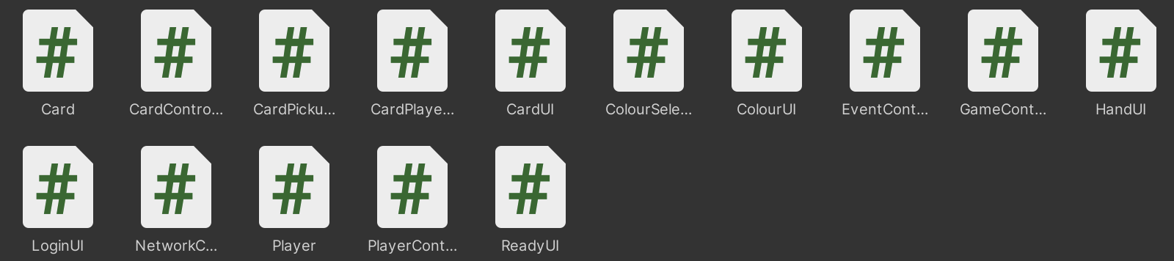



## Success Criteria 1 – Clean UI

I set clear UI as success criteria 1 as it allows me to explain the front-end of my program before I explain the back-end code, so it is clearer what I am explaining. My success criteria often overlaps, but I have tried to categorise the main content for each of them. The goal of this success criteria was to provide a user-friendly UI that is sleek, clean, and overall modern. This included good use of white space, padding, margins, and a consistent colour scheme and font. So, what makes a design modern?

1. Simplicity – cluttered and complex interfaces can be overwhelming for users. Clean and straightforward designs with a focus on essential elements contribute to a modern aesthetic. I have successfully achieved simplicity.
2. Typography – readable and well-planned typography is a crucial aspect of modern UI design. Legible and clear fonts, correct font sizes, and effective use of spacing contribute to a visually appealing and user-friendly interface. I have used a consistent font and effective spacing within my project.
3. High-contrast colours – bold and vibrant colours can draw attention to important elements which differentiates them, creating a visual hierarchy and improving readability. I have used a colour set, and cleverly used Color32 values, which includes alpha, to differentiate aspects of my program.
4. Card-based layouts - this organizes content into distinct cards. This modular approach allows for easy organization of information. With the use of hands, and actual cards in my game, I have used this approach.
5. Integration of images - real images, high-quality photography, or custom illustrations or drawings. This adds “personality” to the interface and contribute to a more engaging user experience. I used aesthetic backgrounds and icons to add depth to my project.
6. Dark mode - dark backgrounds and lighter text, has become a popular feature as it is not only visually appealing but also reduces eye strain, especially in low-light environments, which most gamers are used to. This will be great for Mr Dorrell’s fans.

I have significantly more files for the client as there is lots of UI interaction to control which the server does not require. By using many different scripts, it allows further separation of my code into sections. These scripts can each be managed by different game objects if required. Each script contains one class, which has the same name as the file name. My SV project has one scene called “Main”, whereas my CL has two scenes called “Login” and “Game”. By taking this modular approach, I can easily implement new features and modify existing ones. This has allowed me to achieve my success criteria of clean UI. Throughout this section, I will also be talking about the many different game objects within my game, and which aspect on the UI the correlate to. Unity offers lots of different UI elements that can be modified and customised to fit a design. These elements are positioned relative to the canvas that they are on and can be set to scale to a screen size. However, for my project, I simply set the canvas to be 1920x1080pixels, but will still work on larger or smaller displays as it will automatically scale down, but with black bars either horizontally or vertically to fill the empty space.

**Main Scene**

 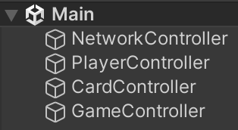

My server scene contains no UI and does not even contain a camera to render anything. This allows for resources to be allocated strictly to processing data to and from clients. Each of the 4 game objects has a component of 1 script that correlates to their names. Other scripts such as Card, Player and EventController do not need to be initialised in run-time by a game object as they are accessed through the scripts that have been initialised upon running the program.

**Login Scene**

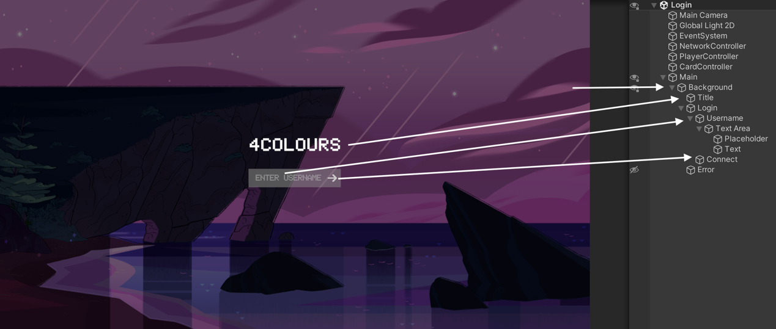



This scene is specifically for the login for multiplayer. The main camera and global light 2D are both renderers for the UI. NetworkController, PlayerController and CardController all have their name-matching scripts added as components. Upon evaluation now, CardController might have been better in the Game scene as it is not required until the game starts and would fit better with the modular approach. For example, when single player is added, CardController won’t need to be in separate scenes as single player won’t require the login scene. The Main game object is the canvas which allows me to create UI to be rendered. Background is an image that has a vertical layout group attached to it. This vertical group means the 1st generation of children are evenly spaced and centred for good use of whitespace. Error text is not visible by default but can be seen above. This provides 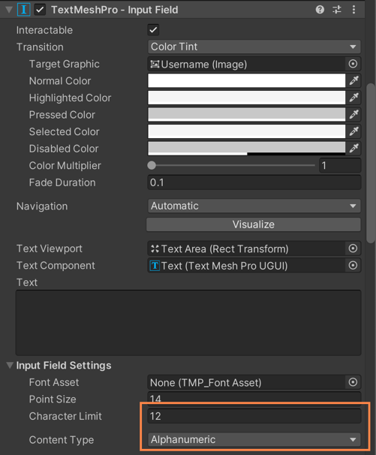feedback to the user, so they know what is happening. I have used an aesthetic background and made sure my elements are darker, rather than lighter. The consistent font is used successfully. In my opinion, the UI is simple and clear to use. The user is given a simple input box and a continue button. This is robust as the user has little choice over input, meaning that they are less likely to break the program. The Unity input box has validation built in which can be seen to the right. The validation is set to allow a maximum username of 12 characters and only allow alphanumeric characters. As someone who has experience with client and server network messages, I know very well that you should never trust the client’s data. This is because client’s can actually send the net messages manually using exploits with their custom data. However, it would not be the end of the world if they managed to bypass this as it’s only a username and not crucial data for the game. For this reason, I did not add validation to check these factors on the server. It’s unlikely that Mr Dorrell’s fans have the knowledge to exploit. I did add validation for a blank username, which appears as Guest, which I will talk about further on in my development. The font displays lower case letters as upper case too. I have put these tests for the username input here, as this is where the validation for alphanumeric characters and character requirements are checked.

**Game Scene**

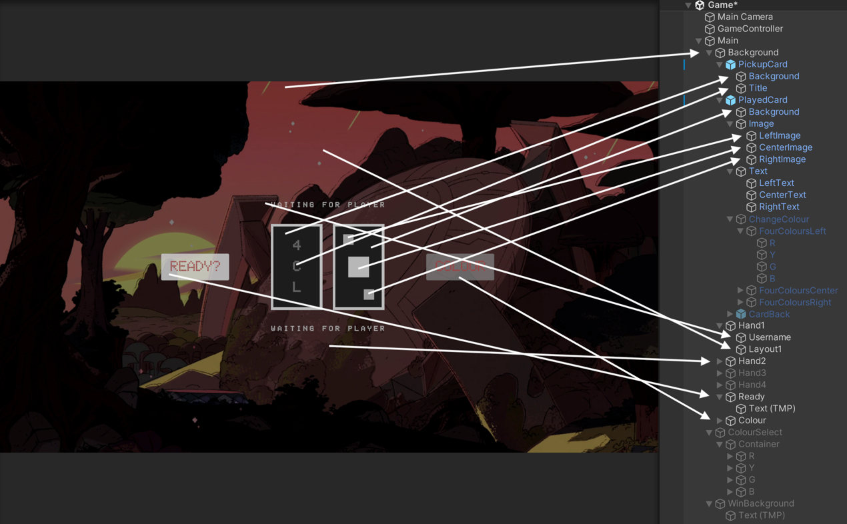

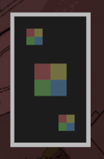

This scene is used for the multiplayer game but can easily be adapted for single player too. GameController has the name-matching script attached. The camera is used to render the UI on the current scene. The PlayedCard also has text elements which are not visible by default that are in the same positions as the image elements. Hand 1 is located at the top, hand 2 at the bottom, hand 3 on the left and hand 4 on the right. By default, both hand 3 and 4 are not visible as only 2 players are required to play the game, and they appear/disappear on the player count changing. The change colour element is also invisible by default but can be seen above to the right. The ColourSelect element can be seen below on the left and the WinBackground can be seen to the right below. CardBack is the same as PickupCard. I have continued to use the font throughout my UI designs, as well as making great use of white space. The game is simple, clear and easy to use. “Waiting for player” is the placeholder text for when there is no user connected.

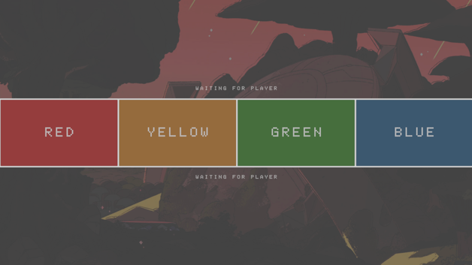 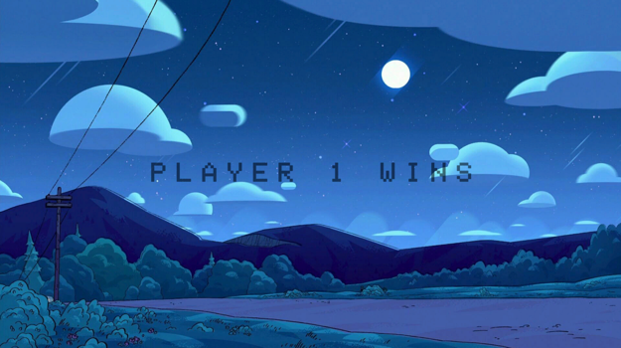

To conclude, I have successfully achieved my first success criteria of clean UI as requested by my stakeholder. The game features a dark but vibrant environment for Mr Dorrell and his fans to enjoy. Due to the incredible use of whitespace within the program, it is simplistic and minimalistic, allowing a user-friendly experience. This will allow fans of any experience to play the game with no prior knowledge.

**Prefabs**

The blue elements in the scene hierarchy are called prefabs, which is short for prefabricated objects. A prefab is a reusable game object or a template that you can create and configure, and then use to create instances of the object during runtime. This is particularly useful for efficiently managing and spawning numerous similar objects in your game. In my game, I have 3 prefabs.

 

Both the player prefab on the client and server are the same, but just the Player script that is attached is different. CardBack is a prefab inside of the Card prefab. It also allows me to use the prefab for the CardPickup game object. The Card prefab has the Card script attached. By using a prefab, you can edit all the objects at once for UI consistency for my success criteria of clean UI.

## Success Criteria 2 – Multiplayer

The goal of this section of my criteria was to allow for a minimum of 2 and a maximum of 4 players with nicknames to join a room together. When a player leaves a game, their cards would be returned to the deck, and they won’t be able to join back. The game will begin when have players have pressed ready. I believe I have partially met this aspect of my success criteria, as the players do not join a room. Currently, the server does not allow for multiple rooms, and functions as a singular room, but this could be implemented into the future. This isn’t a problem as Mr Dorrell cannot play more than 1 game at once anyway. I am going to explain the different aspects of multiplayer, and then explain the flow of the program after.

**Player.cs**

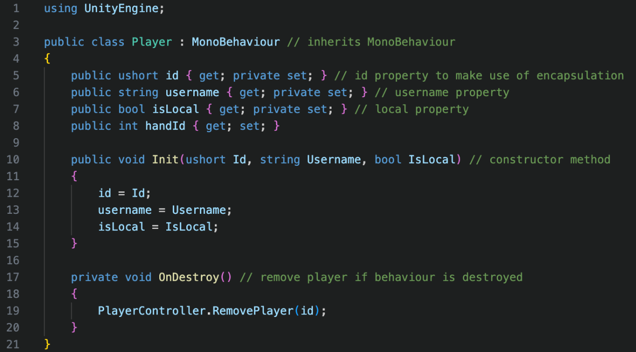

The only namespace required on the client is UnityEngine for the MonoBehaviour inheritance to allow the class to be added to a game object. The isLocal property is simply to state whether the player is the local player, instead of constantly comparing the local id, stored in NetworkController, to an id provided. The handId property is the player’s hand position (1-4) and can be publicly set, as positions can update when a player leaves, or joins. The Init method is the constructor method, but does not need to be called automatically, as the object is instantiated, which means it can be modified at any given time. The handId is not set within this method, as it is managed by the GameController. When the game object that the player is attached to, the PlayerController removes the player internally. This class differs slightly on the server, as the server has more data to manage than the client does for the different players. isLocal is not required on the server, as no player is local on the server.

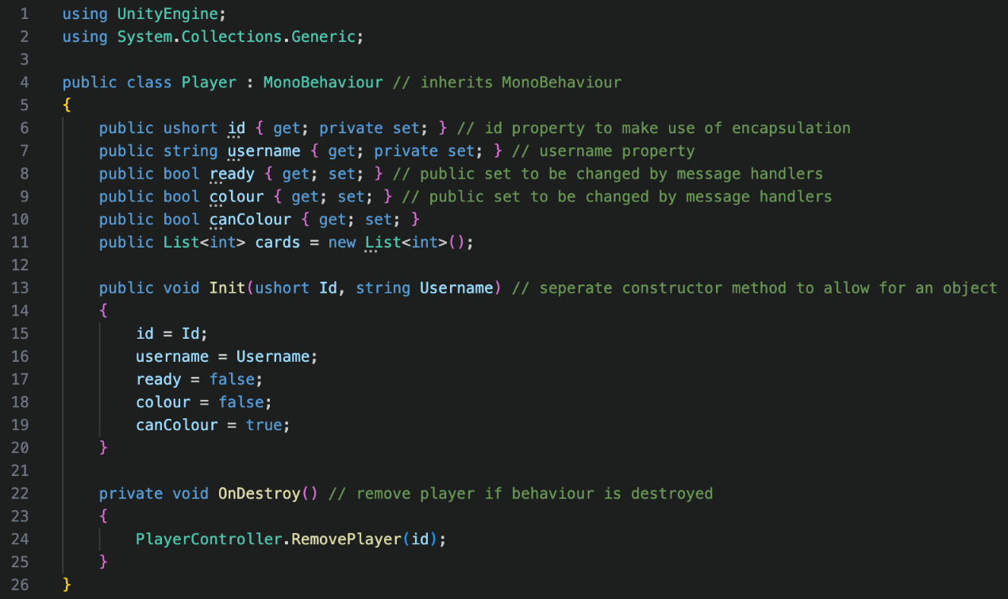

An additional namespace of System.Collections.Generic is required as there is use of a list created within the class. The ready property is whether the player has pressed the ready button, the colour property is whether the player has pressed the colour button, and the canColour property with whether they are allowed to press the colour button. These are all publicly settable, as they are managed by other classes. Lists do not support properties, but will need to be public as again, it is managed by other classes. All the properties are initialized with parameters, or default values, except the list, which has already been initialized. The OnDestroy method serves the same function on both the server and client.

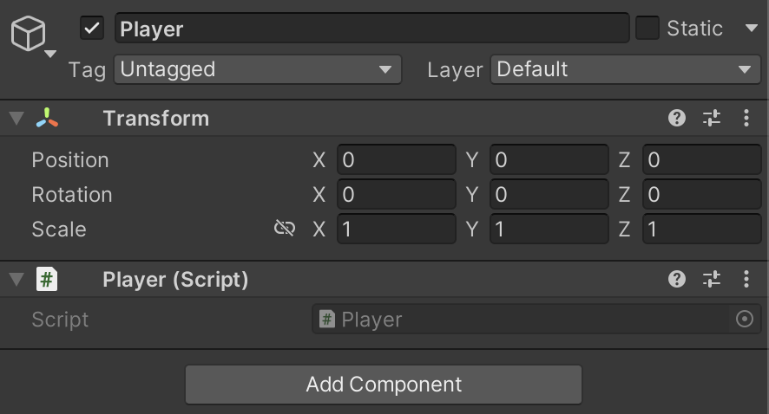

The Player prefab that is instantiated when a player joins, only contains a game object called Player with the Player script attached, on both the client and server.

**EventController.cs**

Events are mechanisms in Unity that allow for communication between objects. It means when a condition changes, other objects can be notified. This allows me to link systems in different scripts together. Events can be subscribed to and unsubscribed to with different methods. Let’s say I have an event called SomethingHappened and a method called DoSomething. I can subscribe the method to the event by assigning it with a += operator and unsubscribe the method using a -= operator. This means when I invoke the event SomethingHappened, DoSomething will be called. It is good practice to unsubscribe from events even if you know they won’t necessarily need to be, as it prevents memory leakage by cleaning up unused. Overall, it allows me to continue to use my modular approach by reducing dependencies but allowing communication. On my server, I have 3 events.

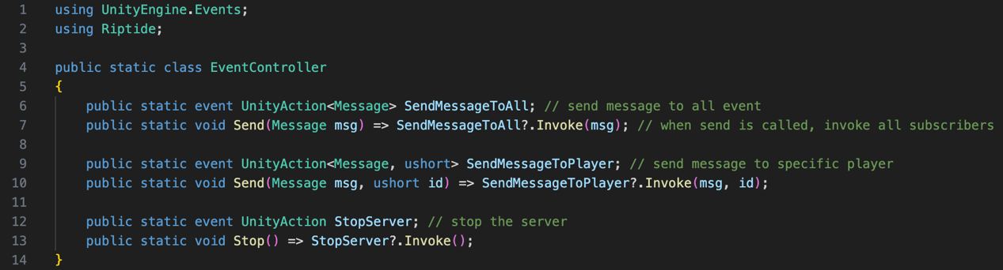

I’m using 2 namespaces in this script. UnityEngine.Events is used for the UnityAction method and Riptide is used for the Message data type. SendMessageToAll is a method that takes a Message data type. This event is called by EventController.Send which takes msg (Message) as a parameter. Calling this method invokes all methods subscribed to the SendMessageToAll event. This event has an overwrite called SendMessageToPlayer which takes an additional data type, ushort. This ushort is used for the id parameter of EventController.Send which invokes the SendMessageToPlayer event and subscribed methods. Unlike the other events, StopServer takes no parameters and is called by EventController.Stop which invokes the subscribed methods too. There are more events on the client than server, as the server contains less files which require less communication between them. I decided to make EventController static, so it does not need to be created as an object and does not need to be assigned to a game object. This means that all methods and variables will also have to be static. I will explain these events further when it comes to showing the subscribed methods themselves.

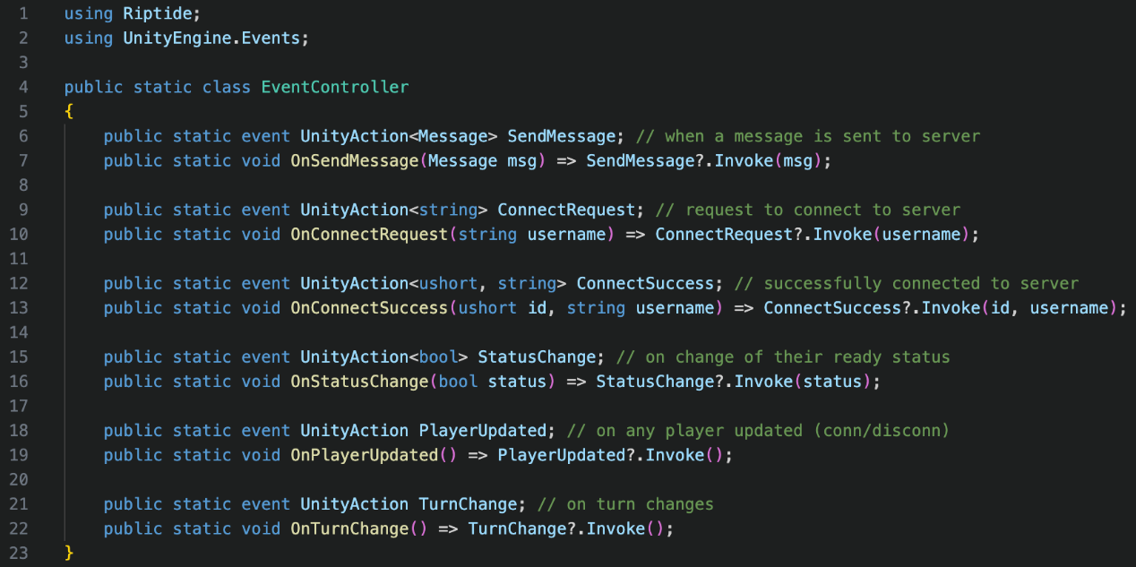

Like the server, the client has a static class and includes Riptide and UnityEngine.Events for the same reasons. As the client only needs to send messages to the server, not specific clients, or all clients, it only has 1 message event called SendMessage, taking Message as the data type. The use of events is commented next to them in green. I could explain each event individually, but I would be repeating myself as they all function in very similar ways, and I believe I have justified the use of them all successfully. I felt I used events appropriately in my project, and they provide a way to call private methods instead of making them publicly available. I used a good combination of events and calling public methods and made the decision of which one where appropriate. These events are tested within the program flow.

**NetworkController.cs**

A different network controller exists on both the client and the server but has similar functions. The goal of the NetworkController class was to manage the Client and Server objects provided by Riptide, and to manage the main communication between them.

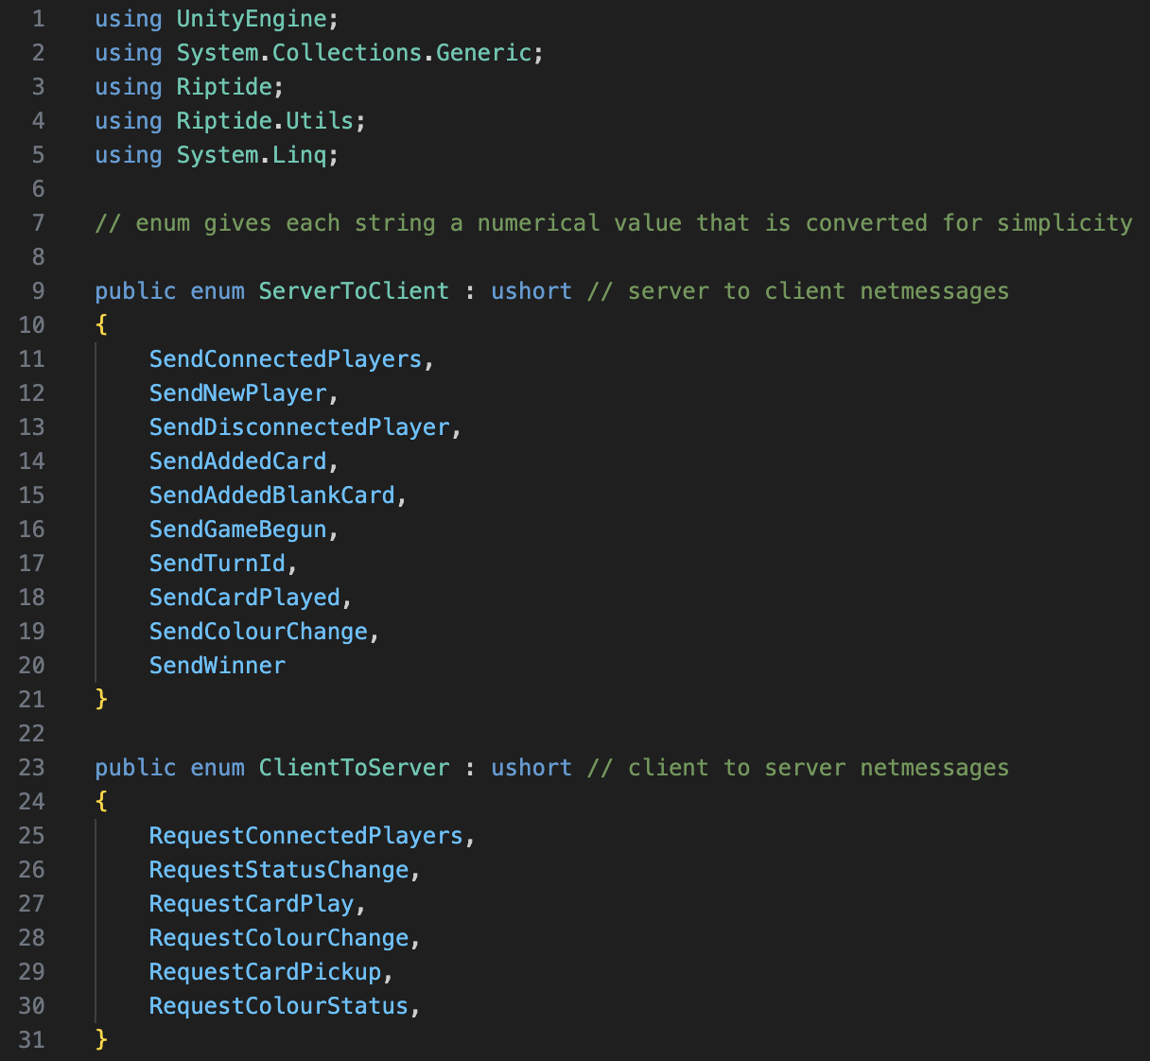

Within my network controller on my server, I am using 5 different name spaces. UnityEngine allows for the use of classes such as Debug, and the use of game object methods such as Destroy. MonoBehaviour provides a base class that can be inherited from, saving creating a custom singleton that would take time to develop, which I am short on. Debug methods are used to print errors into the console to find bugs, and the destroy method deletes a game object. The library System.Collections.Generic implements the dictionary data structure and the associated methods. Riptide.Utils provides the logging system for Riptide, to print errors and information into the console. System.Linq allows for additional dictionary methods such as finding the minimum or maximum key. I have previously explained the purpose of the Riptide namespace. Riptide requires message ids in handlers to be able to know which message it is receiving. Both enumerators ServerToClient and ClientToServer exist on both the client and server. The purpose of these enumerators is to provide a worded identifier with a ushort message id. This is easier to remember and required by Riptide to differentiate between messages. By typing words rather than numbers, it’s less likely for me to make an error and listen to the wrong message for example as the number 5 alone does not tell anyone a lot of info.

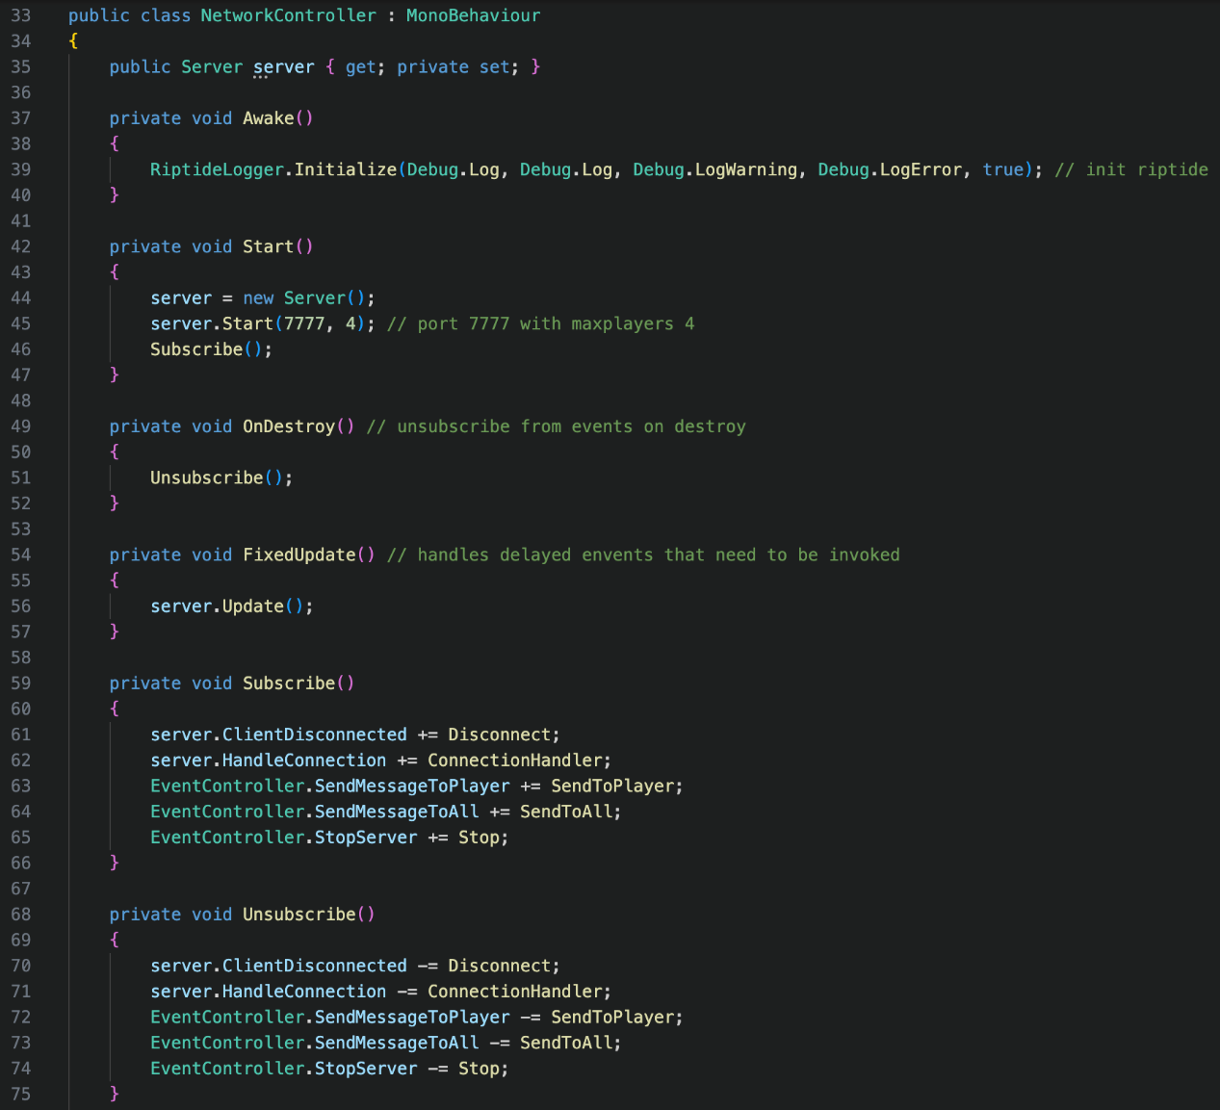

NetworkController only has one attribute which is server that has the data type as the Riptide Server class. Unity runs Awake methods when the script is initialised and runs Start methods when the script is loaded into a scene. Both Awake and Start are MonoBehaviour methods. I initialize the Riptide logger in the awake function, as I need to ensure that the logger is loaded before I create and start the server in the Start method. The Initialize method for the Riptide logger can take 6 parameters, which can be seen in the documentation.

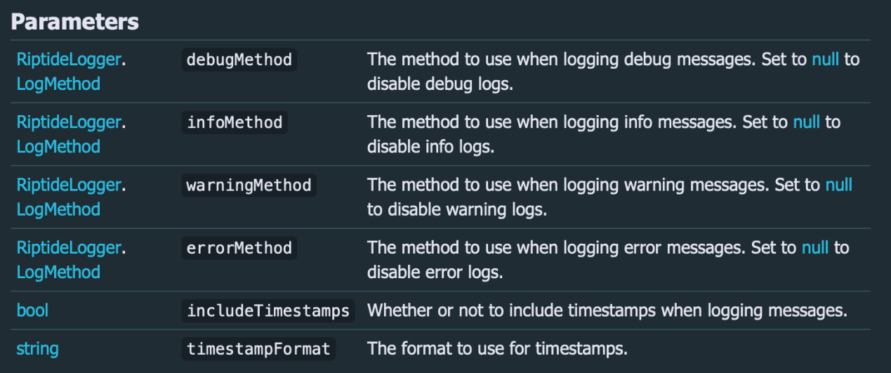

Instead of using my own debug methods, I used the default Unity methods which are Debug.Log, Debug.LogWarning and Debug.LogError. These allow me to see feedback of my networking, as well as the severity of issues. I set the includeTimestamps parameter to true as it’s useless to know when the error has been produced in real-time. The timestampFormat parameter is optional and by leaving it blank, it uses the default timestamp format.

During the Start method, I assign a new Server object to the server property. After it has been assigned, I call the Riptide Start method on the server. The parameters take a port number as an integer, and maximum number of players as an integer. I used port 7777 as it is often unused, but Mr Dorrell will have to check this for himself. It may be useful to have a config file, rather than a static value, as Mr Dorrell may be unable to compile the program himself. The max players will always be 4. I then call my Subscribe method.

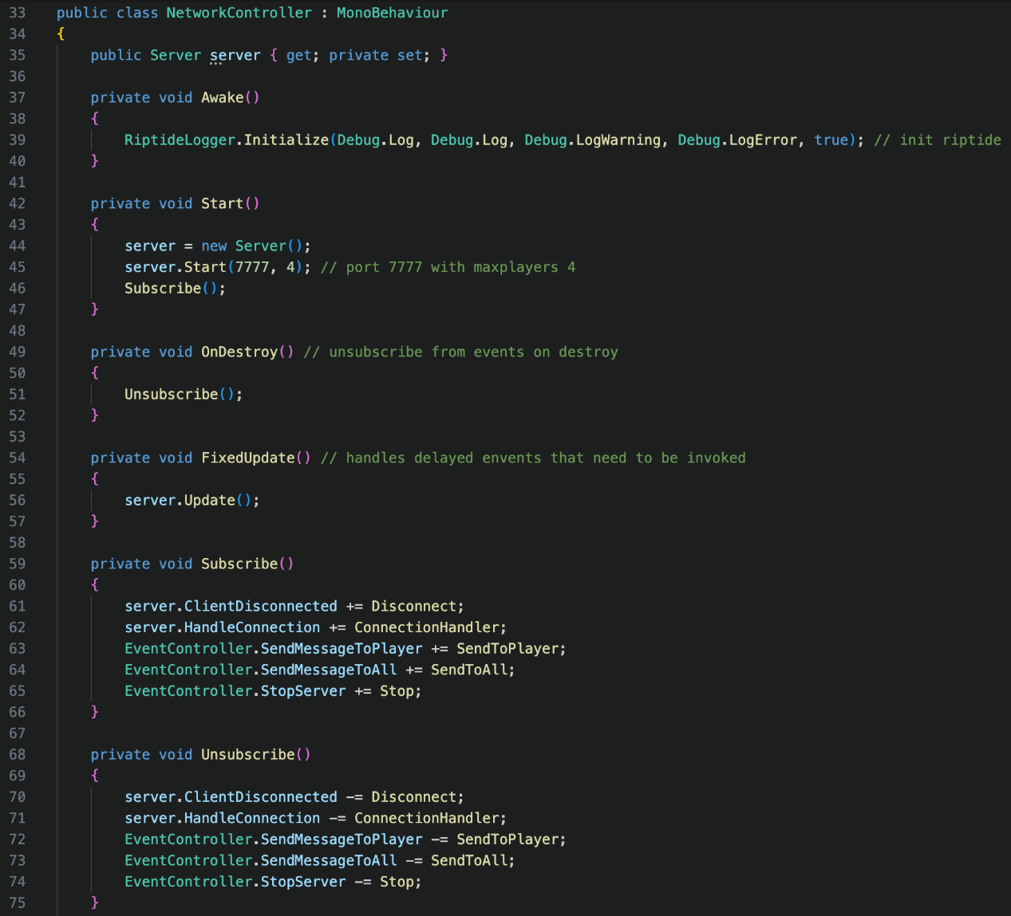

The Subscribe method simply subscribes all my methods to certain events, which will be explained below. The Unsubscribe method obviously unsubscribes from the events. This is called when the game object parent is destroyed, preventing memory leakage. Unlike the MonoBehaviour Update, FixedUpdate is called 50 times per second by default, instead of every frame. Frame rate is variable, and it needs to be checked continuously. The Riptide Update method’s role is to handle any received messages and invoke any delayed events.

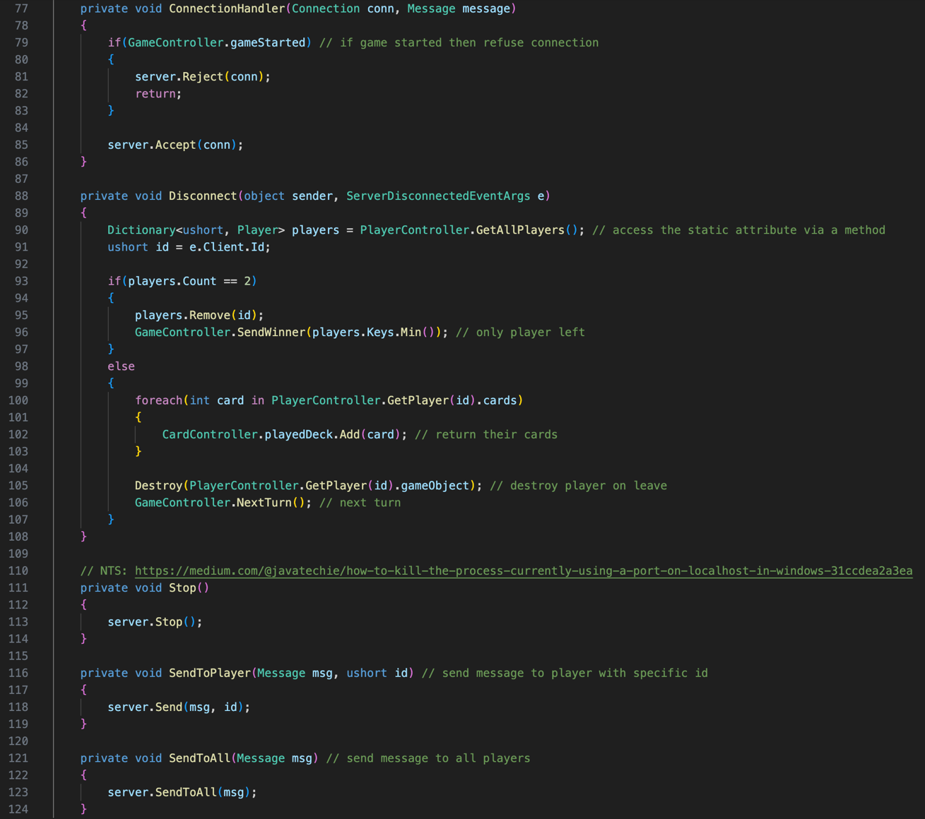

The first event that I subscribe to is ClientDisconnected which is provided by Riptide and invokes my Disconnect method when a client disconnects. Disconnect takes 2 parameters that are passed in by the ClientDisconnected event. The first is the sender, which is type object, and the second is e, which is a class called ServerDisconnectedEventArgs. The variable e for event arguments is common practice in Riptide. There was no need for me to make sure of the reason field, and it would not be communicated to any clients, and is already printed into the console by the Riptide logger that I defined earlier.

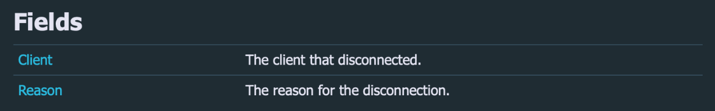

Within my Disconnect method, I have 2 variables. The first is players which is dictionary that is of types ushort and a Player class. A static dictionary in my PlayerController is accessed by reference through a manual get method, as dictionaries and properties are not compatible. The secondary variable is a ushort called id, that accesses the client id from the event arguments. I then check if the number of players is equal to 2. If there are only 2 players, and 1 leaves, then the only player left automatically wins. To check this, I remove the player who left from players, and then find the minimum key. Dictionaries cannot be accessed like lists to find the first index, as they are indexed by keys. I then call the SendWinner method from GameController, which ends the game. GameController will be explained in the original rules’ success criteria. If the player count is not equal to 2, then the else statement will be executed instead. The foreach loop will return any cards from the player into the played deck of cards as they would be unshuffled. If they have no cards, nothing will happen, and the rest of the statement below will execute. We then destroy the game object of the Player and move onto the next turn if it was their turn.



Private methods are only available in the scope they’re defined and void simply means it returns no value. The next event that is subscribed to is the Riptide server.HandleConnection with the ConnectionHandler method. When the game has started, a Boolean variable is set to true in GameController. If it is true, then the connection trying to join is manually rejected from joining and the method is returned. If the game hasn’t started yet, it will accept the connection. If a client tries to join a full server, then Riptide rejects the connection internally.

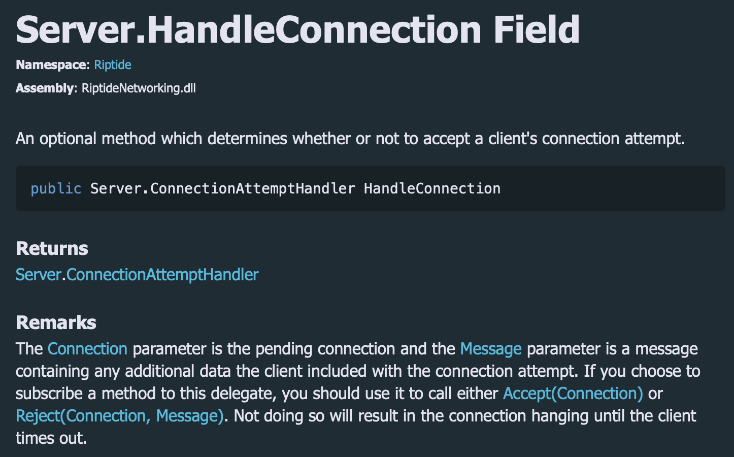

As I subscribed a method to the delegate, I needed to call accept or reject, which I did not originally realise. This left the connecting hanging and client timing out, like stated in the documentation above. You can provide a message when rejecting a client, but as I only have one manual rejection, there was no need to as a manual rejection means the game has started and I would be passing unnecessary data to the client.



The next 3 methods are subscribed to my own events. By using events, it means I can keep my server variable private, and only access via methods. The Stop method simply stops the server, disconnecting all clients. SendToPlayer sends a net message to a specific client id, while SendToAll sends a net message to all clients. SendToAll can also take a second parameter of a client’s id as a ushort. This actually excludes the id and is useful for sending data to other clients from a client who already has the data. When I needed to do this, I simply used a for loop, and invoked the SendToPlayer method for all players except the one that I didn’t want to send it to. Both ways are acceptable, but the way I used takes longer to write the code. NetworkController also exists on the client, but with slightly different code.

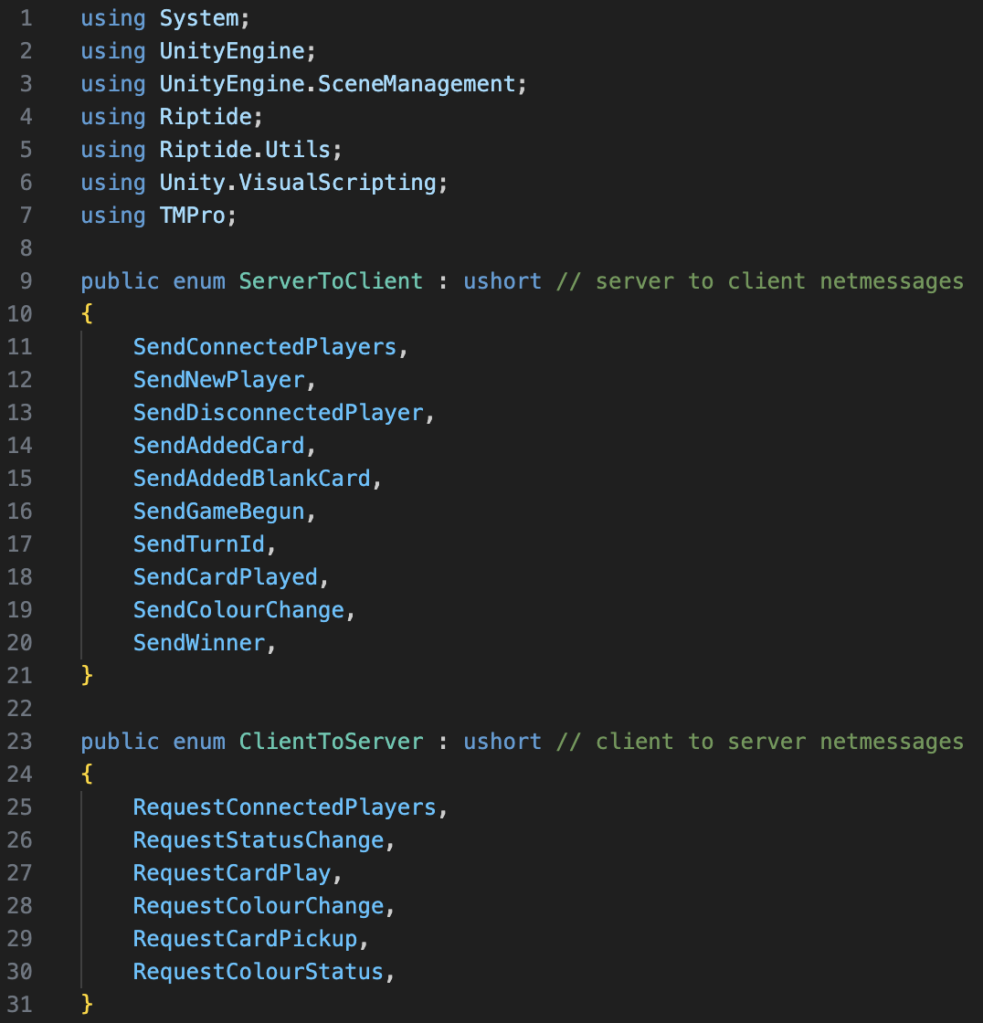

Every single file contains the namespace, Unity.VisualScripting as it allows Unity integration with visual studio. However, it only works with one Unity project at a time, so when I have both the server and client files open at the same time, it tends to break the integration. Most of the time, this namespace isn’t visible in the file, as it is hidden when integrated. I do not need System.Linq on the client, and instead use UnityEngine.SceneManagement and TMPro. SceneManagement allows me to load new scenes, like changing from the login screen to the game. TMPro allows me to access text mesh pro objects within the scene. As stated above, the enumerators are the same on both the client and server.

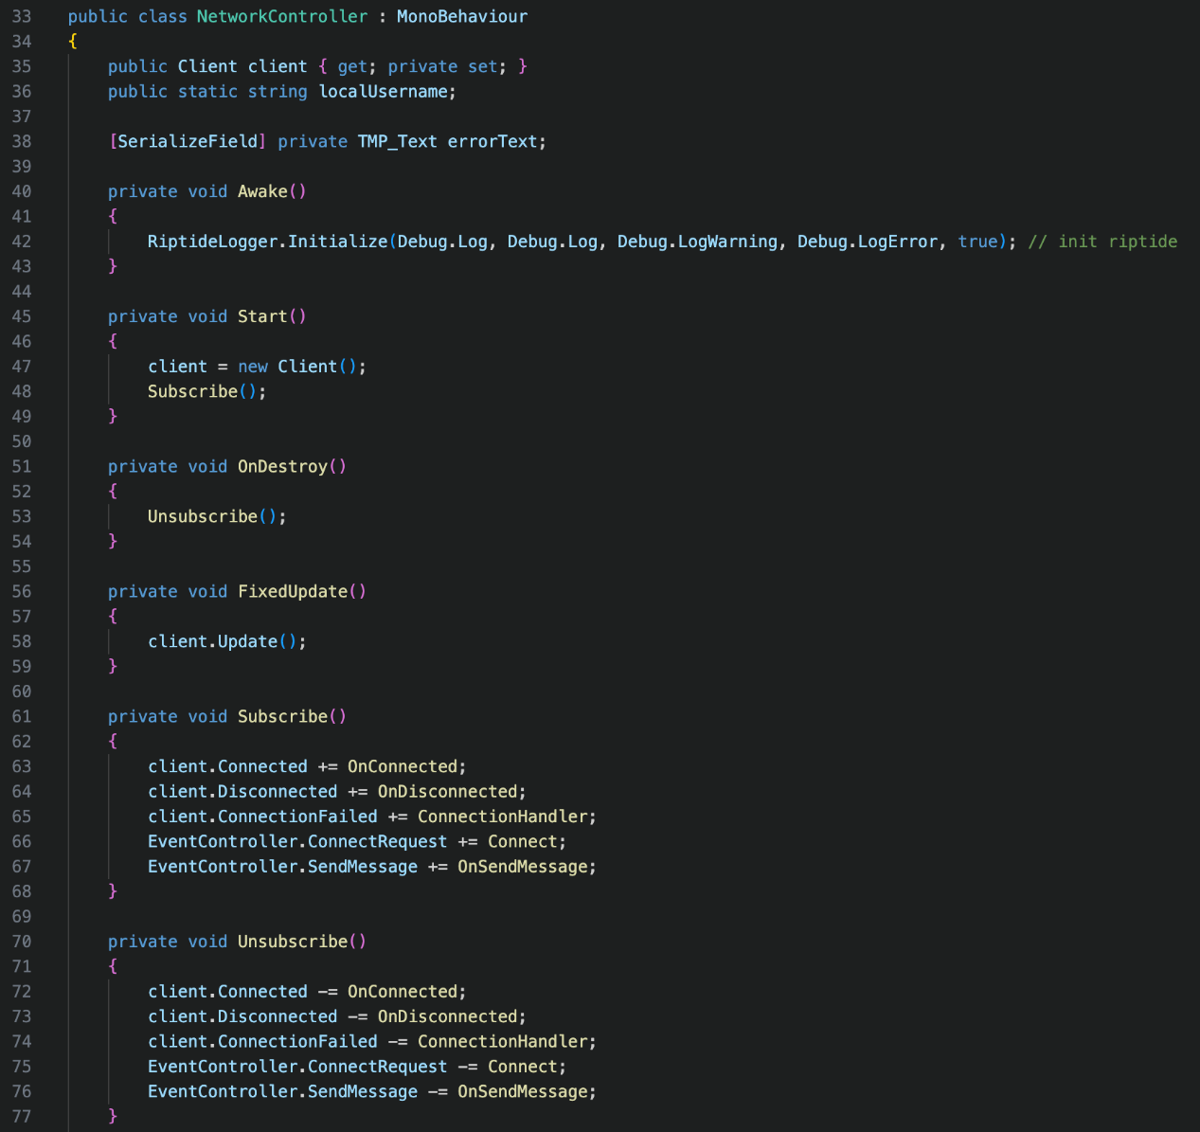

I then create the NetworkController class that inherits from the MonoBehaviour class as well. Instead of creating a Server object this time, we create a Client object which will be assigned to the client property. I have continued to use encapsulation, allow the client property to be read by get methods, but only be written locally by set methods. This class also contains a static variable for the username of the local client. Message handlers by Riptide are static, meaning that methods and variables that are used within them, also have to be static. So, although there is only one instance of the NetworkController class, some variable and methods need to be static to be able to be accessed.

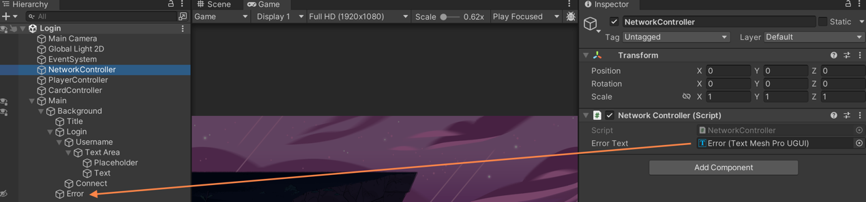



The last variable is the errorText and by serializing the errorText field, it allows it to be visible in the inspector, without making the variable public. This way, I can assign the text mesh pro text (TMP_Text) to the variable.

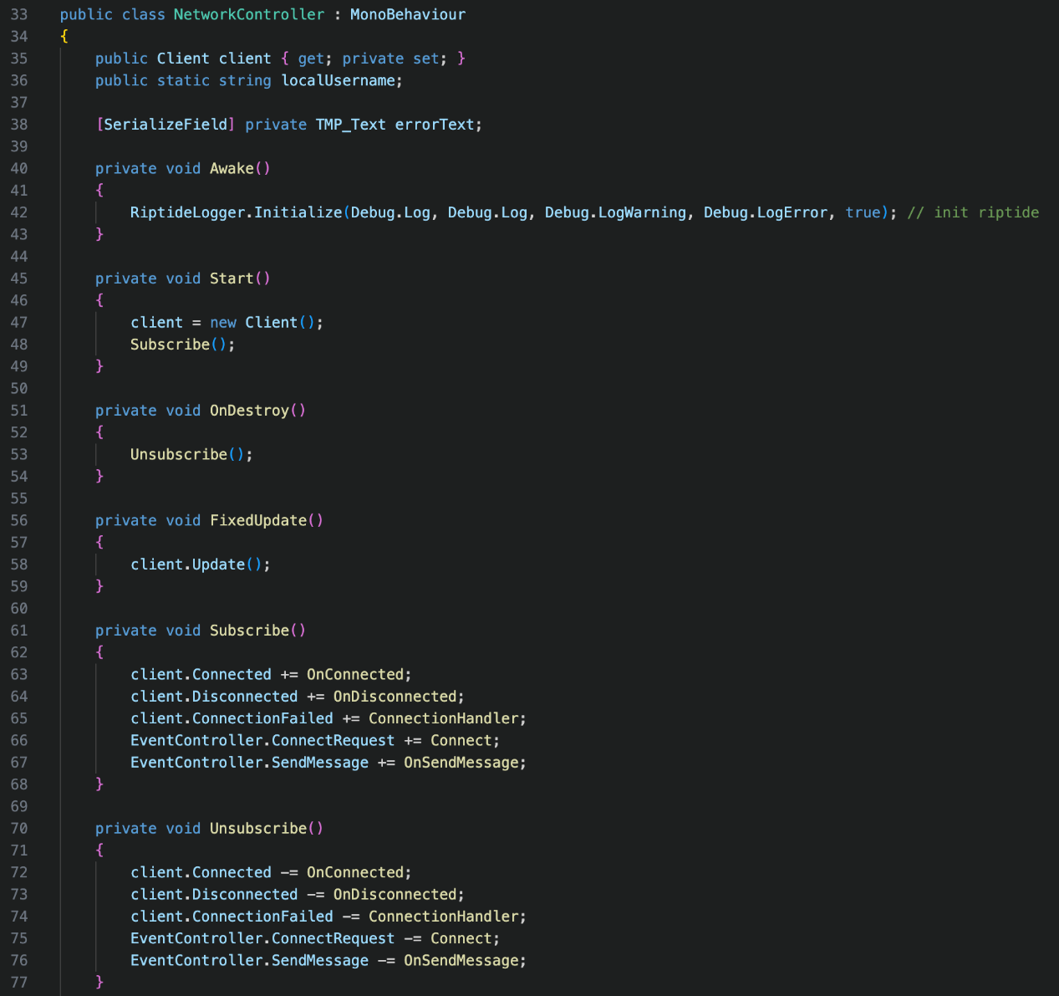

Then, I create 4 methods. Just like the server, the Riptide logger has to be initialized in the Awake method before the Client object is created in the Start method, where the events are also subscribed to. When the object is destroyed, we unsubscribe as usual to avoid memory leakage. Similar to the server’s NetworkController class again, we used fixed update, but to update messages for the client.



client.Connected, client.Disconnect and client.ConnectionFailed are all Riptide events. Connected is invoked when the local client establishes a connection to the server, and Disconnected is invoked is when the local client loses connection to the server. ConnectionFailed is invoked when the client connection is rejected from the server. EventController.ConnectRequest is invoked when the client tries to connect on the Login scene upon pressing the arrow. EventController.SendMessage is used to send messages to the server. I could have written all these subscriptions into the method where the method is called, but by writing them in a separate method, it allows for a modular approach and clear code.

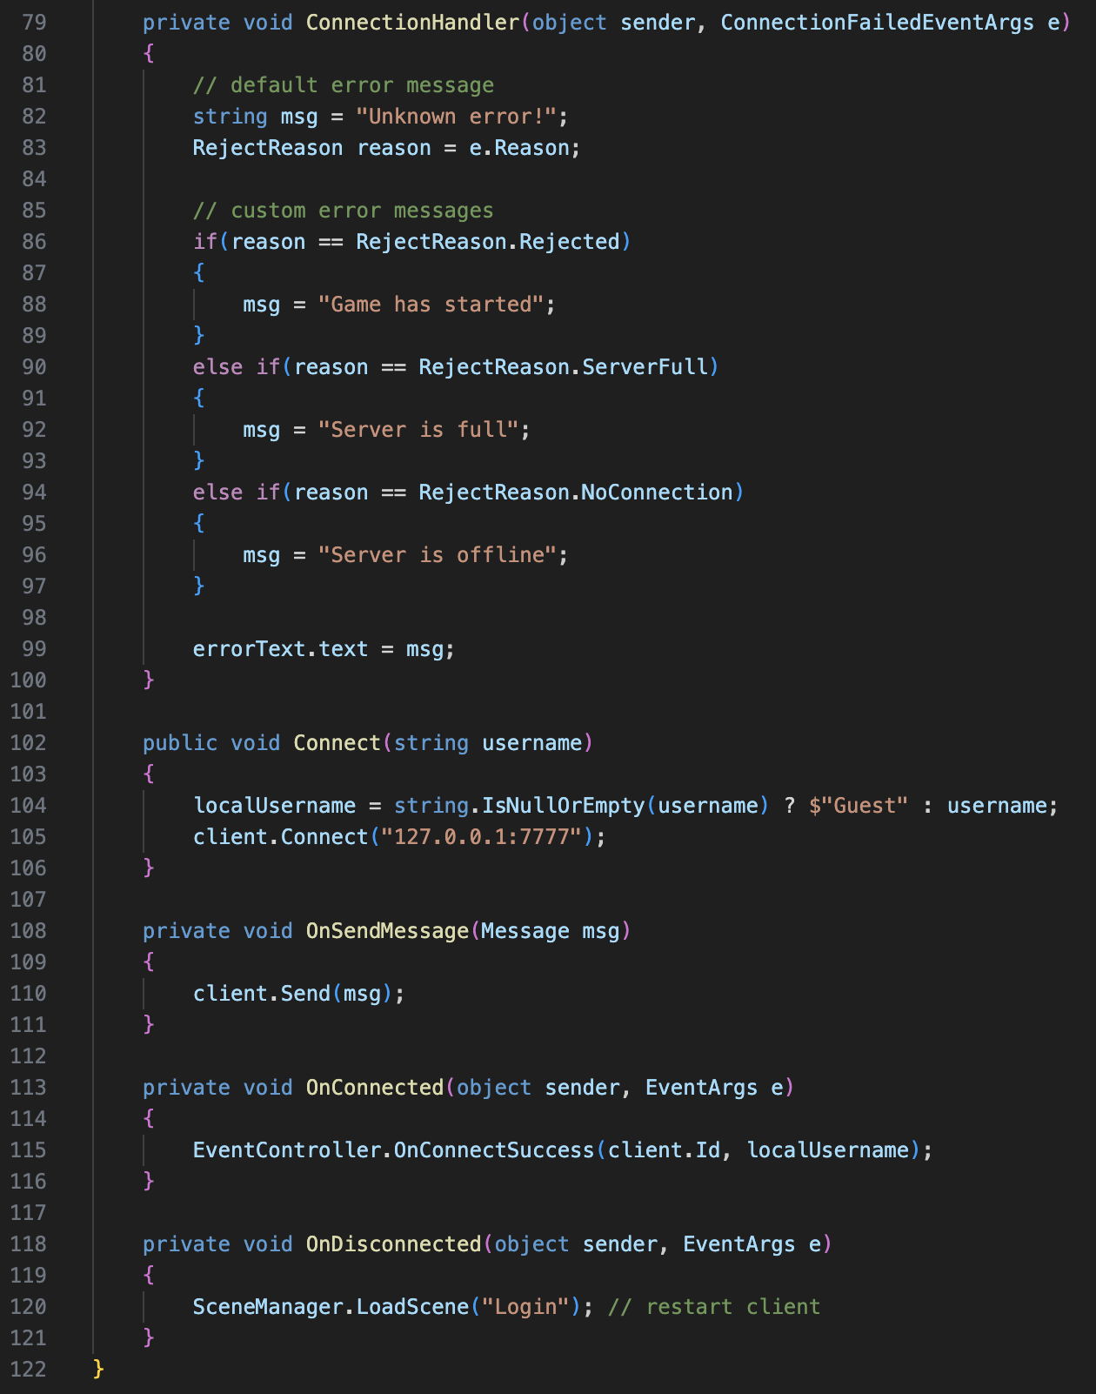

The default error that is displayed is “Unknown error!” but there are also custom messages. A manual reject is because the game has started, and the other reasons are because the server is full or not responding. At the end of the selection, the errorText text is set to the msg variable, which may have been updated.



OnSendMessage is used to send the message created to the server, where it can then be processed. OnConnected is used to call the event EventController.OnConnectSuccess where the game can start to be setup in the PlayerController. OnDisconnected simply reloads the login scene, which means the client is essentially restarted and all data wiped. Both OnConnected and OnDisconnected can have their own event arguments, but as I don’t use them, I just use the default event arguments to pass them in. The last method in the NetworkController is the Connect method.



This method is public so it can be accessed by the LoginUI class. It sets the localUsername to the username parameter, or Guest if it is null. The client then connects to the server, on the same port. 127.0.0.1 is the IP address for local host.

**LoginUI.cs**

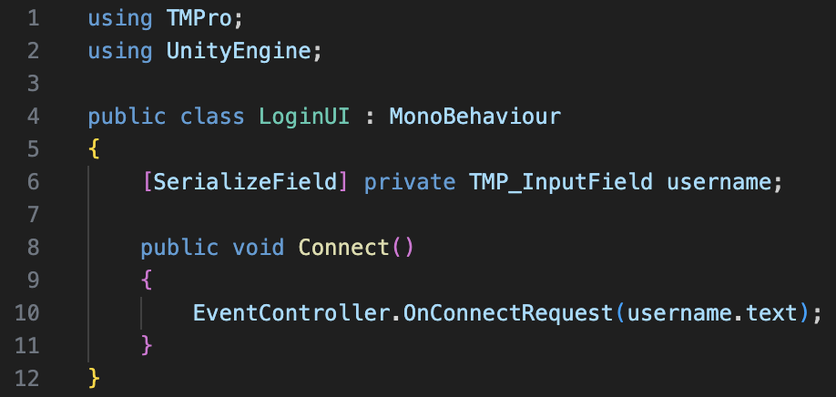

This time, the TMPro namespace is used to access the username field, which is a TMP_InputField. The UnityEngine namespace is required for MonoBehaviour inheritance to allow for compatibility with game objects. The Connect method is called when the arrow button is clicked, and it invokes the EventController.OnConnectRequest event, passing the username entered as a parameter. This event then invokes the Connect method in the NetworkController, which I previously spoke about above. The method is public so it can be accessed by the Unity inspector and assigned.

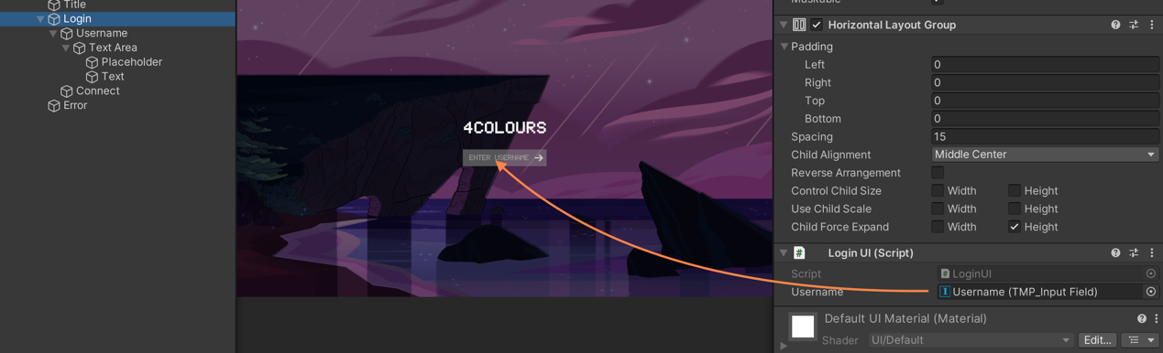

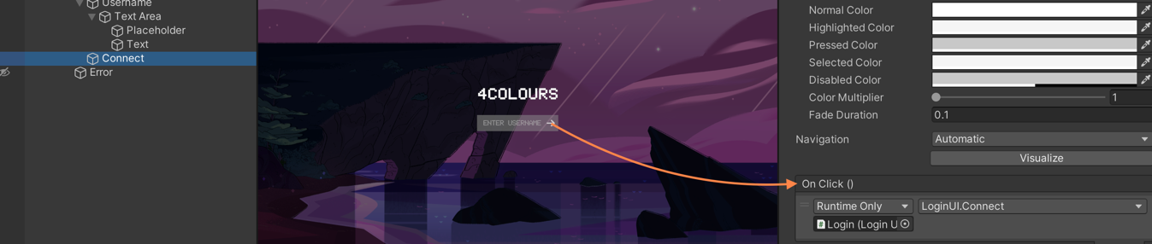

**PlayerController.cs**

The goal of the player controller was mainly to deal with turning connected clients into players and controlling their data. Both the server and client share this idea, but both require different data to handle. I’ll start by explain the server-side code, as this allows the client-side code to be better understood, as it heavily relies on the data provided by the server. The server requires 3 different name spaces.

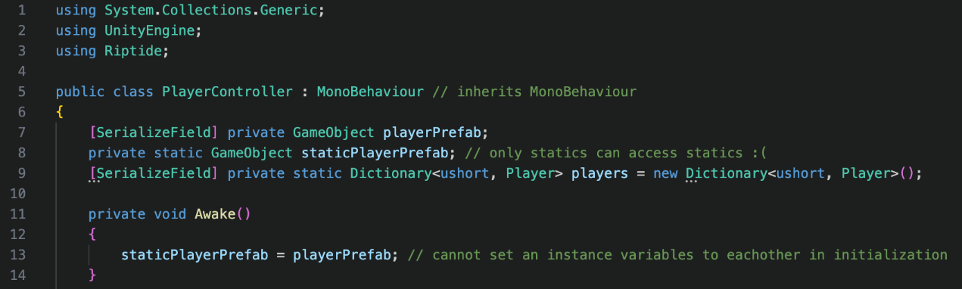

As usual, the UnityEngine namespace is mainly used for the MonoBehaviour inheritance, while the Riptide namespace is used to manage messages between the client and server. Systems.Collections.Generic is required as a list is used. To start off with, there is a player prefab variable, that cannot be static as the field has been serialized. The player prefab is assigned to this variable in the inspector.

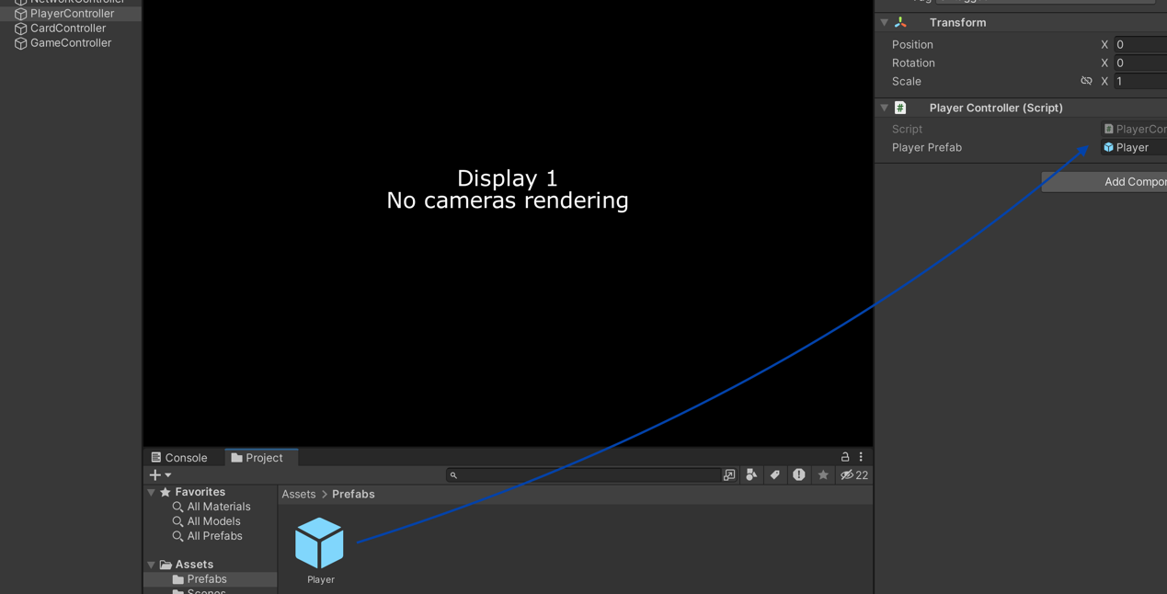

So that the variable can be accessed by a static method that Riptide requires, we have to have a static version of the variable. As instance variables cannot be set to instance variables as the order of assignment can be switched during compilation, I have to assign the player prefab variable to the static player prefab in the awake function, once all the instance variables have been declared. The dictionary is also static as it needs to be accessed by Riptide. As I discussed earlier, even though most of my classes only exist as one object, static types are still good practice to share data, and also are required by Riptide. The dictionary has a ushort as the key, and a Player class as the value.

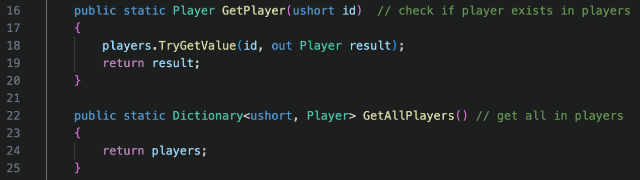

Both of these are get methods, so they are publicly available. They both return the value by reference, which allows the original value to be modified. This is a benefit as it saves memory for Mr Dorrell and his fans, meaning the game can be ran from lower specification computers for a wider fan base. I did not include set methods for each attribute of the player in the dictionary as I felt that the modification would be easily visible by assignment or the get method. The GetPlayer function uses the TryGetValue method. If the player is found, the object is outputted from the correlating id. If it is not found, then a null value is returned to show that the id does not exist in the dictionary. The GetAllPlayer method is simply a “gateway” to the static attribute of the class in other files.

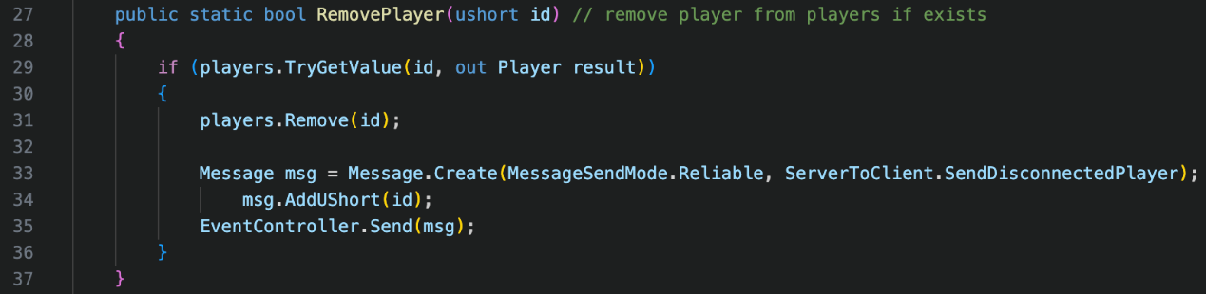

I realised that for the RemovePlayer method, I did make use of the returned Boolean value. To adjust, I changed “public static bool” to “public static void” and removed the return of true and false. This change can be seen in my appendix, for both the client and server. If the player id can be found in the player dictionary, then it is removed. This validation ensures that there is no error upon attempting to remove an id that does not exist. A net message is then sent to all clients, containing the id of the player that disconnected. Riptide already has this built in, which I did not realise at the time. My way is still valid, but in the future, it could be adapted to listen for internal disconnects on the client, instead of manually sending the disconnect on the server to the clients. This means I am currently sending unnecessary data to the clients. It is not a big deal, as it is a tiny bit of data, that does not require much processing power and will not impact gameplay. I have not yet explained why I use MessageSendMode.Reliable for all my net messages.

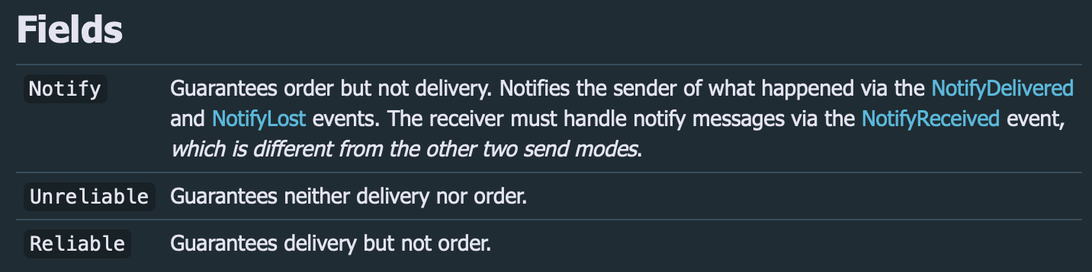

Riptide offers 3 different send modes. I’m unsure as to what method Notify uses, but it does not guarantee delivery. Neither does unreliable, as it uses UDP, which has no checks or connections to see if the message has successfully been delivered. Reliable is the method I picked which uses TCP. As TCP does use checks and connections, it means every piece of data is always received. UDP is great for very frequent messages that do not always need to be sent, like player positions. Some positions can be missed and it’s not a big deal. However, I’m sending data that is crucial to the function of the game, to ensure it works correctly. For example, if a player connects and the message is not sent, the game will not work at all.

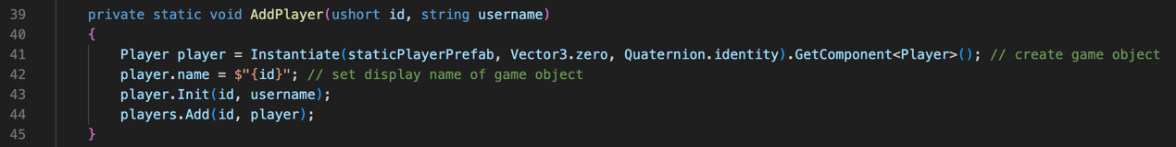

The add player method has the client id as a parameter, which is created by Riptide upon a client connection, and the username parameter would be inputted when the client connects on the Login scene. I instantiate the player prefab which means I am creating a game object of the prefab in the hierarchy during runtime. I get the Player script component and define this as the player variable which has the Player class as the data type. I set the name of the game object that I created to the id, so it is obvious which player object belongs to the correlating client id. I call the Init constructor method with the id and username to set the attributes of the player. After, I use the Add method to add the id (key) and the player (value) to the dictionary.

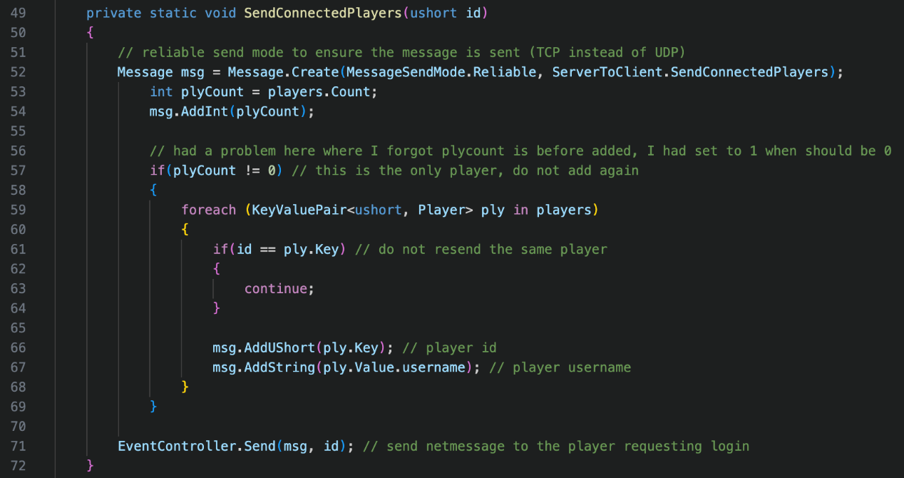

The use of this method is to send each player and their usernames to the client who has just connected. I have coded client and server models in game before, and there is often bad or no support for sending dictionaries or tables. Often, the table is sent as a whole, which is inefficient and is a large data packet. Alternatively, sometimes the option to convert to a JSON table is allowed, but this requires encoding on sending it and decoding on receiving it, which again is inefficient. I figured the best way, would be to store how many items are in the dictionary, and then send each item of the table as separate entities. This can be repeated for dictionaries inside the dictionary if needed. The advantage to this is that there is less data sent over the network, as positions of data are not sent, but can be implied when received instead. We need to know how many ids are in the player dictionary, so we know how many times the for loop will run. As the message is always sent, we cannot enter a for loop on the receiver if there is no data to put back into a dictionary. This is why the count is the first piece of data added to the message. Data can only be read in the order it was sent with a net message.

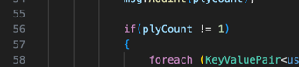I had an issue where I was comparing plyCount to =! 1 when it should have been 0. I was calling the method before the AddPlayer method. This meant that if a 2nd player connected, they would not receive the data of the 1st player connected, as player count would be equal to 1. The only time data should not be sent would be if the player count was 0, as there would be no players currently connected. Then the player id and player usernames are added to the message of all the players, except the player who is requesting the data. The message is then sent to the player who requested the data.

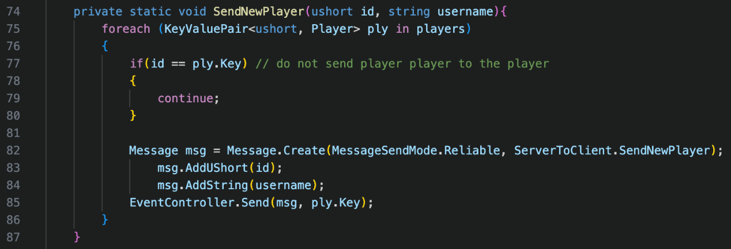

The method SendNewPlayer takes in the player id and the username. Upon evaluation, I thought this was a similar situation to the Disconnect method above where I could have used Riptide’s events to add the player, as the client already receives client connections from the ClientConnected event. However, I realised that I would still have to send the username, which would require an id to associate with it. As a result, I realised that there is no data redundancy and I’m using the best way possible. It sends a message containing both parameters to all the players connected in the dictionary, except for the player that joined where the id passed in is equal to the key in the dictionary.

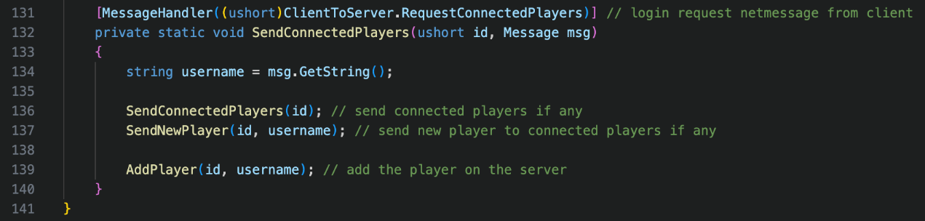

This is a MessageHandler which essentially listens for when a message is received. The MessageHandler here converts the value RequestConnectedPlayers in the ClientToServer enumerator to a ushort and listens for that message id. I realised that I have 2 methods with the same name of SendConnectedPlayers. Although this does not matter because both take the same first parameter, and one takes in an extra parameter, which makes it an override method, it’s better practice and clearer to have them with unique names. I changed the method name to InitializePlayer, as the method actually does more than send connected players. The username is retrieved from the message data. The methods used within this method have been explained above.

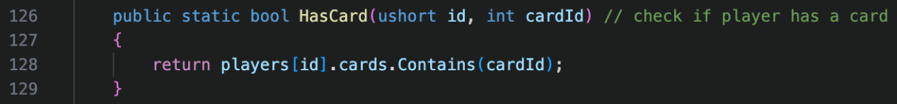

The HasCard method just returns true or false, depending on whether the cards list of the player id that was passed in contains the cardId that was passed in.

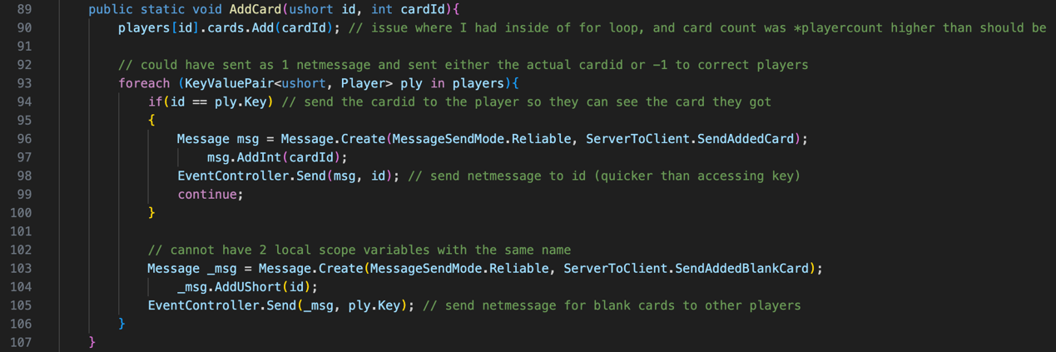

The AddCard method takes in 2 parameters and returns no value (void). The first parameter is the player id as a ushort and the second is the card id as an integer. The card id is added to the player id’s cards list. Originally, I had this in the for loop, meaning the card was added every time it ran. To fix this, I simply moved it outside of the loop as you can see in the screenshot. The player who owns the card, needs the id of the card so they know what card they have to be able to play it. The other players should not know the card information, as this would give them an advantage and ruin the game. Originally, I thought about using one net message containing the id of the player and the card id for the player who’s card it is or -1 for the other players, but this would mean sending unnecessary data like -1. Instead, I created 2 different net messages. The first is SendAddedCard for the player who owns the card, and the second is SendAddedBlankCard for the other players. The SendAddedCard message adds the card id to the message and the SendAddedBlankCard adds the id of the player who received a new card. These messages are sent as the for loop iterates through itself. If the parameter player id is equal to the player id in the key, then they get the SendAddedCard message, and the loop continues to prevent the rest of the code being executed. If they aren’t the card owner, then they get the SendAddedBlankCard net message. SendAddedBlankCard is assigned to _msg instead of msg as you cannot have two variables with the same name in the same scope. There is no need to have unique names as the message variable servers no purpose once it has been sent and is simply used to add data to the message.

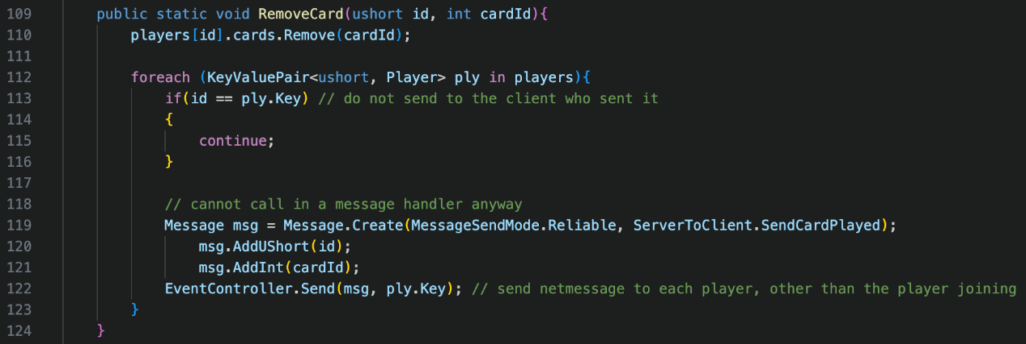

The validation to see if the player has the card is called elsewhere before calling this method, so the card id passed in is removed from the cards list of the player id passed in. The only time this method is called is when a player plays a card, therefore there is no need to send a message to the player, as this can be done locally on the client. All the other players in the for loop receive the SendCardPlayed message containing the player id who played the card, and the card id that they played. The card id is used so they players know what cards they can play next when it is displayed on the played card pile/deck. Messages cannot be sent inside a message handler and have to be done via a static method. The client has similar methods.

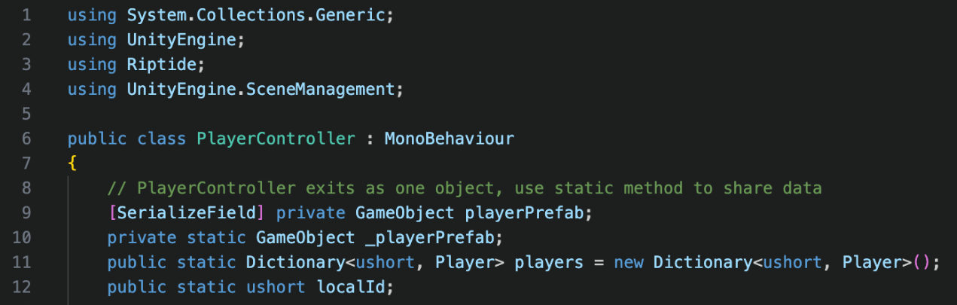

The client has the same namespaces as the server, with the additional UnityEngine.SceneManagement to switch scenes between Login and Game. Just like the PlayerController script on the server, the client also has the PlayerController script attached to a game object as a component and requires MonoBehaviour inheritance. The player prefab is attached to the playerPrefab variable, which is made visible by [SerializeField] in the inspector.

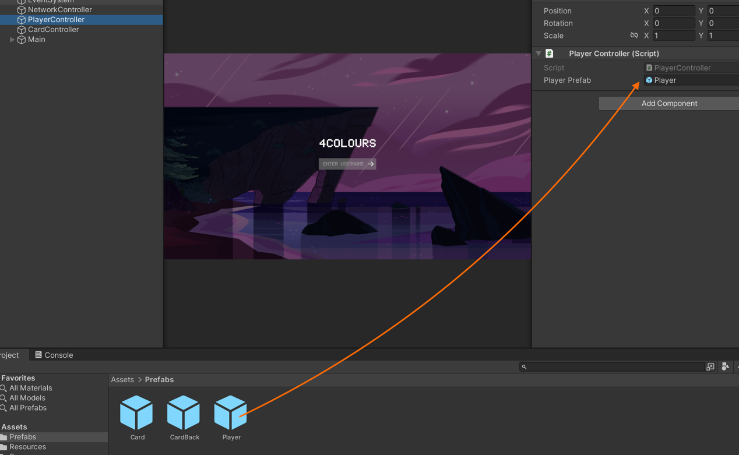

A static version of this variable has to exist, as static methods can only access static variables unfortunately. The same dictionary structure on the server version of this file exists on the client. The localId variable stores the local player id.

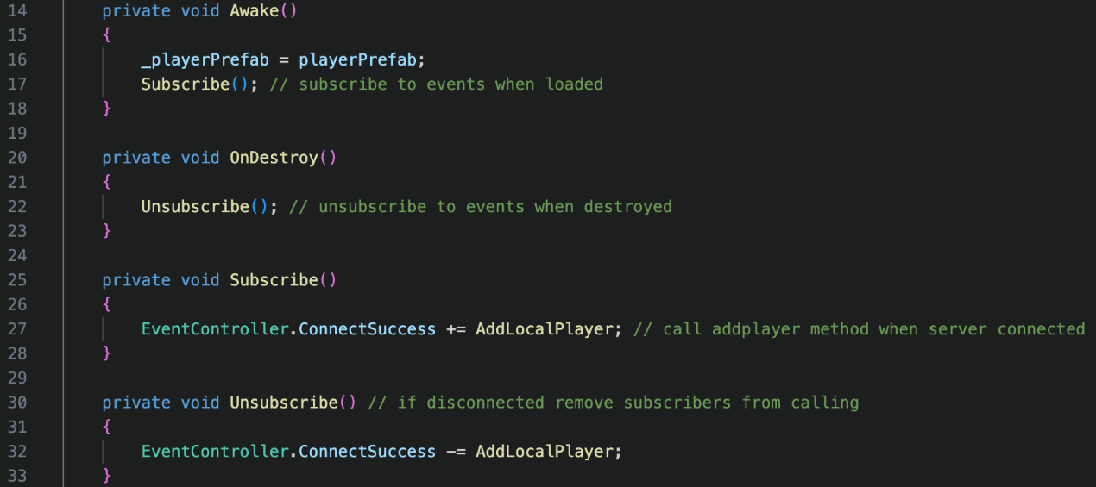

Just like on the server, the static variable is assigned the player prefab instance variable when the awake function is called after initialisation. The subscribe method is called after the variable is assigned, and the unsubscribe method is called when the object attached is destroyed. The only event that is subscribed to in this class is the EventController.ConnectSuccess which invokes the AddLocalPlayer method. The ConnectSuccess event is invoked in the NetworkController class by the OnConnected method.

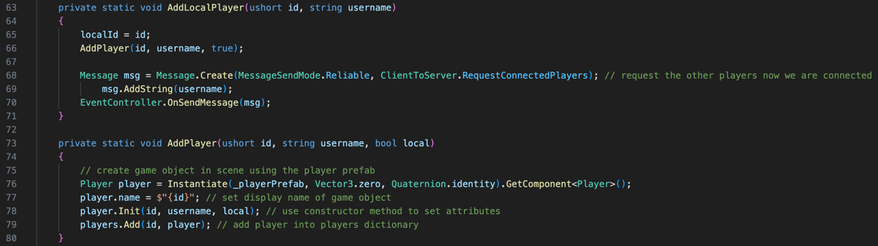

The AddLocalPlayer method takes in 2 parameters that were passed in by the invoked event. As this player is only for the local player, the localId is set equal to the id that was passed in. The AddPlayer method is called to create the player with their id, username, and local set to true as they are the local player. The player username is sent to the server in the ClientToServer.RequestConnectedPlayers net message. The AddPlayer method instantiates the player prefab and sets the name of the object to the player id. The constructor method for the player class (Init) is called with the same parameters as the AddPlayer method. The player id (key) and the player class (value) is added to the players dictionary.

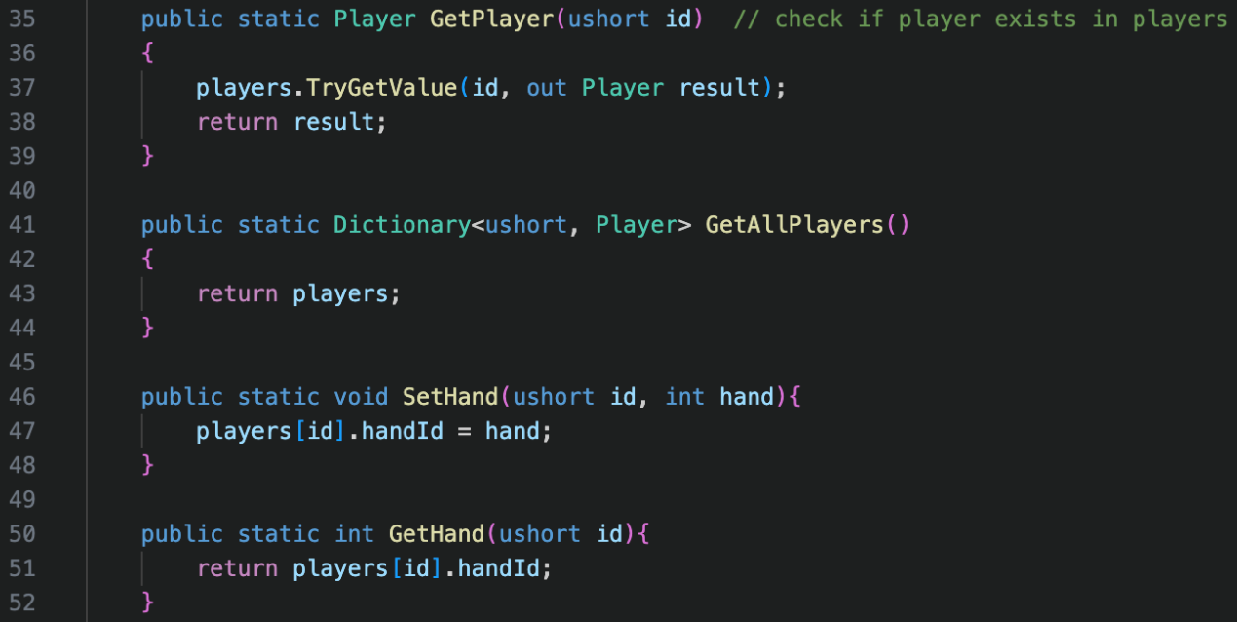

The GetPlayer and GetAllPlayer methods are identical and have the same use as on the server which was discussed above. The client has 2 additional methods called SetHand and GetHand. They manage the 4 different hands with the game. I assign a handId to the player class. As the set hand does not return a value, it is void, whereas the get hand returns an integer. SetHand takes in the id of the player, and the handId to assign to the player. The GetHand method just takes in the id of the player, to get their hand. The same reasons as stated above to the need of the static method. handId is a property, so these methods actually access the internal get and set methods of the player class. These handIds correlate to the hand positions in the UI hierarchy of the Game scene. For example, handId 1 correlates to Hand1. These only exist on the client as this is where the processing happens. This saves processing power on the server, and reduces net messages, which means the server should run smoother, and be more responsive as it is handling less data. This is good for the stakeholder as hosting will be cheaper.

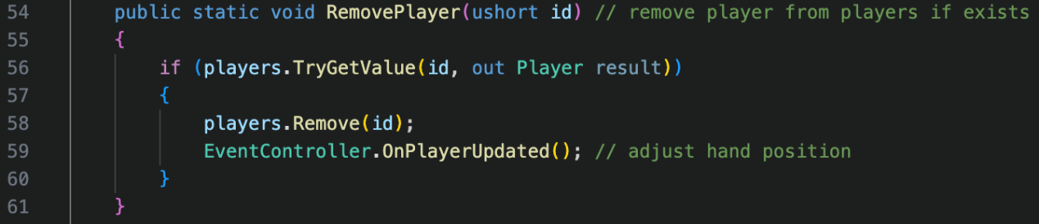

Now, if the id exists in the player dictionary, then it will be removed and the OnPlayerUpdated event will be called to trigger the hand positions to update. This is to meet the clean UI success criteria, as the players should be in the correct position depending on the number of players, to make the flow of the play clear.

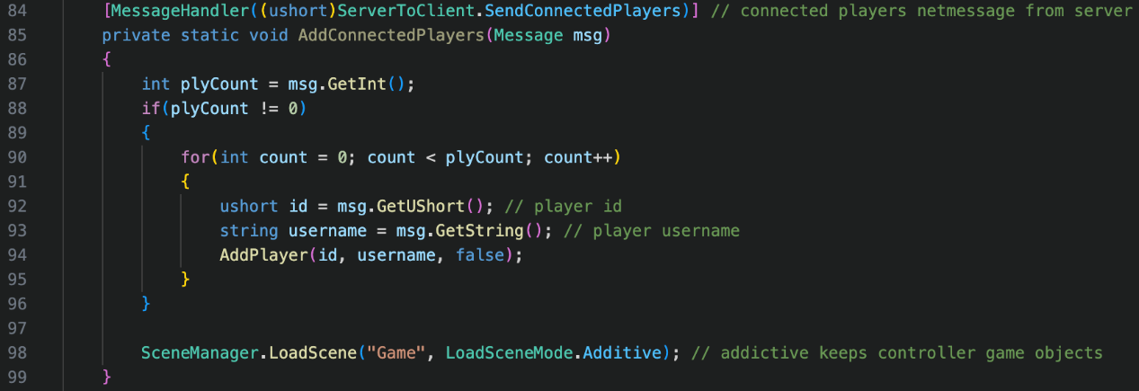

This is the message handler for the ServerToClient.SendConnectedPlayers net message that was discussed earlier. This method reads the data that was received from the server to add players that are already connected before the local player joined. It starts by checking the player count. If the player count is equal to 0, there are no players that are already connected to add, and the player simply moves into the Game scene. This is to ensure data is not attempted to be read, if it does not exist, as it would create an error. If the player count is greater than 0, then the for loop is iterated to the value of player count, to ensure the right amount of data is read. Each for loop adds the player via the AddPlayer method, with the id, username, and local set to false. Once the loop has completed, they are moved into the Game scene. The Game scene is loaded with LoadSceneMode.Additive to ensure that the controllers that are in the Login scene are not destroyed. If they were to be destroyed, then data would be lost. By loading the scene additively, game object do not need to be recreated, saving processing power for the stakeholder, to allow the game to be run on lower specification machines.

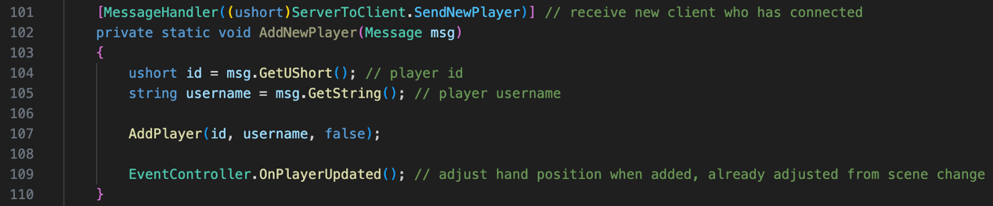

This is the message handler for the ServerToClient.SendNewPlayer net message that was discussed earlier too. This method adds players that have joined after the local player. The player is added via the AddPlayer method too, with the id, username, and local set to false. Once this is completed, the EventController.OnPlayerUpdated event is called to adjust the hand positions in the Game scene. This did not need to be called in the AddConnectedPlayers method as it is already called when the scene changes and the hand positions are setup.

**HandUI.cs**

This class only exists on the client. The goal of this class is to manage the data of each hand which includes the username.

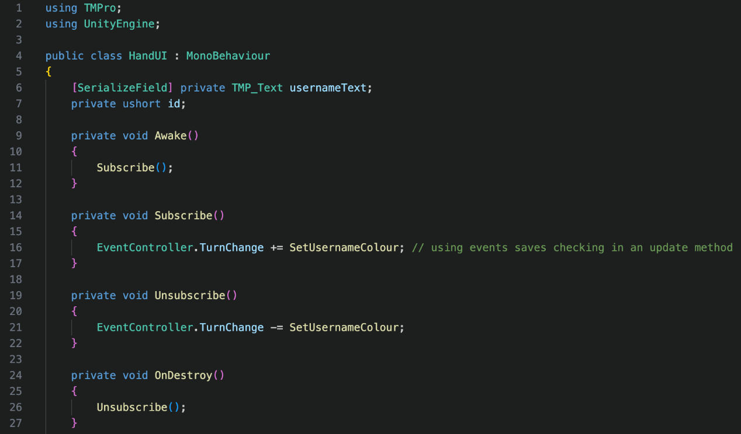

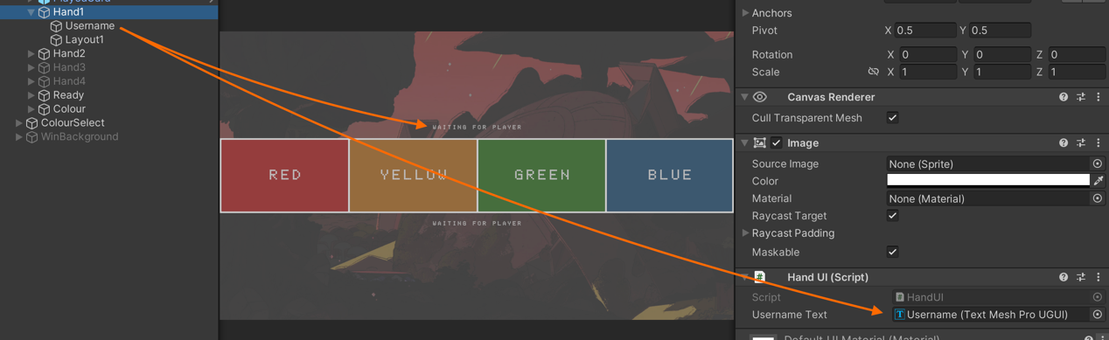

The TMPro namespace is used for the TMP_Text data type, and the UnityEngine name space is used for the MonoBehaviour inheritance. The class only has 2 variables. The first is the usernameText variable which has been serialized to be seen in the inspector. This text is the username that is displayed, by default, the text is set to “Waiting for player” in the inspector. The second variable is the id, which is the player id who owns the hand position. As usual, events are subscribed to in the Awake method, and unsubscribed to in the OnDestroy method. The only event that is listened for is the EventController.TurnChange which is used to set the player whose turn it is to red, by invoking the SetUsernameColour method. This creates clear play flow for clean UI.

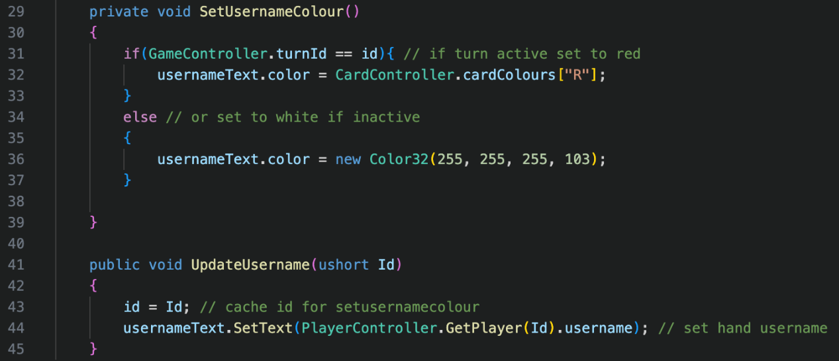

The SetUsernameColour method checks to see if the current turn id of the game is equal to the id owner of the hand. As this is only checked on turn changes, it saves checking it every frame in an Update method, so it is more resource efficient. If true, then the username colour is set to the colour red from the card colours dictionary. This consistent UI colour scheme allows for further clear UI. If false, then the username is returned to the white colour. The UpdateUsername method is essentially the constructor method in this scenario, taking in the id as the parameter. It does not store the username as a variable, as it is stored in the usernameText text box, and does not need to be used elsewhere, saving creating an unused variable.

**ReadyUI.cs**

The purpose of the ReadyUI class if for each player to be able to tell the server that they’re ready to play. Once all players that are connected have pressed ready, and there are at least 2 players in the server, then the game will begin. This is controlled by a different script on the server.

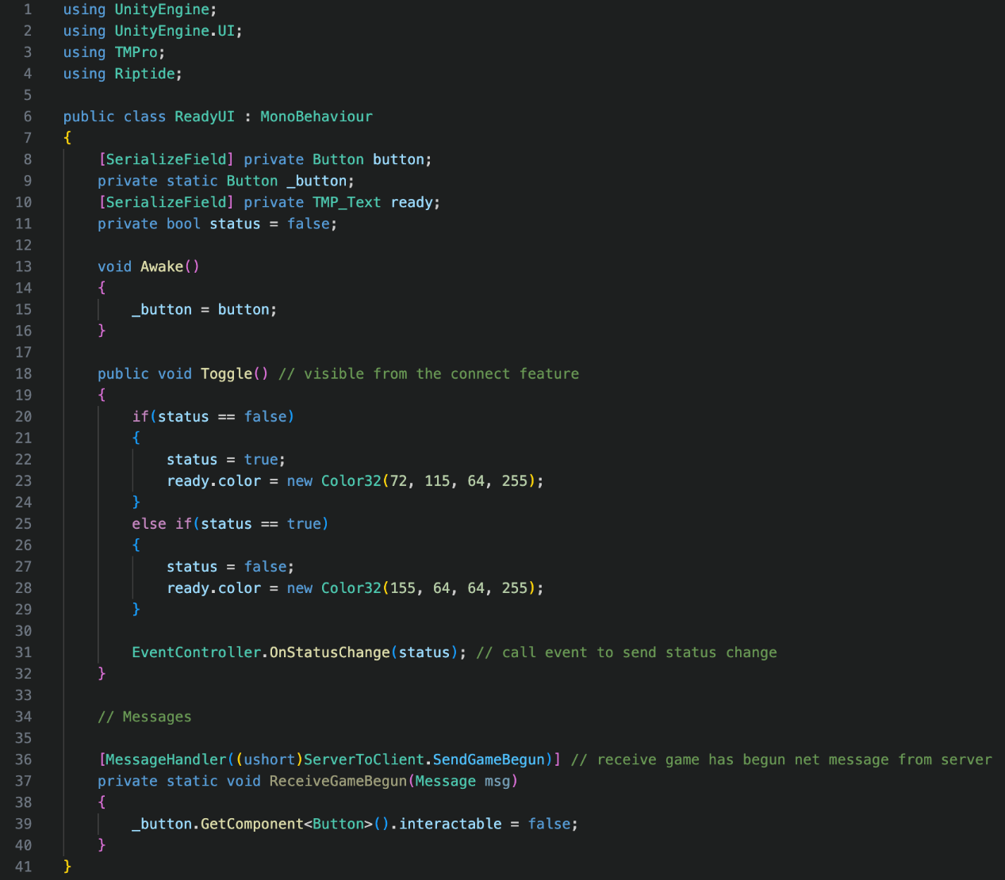

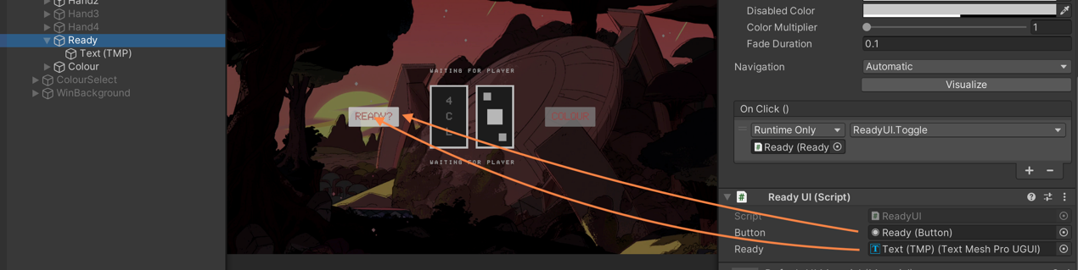

This script has 4 namespaces. The UnityEngine namespace is for the MonoBehaviour inheritance, whilst the UnityEngine.UI namespace is to access UI elements such as whether a button can be interacted with. The TMPro is for the TMP_Text data type and the Riptide is for the message handler later on in the class. Both the button and ready are serialized so they can be accessed in the inspector, and therefore can be assigned a value. The static variable _button exists so Riptide can access it, and it is initialised in the Awake method once the instance variables have been constructed. The status variable provides a flag to whether the button is set to ready (true) or unready (false). The button is interactable by default.

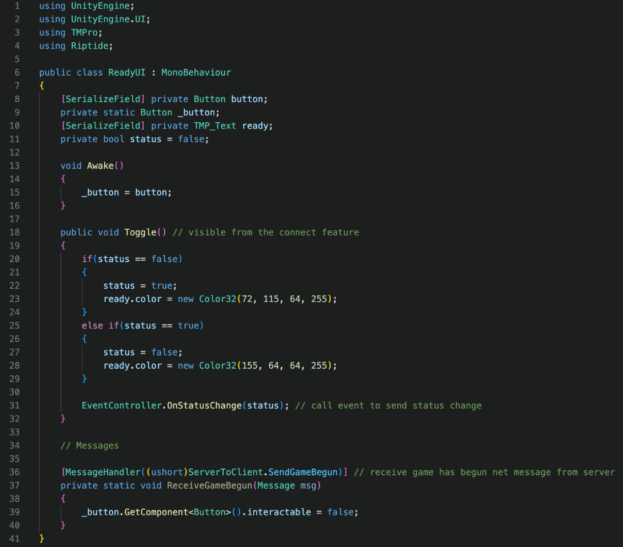

The Toggle method is public so it can be accessed in the inspector to be invoked by the OnClick event. If the button is set to unready (false) and is clicked, then the text colour is changed the green and the status is set to true. If the status is ready (true) and is clicked, then the status is set to false, and the text colour is set to red. Whether the status is true or false, the EventController.OnStatusChange event is called with the event taken in as the parameter, which tells the server their status. There is a message handler at the bottom for the ServerToClient.SendGameBegun net message. When the game has begun, the button is made non-interactable, as the ready button is no longer needed to start the game. This makes it clear to the player that it will not be needed at the current time to meet my success criteria for clean UI.

Upon reviewing my code, I realised I can change the two new Color32 values to access my colour dictionary instead. Although they are in the same colour scheme, by accessing the dictionary, it means that the colours can be easily changed from one point for future maintenance. Instead of creating new colours, by accessing the exist ones made, I am saving memory for the stakeholder and his fans. During the if statement, there is an “else if(status = true)” which is unnecessary. There are only 2 possible values of status, so instead an else statement can be used, as the 1st value is already checked. These changes can be seen in my appendix.

Combining all classes and scripts above, I completed all aspects of the multiplayer success criteria. Collectively, they each contribute to create the multiplayer aspect. As a result, this criterion was definitely a success.

## Success Criteria 3 – Original Rules

The goal of this success criteria was to ensure the original rules of UNO were preserved into the project. Mr Dorrell specifically requested this, and both his fans and I agree with the decision. There must be 108 cards with the correct card type weightings. Each player must start with 7 cards from a shuffled deck, and lowest client id begins. Cards that match colours or symbols can be played on top of each other, and wild cards (black) can be played at any time. +2 cards mean the next player picks up 2 cards and +4 means the next player picks up 4 cards, and the card player gets to choose the play colour. The colour change card means the card player gets to choose the play colour too. The miss a turn card means the next player’s turn is skipped, and the change direction card means the flow of play is reversed. A player can only play 1 card per turn, and if they cannot play a card, then they must pick up a card to complete their turn. By default, the game flow would be clockwise for simplicity. When a player reaches 1 card, they must press the colour button before their next turn, which represents saying UNO in real life. To summarise, the cards and game play must have the correct functionality.

**Card.cs**

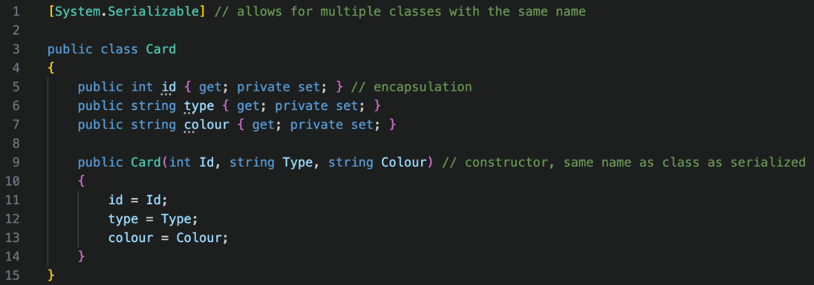

The card class is the same on both the server and the client – so it is outlined green for shared. It doesn’t require any namespaces. The [System.Serializable] allows Unity to store the classes with the same name efficiently, which will allow fans with lower specification computers to run the game, as less processing power is required. All my variables are properties, that cannot be set outside the local scope. They are publicly gettable so the CardUI class can access them. The constructor method has the same name, so when a new object is created, the object is automatically initialised.

**CardUI.cs**

The CardUI class is used to display the information of each card. The script has been serialized to ensure that it can be saved efficiently in memory as there will be lots of object that are require heavier graphical processing.

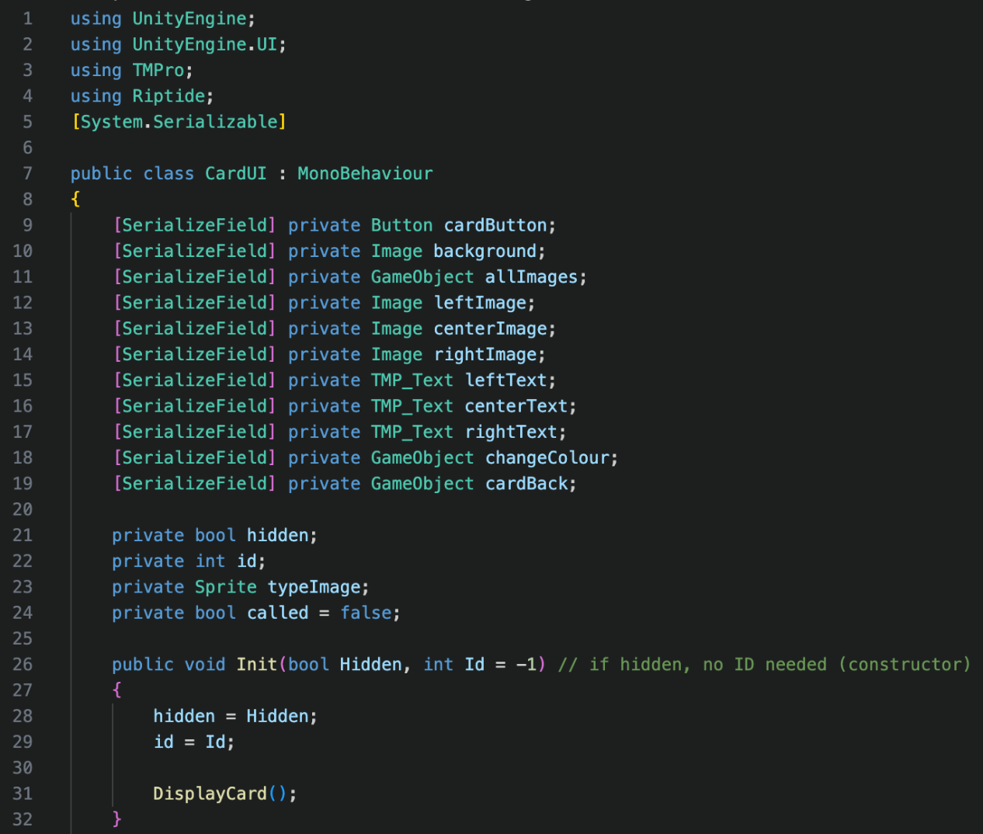

The script uses 4 different namespaces which include UnityEngine for the MonoBehaviour inheritance, as well as UnityEngine.UI to access UI components. The TMPro namespace is used for the TMP_Text data type and the Riptide namespace is for the net messages between the client and server. All the serialized fields are UI objects. There are 2 flag variables used within the class – the first is the hidden variable used to only show the back of the card, and the second is called used to see if the DisplayCard method has already been called. This is useful as objects will need to be reset if they have been edited already. The variable id is the card id and typeImage is the sprite that is being displayed on the card to be cached. Init is the constructor method that takes in a minimum of 1 parameter (Hidden). If a card is hidden, no id would be needed, so it is -1 by default. The attributes are assigned values and the DisplayCard method is called.

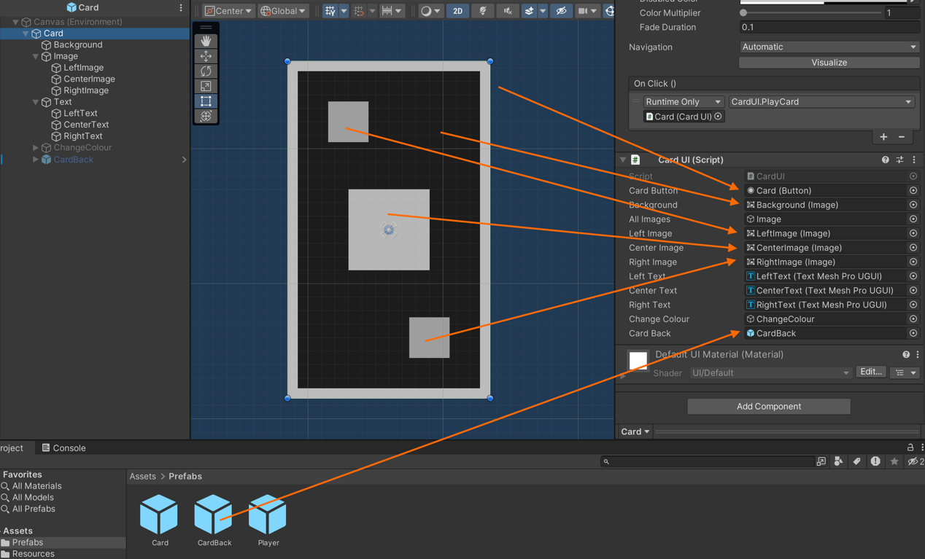

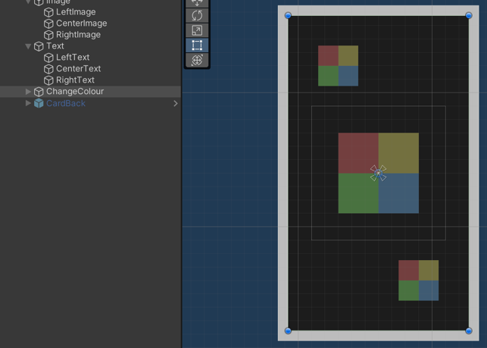 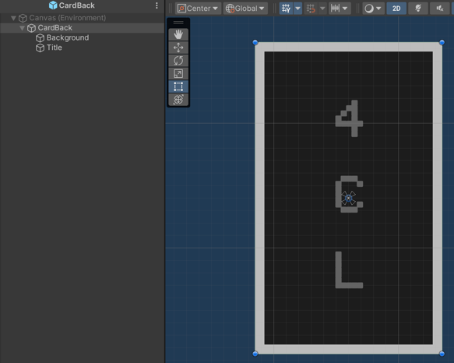

The text is in the same position as the images. The ChangeColour object can be seen above to the left and CardBack can be seen above to the right.

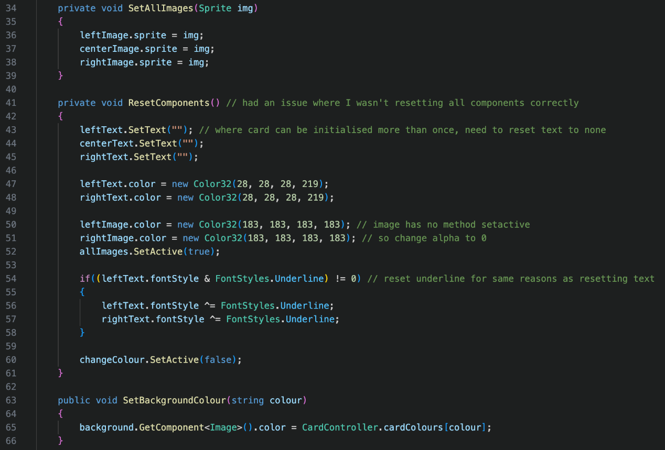

The SetAllImages method takes in a sprite as a parameter and sets this to all 3 images sprite values. This is useful as it saves repeating code. Originally, I had an issue where components were the wrong colours, symbols, font styles or images. This was because I was calling the DisplayCard method multiple times. To allow for multiple calls of the DisplayCard method, I introduced the ResetComponents method, to reset the objects to their default values. Some cards do not use all components that are made active, so the default values are required. First, the text is reset to a blank string, and the left and right text colours are reset. The centre text colour does not need to be reset as it is not changed in the DisplayCard method. The centre image colour is never changed either, so only the left and right image colours need to be reset. All the images are set back to active and the underline from 6 and 9 cards are reset. This is checked by the bitwise operator & to see if there is a font style and an underline font style. If there is, then the font styles are assigned the XOR value of the FontStyles.Underline value. If it is 1, then it is now 0. If it is 0, it is now 1. This “toggles” the underline. The ChangeColour object is also set to inactive to make it invisible. The SetBackgroundColour method is mainly used as the line of code that is called within is quite long and a pain to rewrite. It simply sets the background colour of the card. In the pictures below, the underline was not reset.

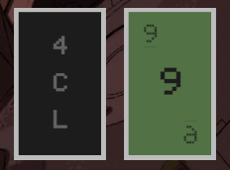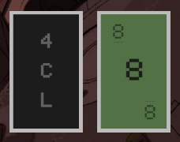

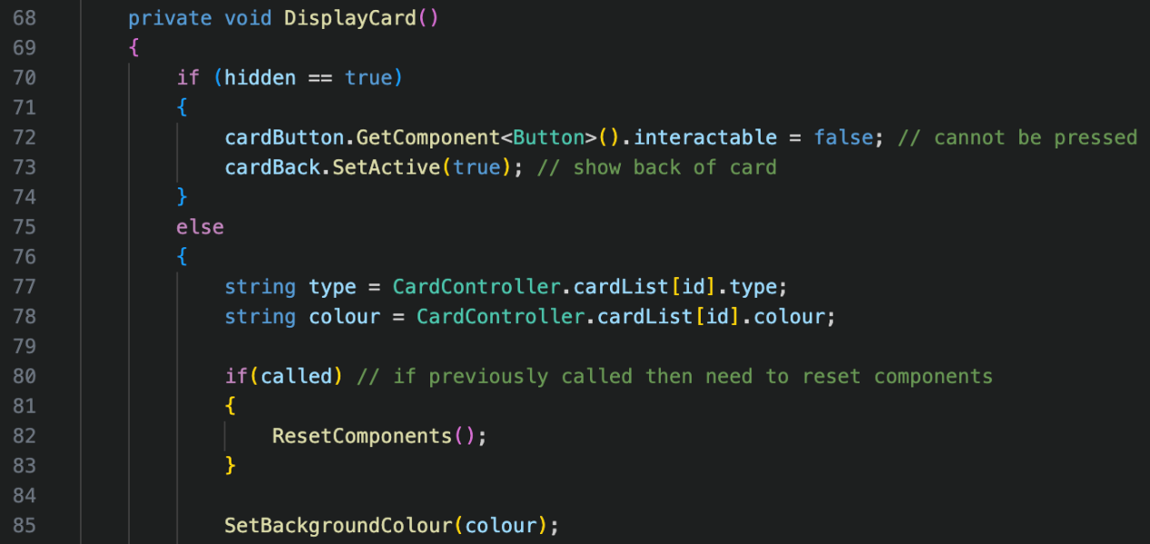

As stated above, the DisplayCard method is used to display the components of the card. Its first check is to see if the card needs to be hidden, and the intractability of the card is set to false as it cannot be used. The back of the card is then set to visible. If the card should not be hidden, then it moves into the else statement. Both the type and colour are cached from the cardList which contains the information for each card id. If the method has already been called, then the components are reset using the ResetComponents method. The background colour is set to the colour of the card. I’ve had to split the method over 2 screenshots as it’s quite long. Next, it moves into a switch statement for the different types of cards.

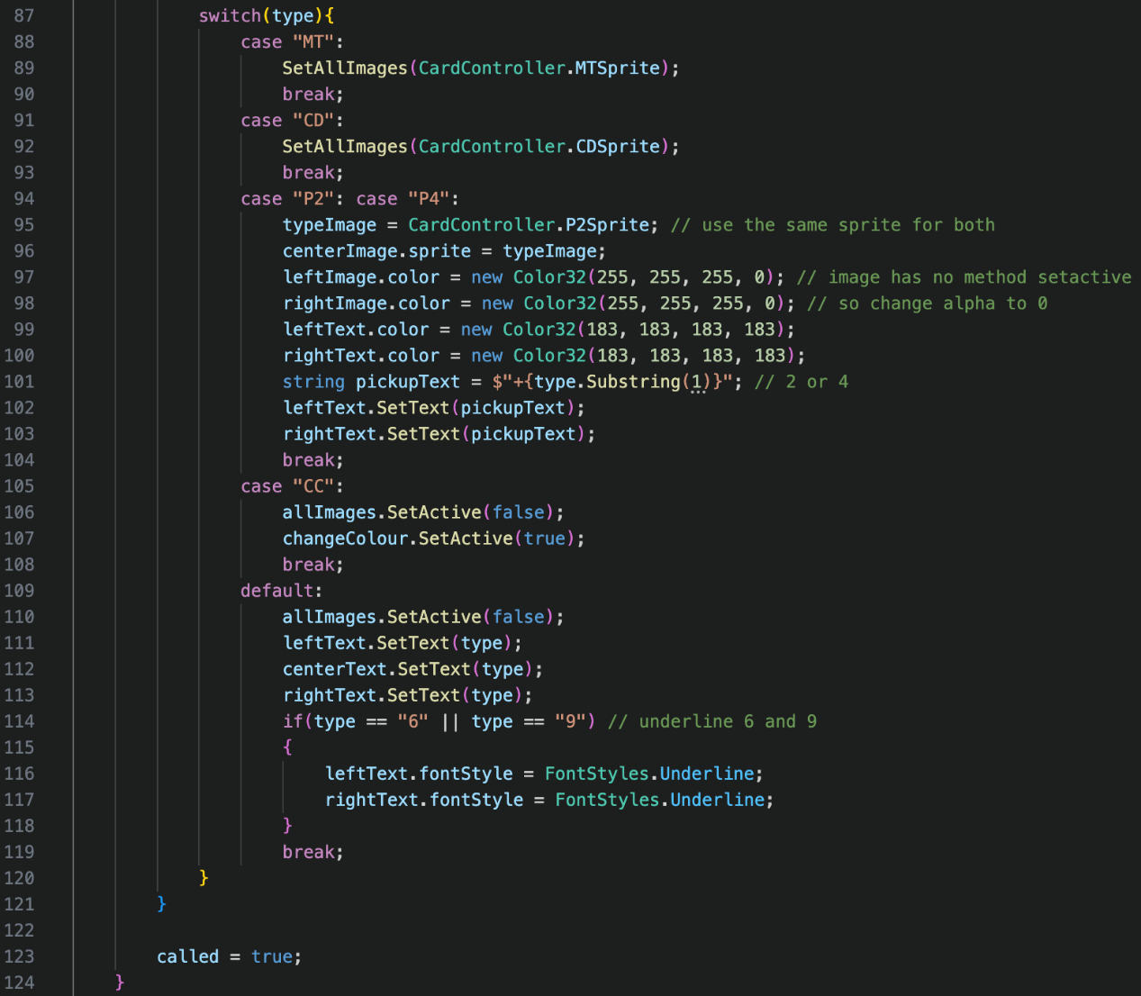

In the case of MT (miss a turn), then all the images are set to the CardController.MTSprite and the statement is broken out of by the break keyword. In the case of CD (change direction), then all the images are set to the CardController.CDSprite. Both P2 (pickup 2 cards) and P4 (pick up 4 cards) have the same case statement to save rewriting code. First, the sprite is cached as it is used for 2 cases internally. Then the centre image is set to this sprite. I decided to use the same sprite for both P2 and P4 as I felt 4 card icons looked messy and would go against for success criteria for clean UI. Images have no set active method, so the only way to disable them, is to set the alpha value to 0. This is what I did for the left image and the right image. I set the left text and right text colours to the same colour as the images, which is a slightly whiter grey. To display either 2 or 4 after the + symbol, I substring the type variable to get the value. I then set pickupText to both the left and right text. In the case of CC (change colour), then all images are disabled, and the change colour object is enabled. The default case is for any number card. All images are set inactive, and all 3 text boxes are set to the number of the card. For cards 6 and 9, then they the left and right text are underlined to make it clear, just like in UNO. Whether the card was hidden or visible, called is set to true at the end of the method.

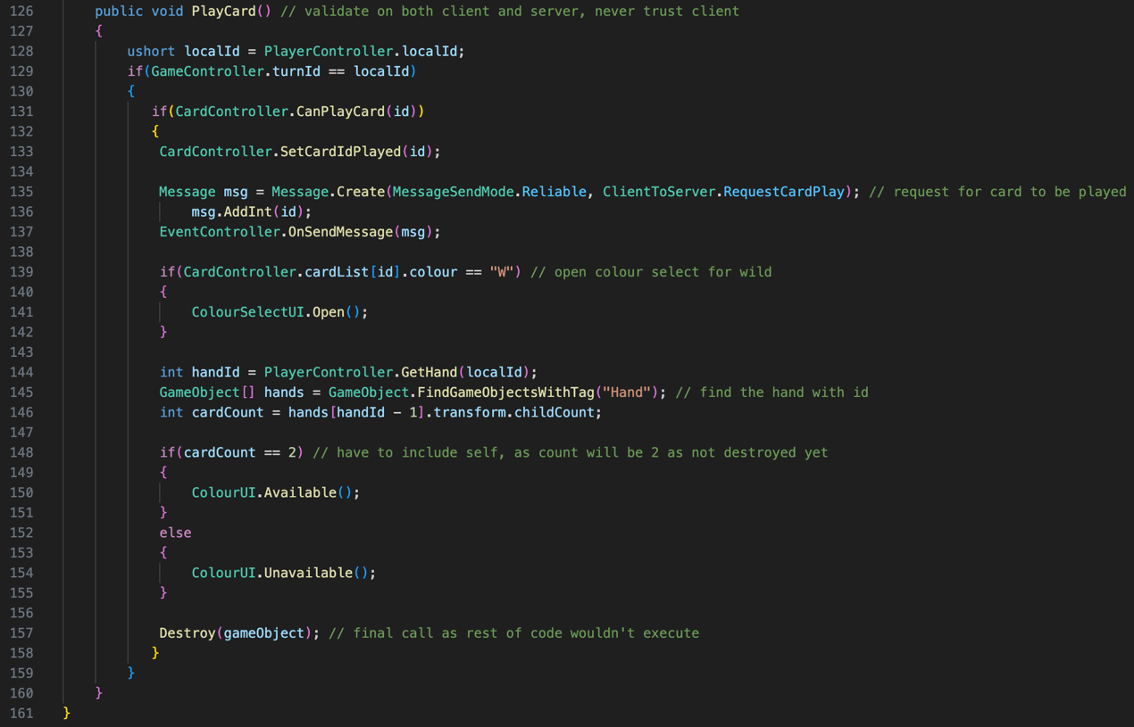

The PlayCard method is called when the card is clicked to be played. This can only be called if the card is not hidden, as the card would not be interactable with. The validation within the method is also checked on the server, as the client can modify or manipulate their own data to the server with exploits. First, localId is cached within the method as it is used more than once in the method. The first check is to see if it’s the local player’s turn. The next check is to see if the card they are trying to play, can be played onto the played deck. If they can, then CardController.SetCardIdPlayed is called with the card id as the parameter. The card id is then sent to the server, to be checked and sent to other clients if the data is valid. If the card was a wild card, then the UI to select the play colour is opened. The hand of the local player is fetched. As FindObjectsWithTag finds objects in order of the hierarchy, the hands will be in the correct ascending order and positions in the array. The hand is the handId – 1 as the array starts at 0 and the hand positions start at 1. The number of cards is equal to the number of children of the hand. If there are 2 cards, then the Colour button can be pressed as the ColorUI.Available method is called. If not, then it cannot as the ColorUI.Unavailable method is called. The Destroy method is called when all the code for the card to be played has been executed.

**CardController.cs**

The code for CardController differs on both the client and server but contains some of the same methods. The aim of the CardController is to manage most of the data about the cards. To start, I will explain the code on the server side first.

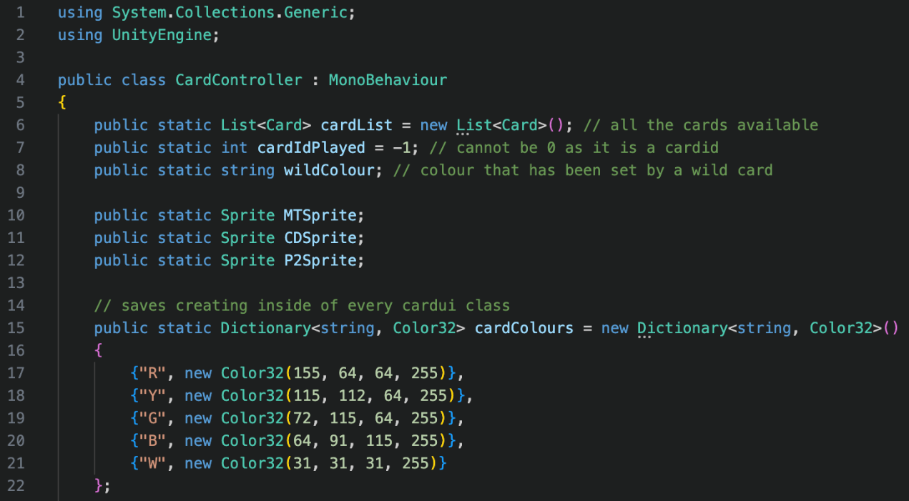

Originally, I had 3 namespaces. I had riptide too, but I removed this namespace as it was unused. Now there is 2 namespaces which are UnityEngine for the MonoBehaviour inheritance and System.Collections.Generic for the use of lists and dictionaries. All variables are public as they are accessed in other classes such as the game controller. The first variable created is a list to store all the cards that are available. Having one central point of data, means that only an identifier needs to be stored in other places, instead of resaving all the data each time. The next variable is the card id that has been played. By default, it is -1 to show that no card has been played yet. It cannot be 0 as that would reference a card id. The wildColour variable stores the colour of that has been changed by a wild card. MTSprite, CDSprite and P2Sprite store the loaded sprites, and ensure that that each is only loaded once. If they are continuously loaded, then it can cause memory leakage and cause the sprites to disappear. The cardColours dictionary stores the colour scheme of the cards to have consistent UI for my first success criteria. It also saves creating new colour values continuously, which frees up memory and reduces time taken to write code. Both cardColours and the sprite variables are initialised in this script, as there is only one object of CardController, unlike CardUI, where it would they were be stored multiple times.

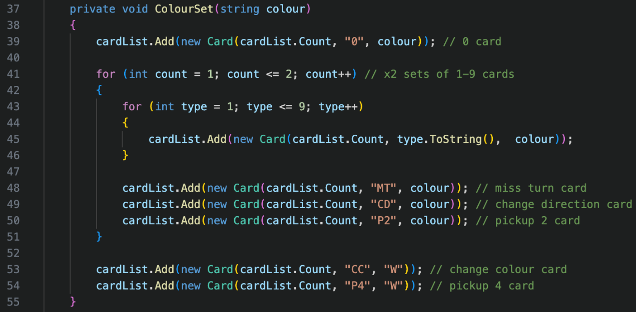

The ColourSet method is used to create each colour set. Each card colour set contains one 0, two sets of 1 to 9, one miss a turn, one change direction, one pickup 2, one change colour and one pickup 4. By putting this into a method, it means code does not have to be rewritten for all 4 colour sets. Each colour set is passed in as a variable when the method is called. I used W for the wild card colours. Although B makes more sense for black, it is already in use for blue.

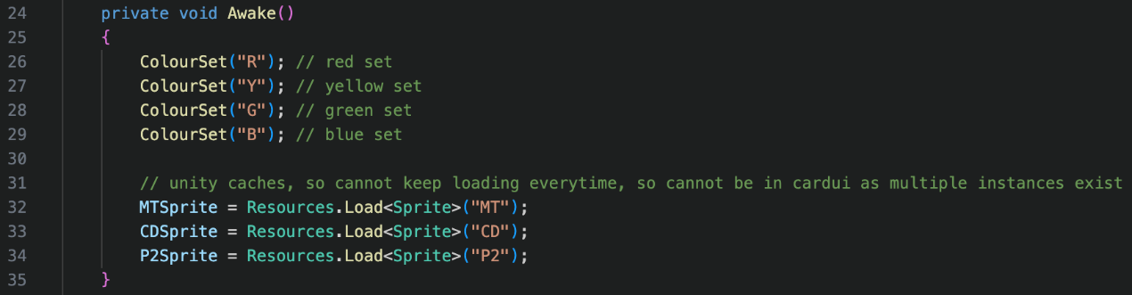

In the Awake method, all 4 colour sets are created, and the sprites are loaded.

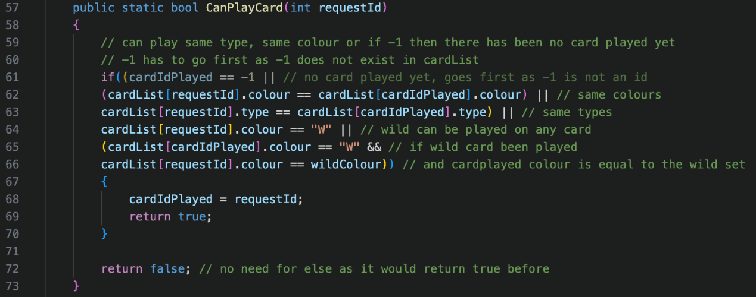

The CanPlayCard method checks whether a card can be played on top of the card that was previously played. All statements are joined by OR operators as only one statement has to be true. The first check is to see if cardIdPlayed is equal to -1, as this means no card has been played. This has to be the first check as cardList[cardIdPlayed] would not exist and would cause an error. If no card has been played, any card can be chosen. The next check is to see if they are the same colours, then if they are the same type. If the card they’re trying to play is a wild card (“W”) then it can be played on any card, so no comparison is made. If a wild card was previously played and the card colour, they’re trying to play is equal to the wild colour played, then they can play the card too. If they could play the card, then the cardIdPlayed is set to the requestedId and true is returned. If not, false is returned.

Upon reviewing my code, I do not need to assign requestId to cardIdPlayed as the method that can be seen below is called when the card is played in the CardUI class. This meant it was being assigned twice. This change can be seen in my appendix.

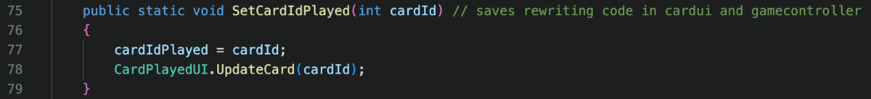

This sets the cardIdPlayed to the cardId taken in by the parameter. The card displayed the previously played card is updated to display the new card id through the CardPlayedUI.UpdateCard method.

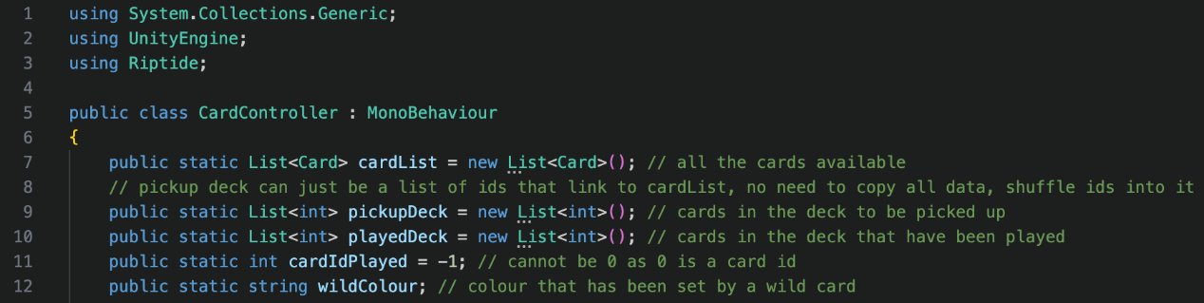

On the server, there are 3 namespaces. UnityEngine is for the MonoBehaviour inheritance as usual, and Riptide is for the net messages. System.Collections.Generic is to create and access lists. All cardList, cardIdPlayed and wildColour are the same as the client and have the same reasoning. There are 2 new variables on the server called pickupDeck and playedDeck. The pickupDeck is card ids that are shuffled that can be added to player hands. The playedDeck contains the cards in the order that they were played. These can be shuffled back into the pickupDeck there are no cards remaining to be picked up. These 2 lists are not required on the client, as the client does not need this information.

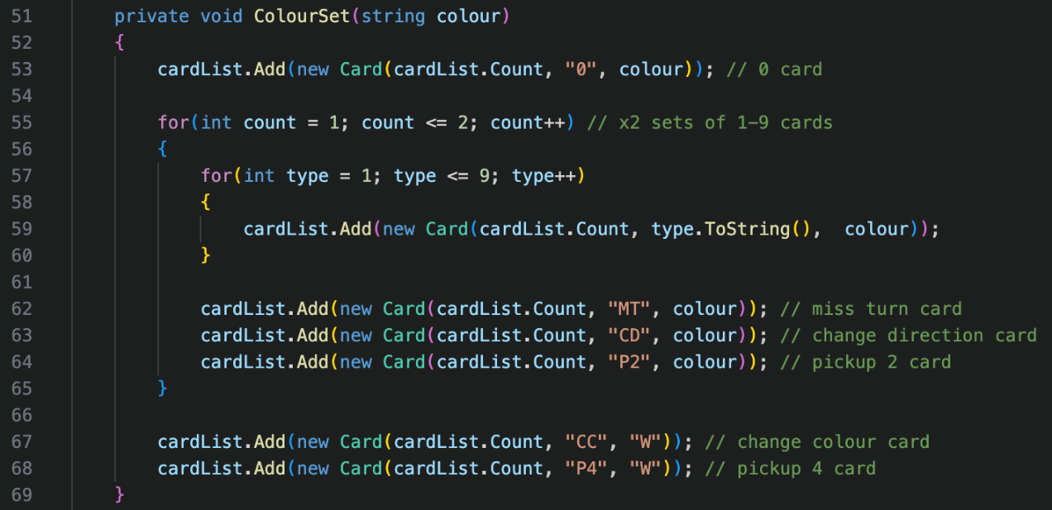

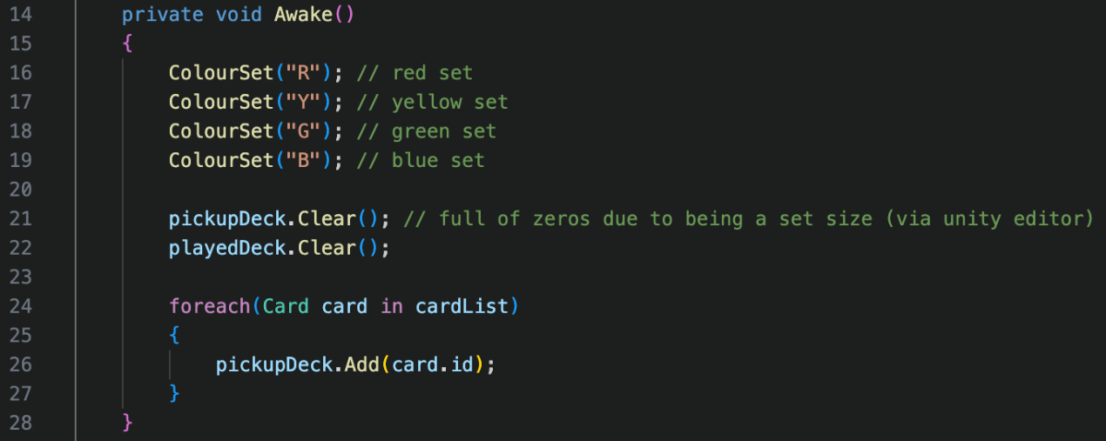

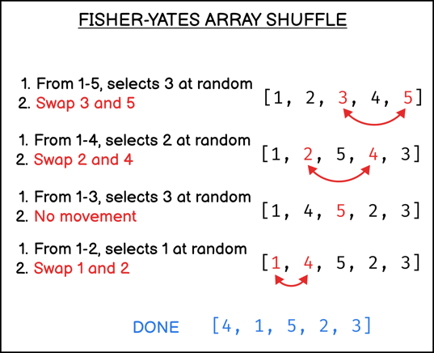The colour sets are created on the server in the way they were on the client. I had an issue where the decks were filled with 108 values of 0, plus the 108 card ids, totalling to 216 values. As a result, I just decided to clear the lists. I could not copy the cardList into the pickupDeck as they are both instance variables, and can be initialised in either order, which would result in an error, as cardList may not exist yet. To work around this, a for each loop adds each card id into the pickup deck. The pickupDeck is then shuffled. The algorithm I decided to use is the Fisher-Yates shuffle. Iterating through the list in reverse order, a random number between the 1st index and current index. These 2 index positions are swapped. I chose this algorithm because it has a time complexity of O(n) which is linear. As there is a small number of items in the list, it will not take long to shuffle. It has a space complexity of O(1) as there is only one temporary variable used to swap the elements. It is very easy to implement for my time constraints within my project.

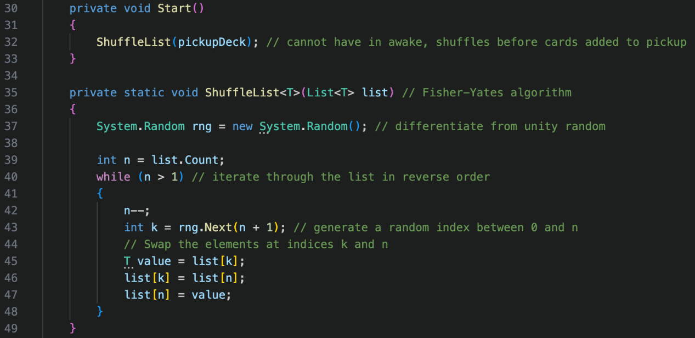

The deck is shuffled in the Start method by the ShuffleList method, after the deck has the card ids added in the Awake method.

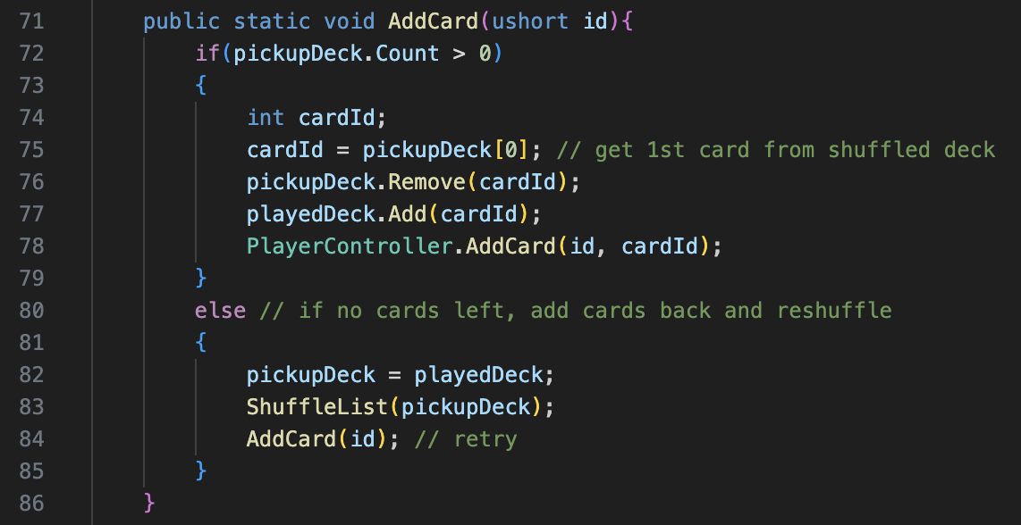

This method is used to add a card to a player id. If the pickupDeck is empty, then the playedDeck is assigned to the pickupDeck, and it is shuffled. The method is recalled and playedDeck is now no longer empty. If the pickupDeck is not empty, then the card id in the 1st index of the pickupDeck is stored in the cardId variable. This cardId is then removed from the pickupDeck. I have just seen a mistake in the code and the cardId should not be added to the playedDeck, as the card hasn’t been played. This change can be seen in my appendix. The card is then added into the player’s cards list through the PlayerController.AddCard method.

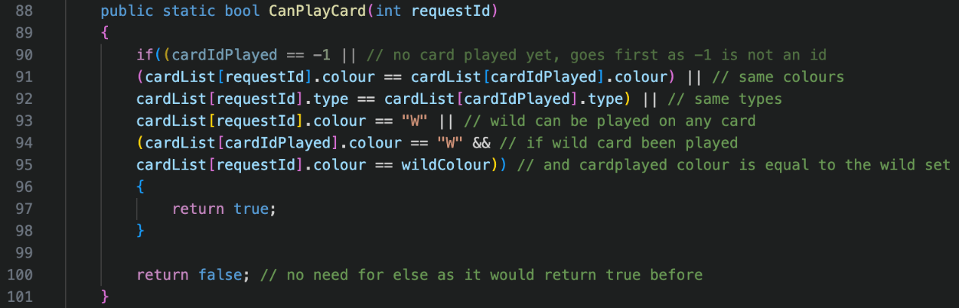

The CanPlayCard method is identical to the client’s version which was discussed above. I was also assigning the requestId to the cardIdPlayed when I was already doing this elsewhere, like I was on the client. I have removed it here to match the appendix, but this can be seen in the client’s screenshot of this method.

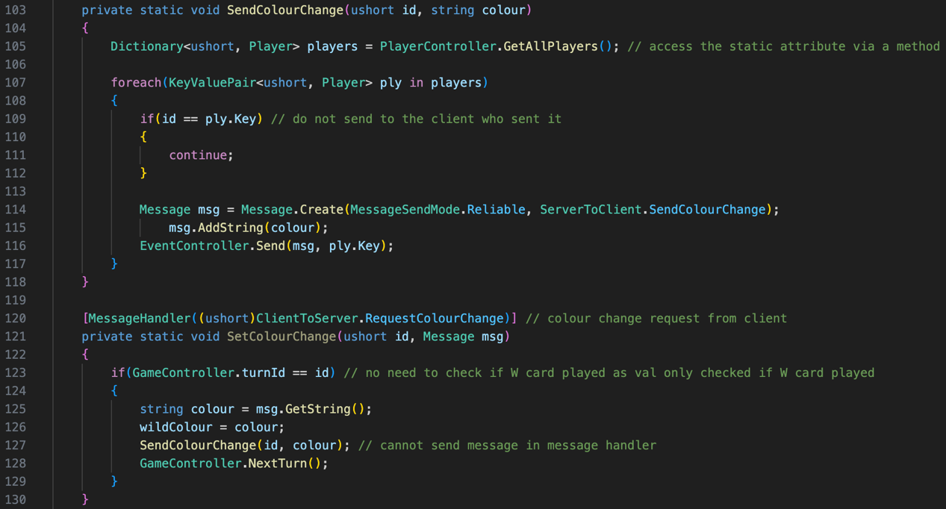

The SendColourChange method takes in the player id who has changed the colour, and the colour they would like to change the wild colour to. The static player dictionary is accessed, and a for each loop iterates through it. If the player id of the loop is equal to the id passed in, then the player is skipped, and the loop continues. This prevents sending the colour to the player who picked the colour, as obviously they know what colour they picked. The rest of the players are sent the ServerToClient.SendColourChange net message which contains the colour. This method is called within the message listener for the ClientToServer.RequestColourChange net message. If it is the player’s turn id, then the colour is read from the statement, the SendColourChange method is called, and the next turn happens. There is no need to validate whether they could actually change the colour because of a wild card here, as the wild colour variable is only allowed to be compared to in the CanPlayCard method, if a wild card has been played.

**ColourSelectUI.cs**

The ColourSelectUI class only exists on the client. ColourSelect is set active (visible) by default, as the Awake method needs to be called which requires it to be active.

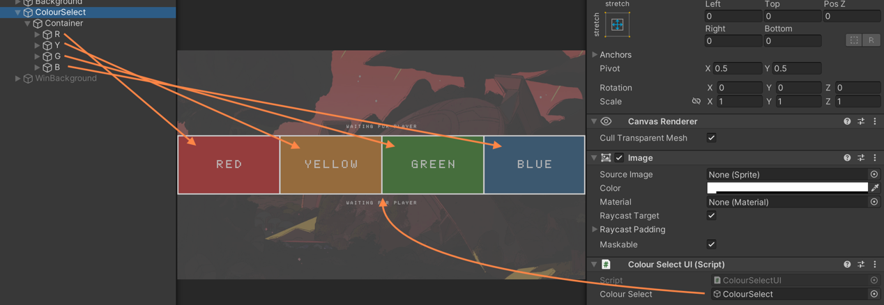

Each colour is a button.

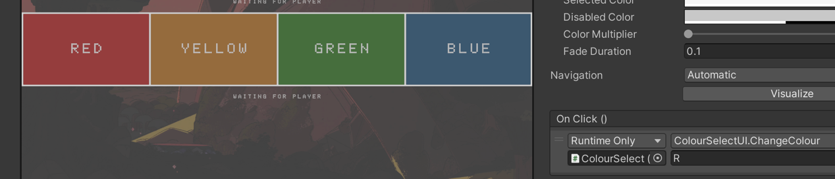

When the button is clicked, ColourSelectUI.ChangeColour is called, with the colour as a parameter. E.g., Y for Yellow.

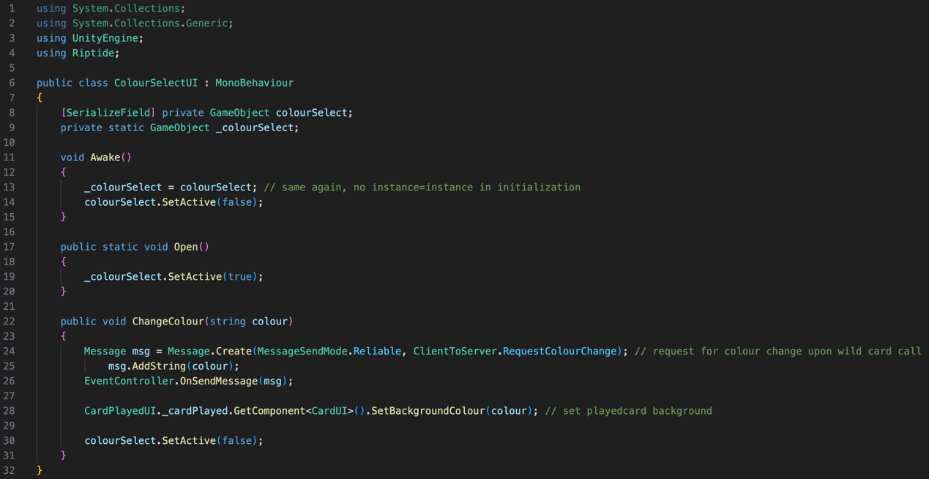

Originally, there were 4 namespaces, but System.Collections and System.Collections.Generic were unused, so I removed them, and this can be seen in my appendix. UnityEngine is used for the MonoBehaviour inheritance and Riptide is used for the net messages. Like usual, the colourSelect variable has been serialized so it can be assigned in the inspector. This is assigned to a static variable in the Awake method so it can be accessed by other static methods which are required by Riptide. Once colorSelect has been assigned to _colourSelect, then the game object is set inactive, so it is not visible and in the way of the game play. The Open method simply sets the object to active, so it is visible. The ChangeColour method sends the colour they chose to the server with the ClientToServer.RequestColourChange net message, sets the background of the wild card to the colour they chose, and sets the colour select object to inactive once complete.

**CardPickupUI.cs**

This class also only exists on the client. This is a very simple class that is used to request a card from the pickup deck, as they play cannot play any cards.

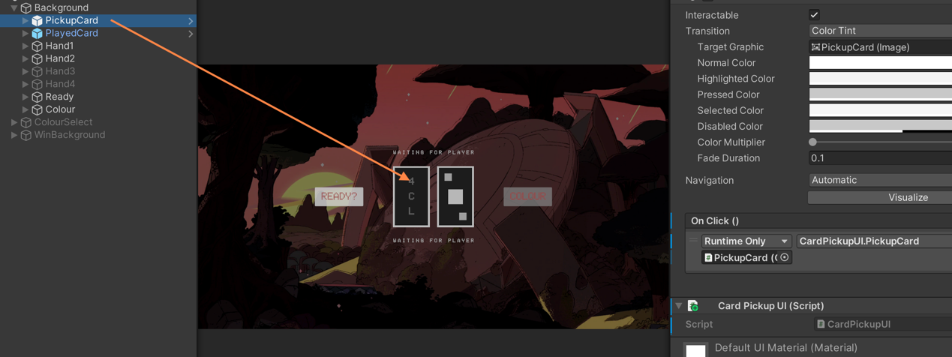

When the pickup card is clicked, the CardPickupUI.PickupCard method is called.

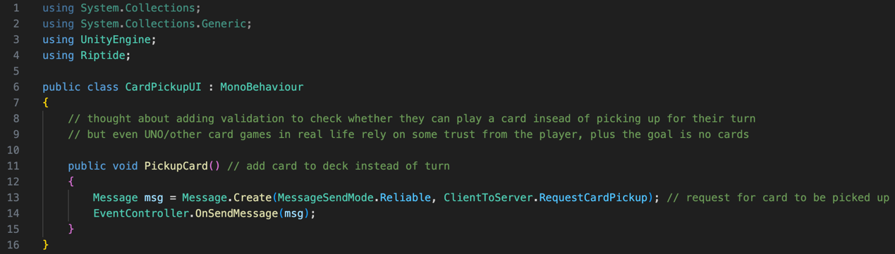

As System.Collections and System.Collections.Generic were also unused in this script, I removed them, and this change can be seen in my appendix. Now, there are only 2 namespaces. UnityEngine is for MonoBehaviour inheritance and Riptide is for net messages. I thought about adding validation to check whether they need to pick up a card, or whether they can actually play a card. I decided that in real life, trust is also needed for the game. To represent a real feel to UNO and conserve the original rules, I did not put any validation here. Besides, the goal is to have no cards left. The PickupCard method sends the ClientToServer.RequestCardPickup net message to the server.

**CardPlayedUI.cs**

This is another class that only exists on the client, as it is used to control UI, which does not exist on the server. The CardPlayedUI script is attached to a Card prefab.

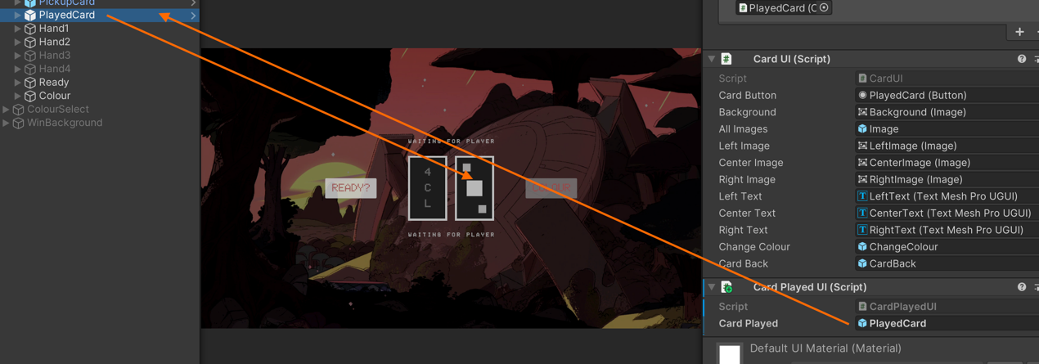

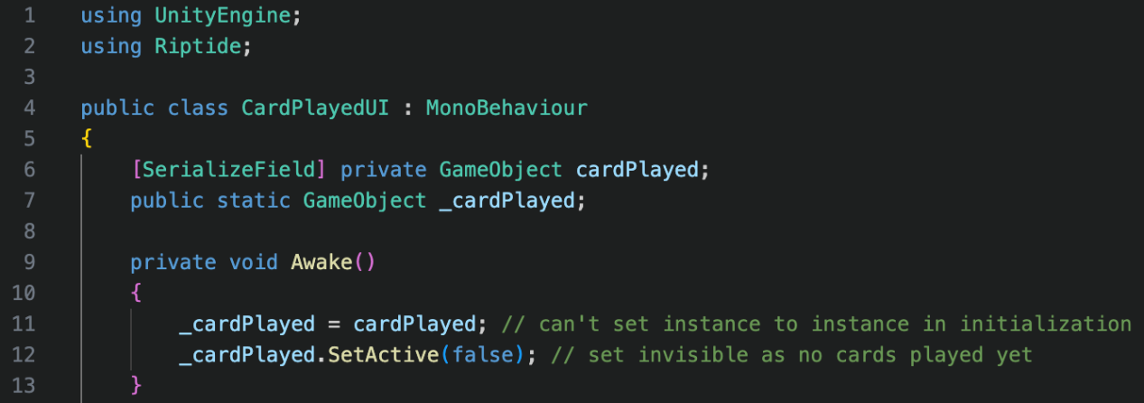

The script has 2 namespaces for the same reasons stated before. The cardPlayed object is assigned to a static variable in the Awake method so it can be accessed by static Riptide methods. For this can happen, the object must be active, so the Awake method is called. Once the variables have been assigned, the played card is set to inactive (invisible).

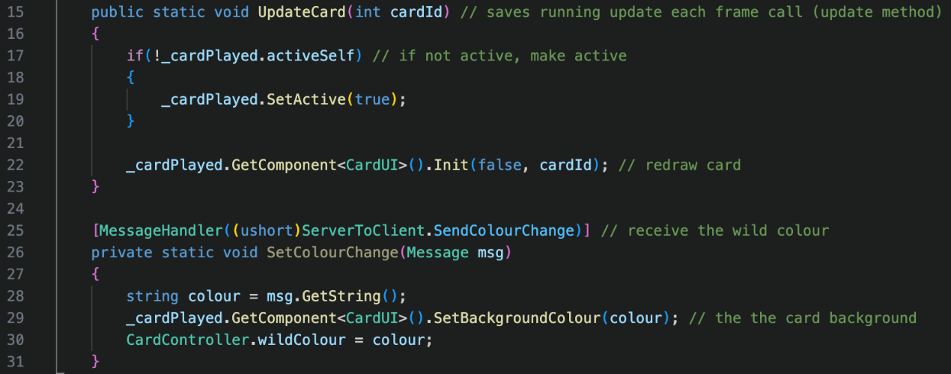

As stated above before, the UpdateCard method is used instead of the Update method, so it is only called when required, instead of every frame, which improves performance for the client. The card is updated when a card has been played. This is why the object is checked to see if it is active. If it is not active, it needs to be active now, so it is visible. The card is then redrawn with the new cardId to display the new card information that has been played. I decided the best place to receive the ServerToClient.SendColourChange net message was this class, as the background colour of the played card needs to change so the player knows what colour to play. This happens when the message is received, and the CardController.wildColour is set to the colour too.

**ColourUI.cs**

Again, the ColourUI class only exists on the client and is very similar to the ReadyUI class. It functions in the same way but has a slightly different purpose. The button is only interactable when the player has just played their 2nd to last card, and while it has not yet reached their next turn to play their last card. If the button was not pressed, and they played their last card, then they will receive a penalty of 2 cards.

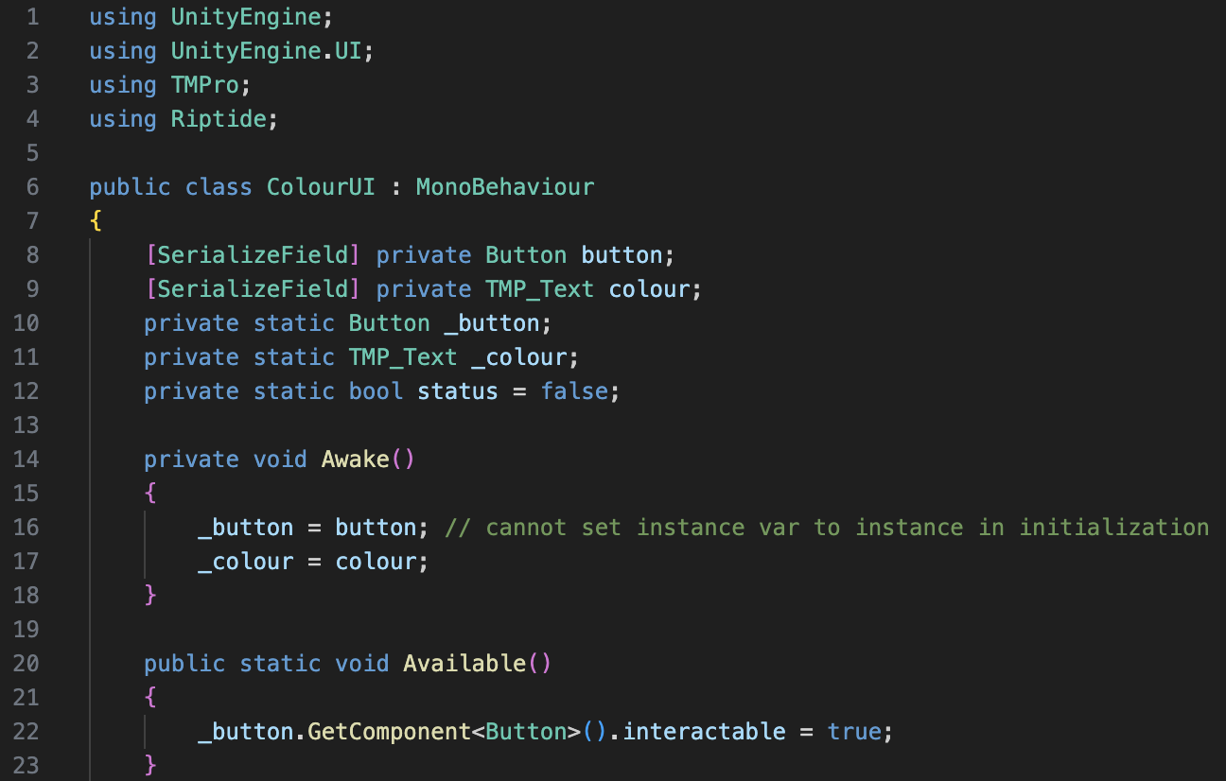

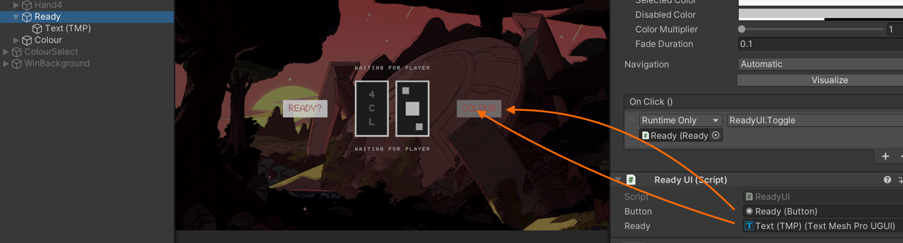

The ColorUI class has 4 different namespaces. UnityEngine is for the MonoBehaviour inheritance, and Riptide is for the net messages. TMPro is for the TMP_Text data type and UnityEngine.UI is for the UI components such as intractability. Status is a flag variable for whether they have pressed the button or not. The button and colour variables are serialized so they can be assigned in the inspector, and static version of these variables exist, which are assigned in the Awake method.

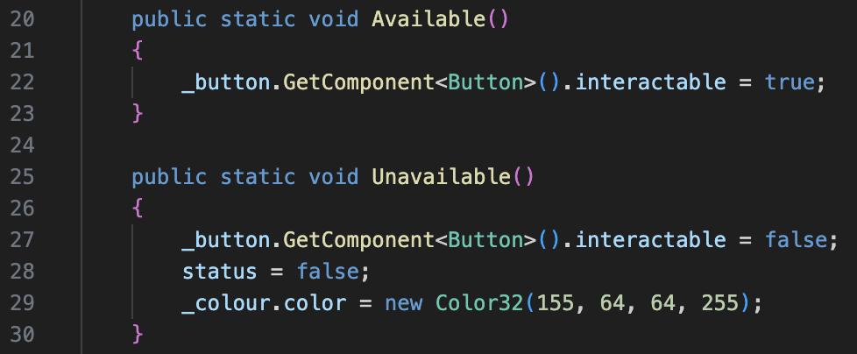

When the Available method is called, the button is made interactable. In the screenshot above, the button is not interactable. If the Unavailable method is called, the button is made unavailable, the flag variable is reset to false, and the text colour is returned to red.

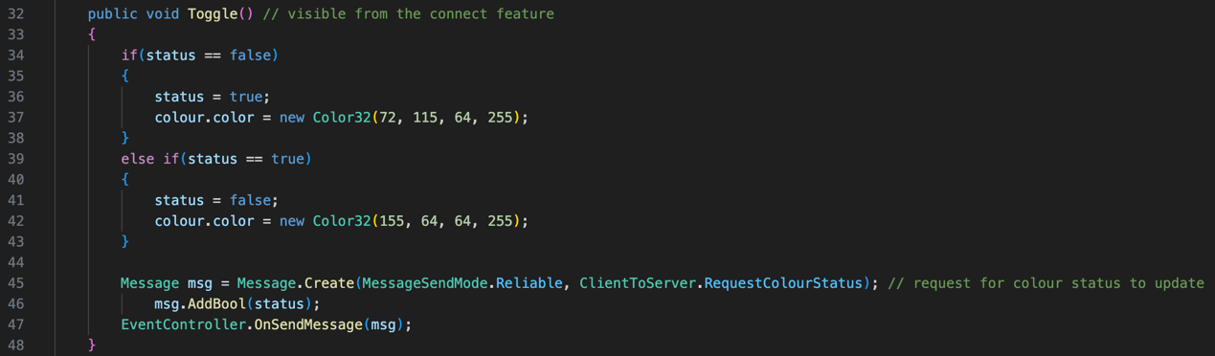

The Toggle method is called when the button is pressed. The button can only be pressed if it is interactable. If the status is false, then the status is changed to true, and the text colour is changed to green. If the status is true, then the status is changed to false, and the text colour is changed to red.

**GameController.cs**

The purpose of the game controller was to control the gameplay itself. It brings together all the other controllers and files and is essentially the main class. Whilst there is usually lots of similarities between the client and the server, this controller is quite different on both sides. This is because the server mainly controls the validation, while the client is controlling the UI. I will start by explaining the server-side version of this class.

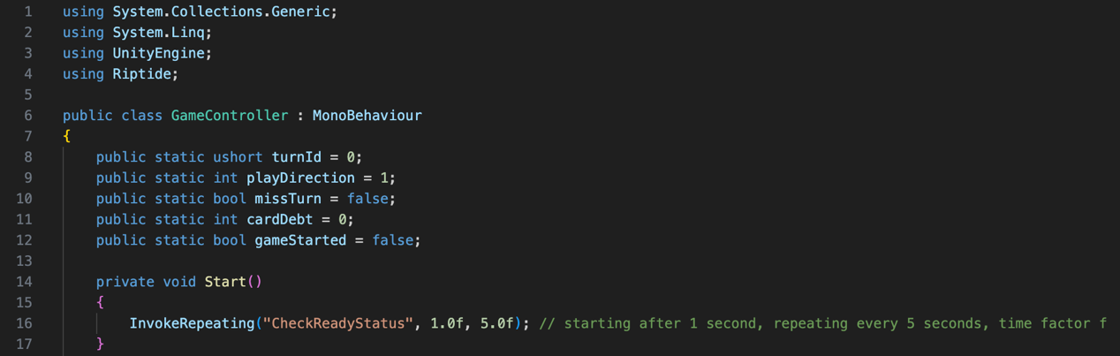

The server-side version contains 4 namespaces. System.Collections.Generic is for list and dictionary data types mainly, whilst System.Linq is used for data querying such as finding the minimum key in a dictionary. LINQ stands for Language Integrated Query and is part of the powerful .NET framework. By using this namespace, it means I do not have to manually code my own methods that I require to search through dictionaries. This class heavily relies on communication with the clients, and as a result, contains lots of static variable to be used by Riptide. The first variable turnId correlates to the client id whose turn it currently is. The next variable is playDirection which correlates to the direction of play – clockwise or anticlockwise. It is clockwise by default, so has a value of 1, and when anticlockwise, it will have a value of -1. A flag variable missTurn is used to check whether the next player will need to miss a turn. To see if the next player needs to pick up any cards, the cardDebt variable stores the number of cards that need to be added to the next player’s deck. I could have added flag variables like missTurn for pickupTwo or pickupFour, but this method creates unnecessary variables. The gameStarted variable is also a flag variable, which is used to reject connections while the game is in progress to stop new players joining. The Start method creates a timer that starts after 1 time factor (f), which is essentially 1 second. This timer calls the CheckReadyStatus method every 5 time factors, which is 5 seconds.

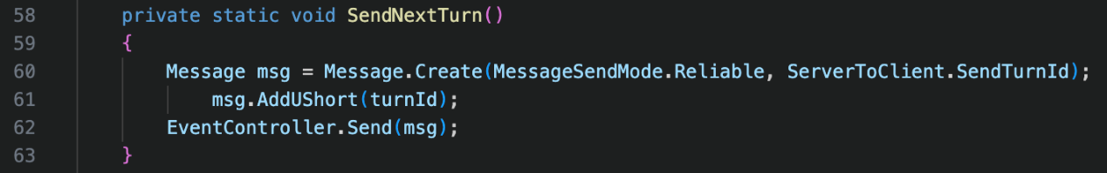

SendNextTurn is a very simple method that sends the ServerToClient.SendTurnId net message to all clients. The message contains the turnId of player who is up to play next.

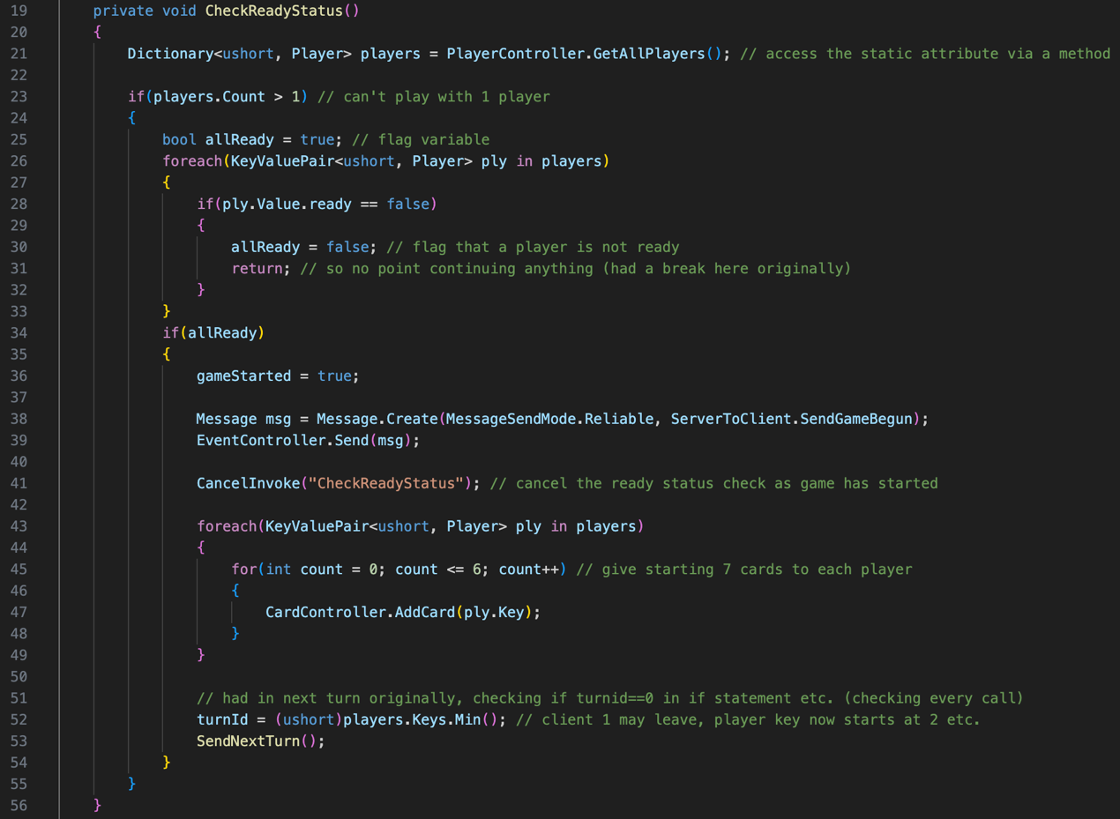

CheckReadyStatus is the method that is called every 5 seconds by the timer. To start off with, the players dictionary is passed by reference. If the player count of the dictionary is greater than 1, then the rest of the checks are carried out. If there is not more than 1 player, then the method ends, as you cannot play a game with 1 player. I use a flag variable called allReady which is used to mark whether all the players have pressed ready. By default, this is true. The players in the dictionary are looped through, and if their ready attribute is false, then the flag variable is changed to false, and the loop is returned out of. There is no point continuing in the loop, if one player is not ready, as all players must be ready for the game to begin. If allReady is true, the method continues.



As allReady is true now that all players are ready, the game can be marked as started. All clients are then sent the ServerToClient.SendGameBegun net message to announce that the game has started. This method no longer needs to be called and checked, so the timer is cancelled, and CheckReadyStatus is no longer invoked every 5 seconds. Each player in the dictionary is looped through again, and each player receives 7 cards which are added by the CardController.AddCard method. Originally, I was assigned turnId to the minimum key in the dictionary in the NextTurn method, which mean the turn never changed from that player. It is important to find the minimum key, as there may be 3 clients. If client 1 leaves before the game starts, no one would be able to play if the turnId started at 1, as client id 1 does not exist. This minimum key is then sent to all clients using the SendNextTurn method as discussed above.

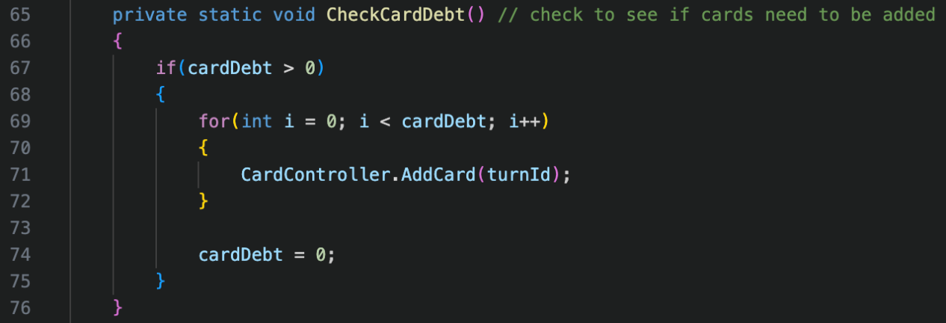

The CheckCardDebt method makes use of the cardDebt variable to check and release any cards that need to be added. If cardDebt is greater than 0, a for loop iterates and increments until the value is reached. Each time the loop iterates, a card is added to the player whose turn it has moved onto to. The cardDebt is then reset.

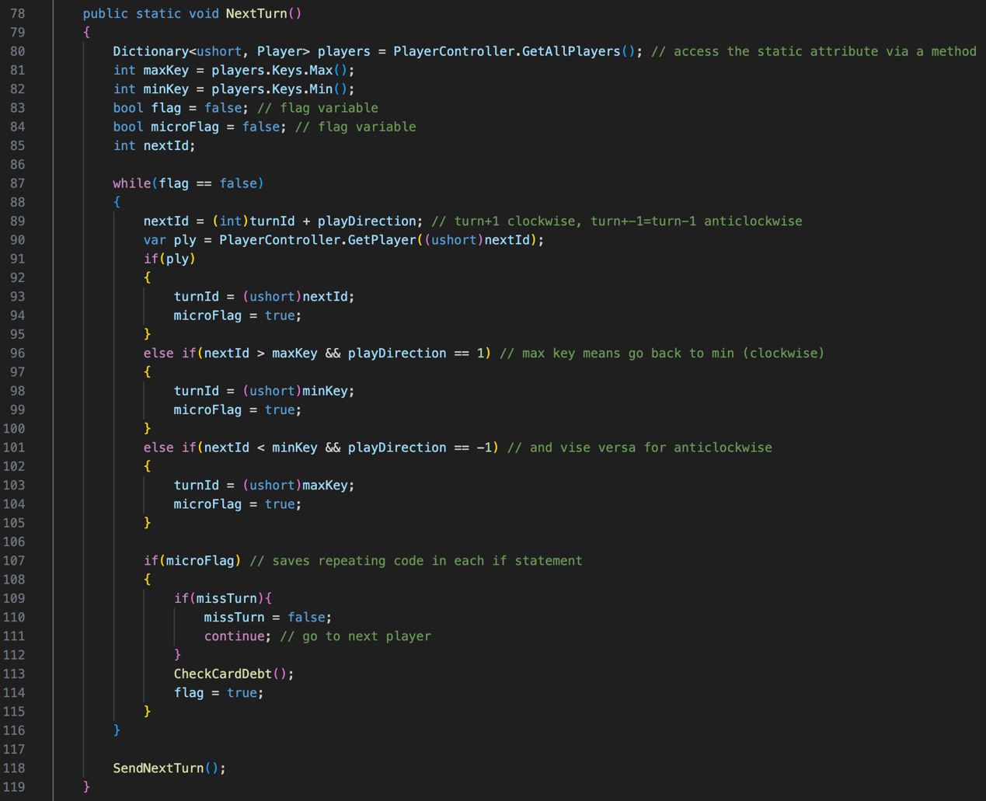

The NextTurn method starts by accessing the static dictionary in a player’s variable. The minimum key and the maximum key are both stored in separate variables – minKey and maxKey. These are used frequently within the method, so by putting them in a variable, it saves rewriting code. There are 2 flag variables called flag and microFlag. The microFlag variable is used within the flag variable. The flag variable is used to check whether a player has been found, whilst the microFlag is used to prevent the repeat of code in an if statement which can be seen below in the while loop.



To calculate the nextId, the turnId is converted to an integer from a ushort, and this is added to the playDirection value. If playDirection is 1, then the play will move clockwise as a value plus +1 will increment. If playDirection is -1, then the play will move anticlockwise as a value plus -1 will reduce. To check whether this player exists, the PlayerController.GetPlayer has nextId passed in the parameter, which was converted to a ushort from an integer. If this player exist, turnId is assigned the ushort casted nextId. If the nextId is greater than the maximum key and the direction is clockwise, then the turnId is reset to the ushort casted minimum key of the dictionary, as we are back to the first player’s turn. If the nextId is less than the minimum key of the dictionary, and the play direction is anticlockwise, then the turnId is set to the ushort casted maximum key, as we are back to the last player’s turn. In all 3 cases, microFlag is set to true to be checked. The first variable that is checked is missTurn. If missTurn is true, then the loop is continued to find the next player, and the missTurn variable is reset to false prior. The CheckCardDebt method is called, and then the flag variable is set to true to prevent the while loop calling again. The loop finishes with the SendNextTurn method.

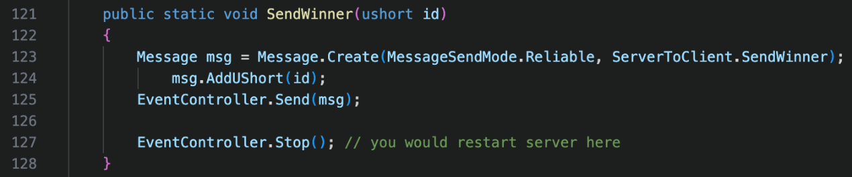

The SendWinner method is used to send the ServerToClient.SendWinner net message with the client id of the winning player. This is where the server could be restarted in the future, but for now the EventController.Stop event is invoked.

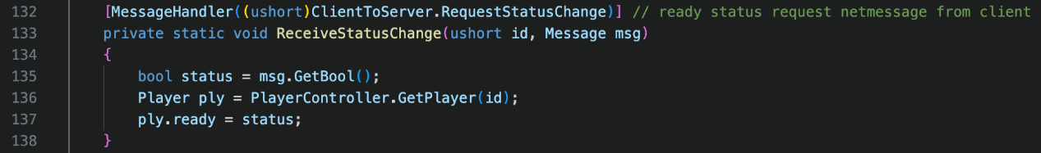

This message handler receives the ClientToServer.RequestStatusChange net message. It gets the true or false value that was sent to the server and updates the player’s ready attribute. There is no validation required, as the button is not interactable once the game started, and even if they manage to modify this value once the game has started, it will have no impact on gameplay.

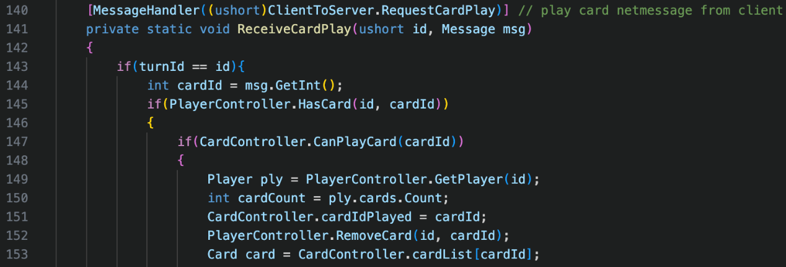

This message handler receives the ClientToServer.RequestCardPlay net message and is the longest method in the whole project. As a result, I will have to split this over multiple screenshots. The purpose of this handler is to receive when a player wants to play a card when a card is clicked on. The first check is that he turnId is equal to the id who sent the net message, to ensure that it is their turn to play a card. The cardId they were trying to play is received from the net message, and the player’s card list is checked to see if they own that cardId. They cannot play a cardId that they don’t own, as this would give them an unfair advantage. The next check is to see whether they can actually play the card on top of the previous card that was played. If all these checks are true, then some variables are set up to be used. The ply variable gets the id’s player class by reference. The cardCount variable counts the number of cards that they player owns. The cardIdPlayed variable is set to the cardId that the player has requested to play. This card is removed from the player’s card list, and the card id’s class is stored in the card variable.

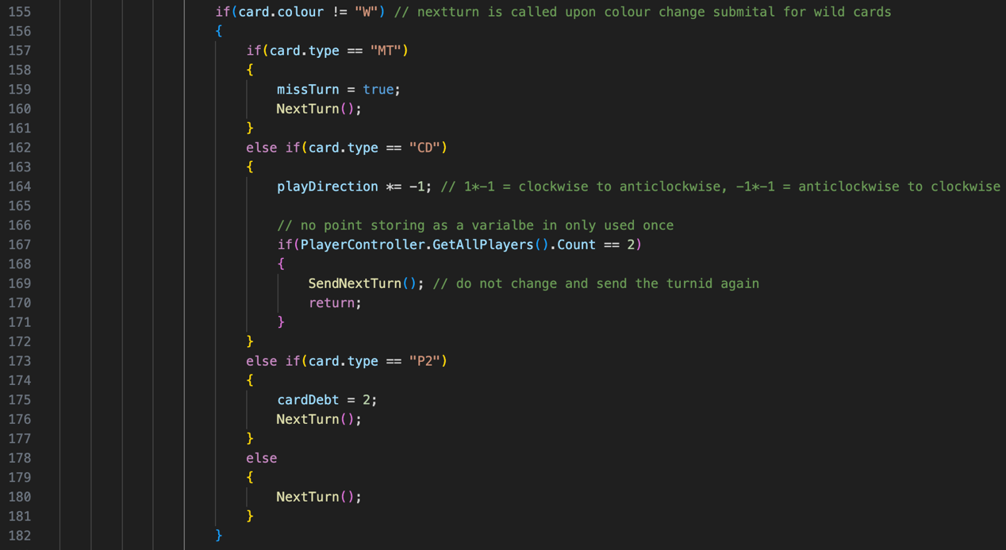

Wild cards have their own NextTurn method call when the card player choses their colour they would like to change the wild colour to. If it is not a wild card, then the if statement is entered into. I could have used a switch statement here, but I decided to just use an if statement as it wouldn’t make much of a difference. If the card is a miss a turn card, then the missTurn flag variable is set to true and the NextTurn method is called as their turn is complete. If the card is a change direction card, then the playDirection variable is multiplied by -1. This is because it will invert the value (1*-1=-1 and -1*-1=1). When there are only 2 players, this does not work alone and the usual flow of play is continued, which it should not. A charge direction card is essentially a miss a turn card with 2 players. If the player count is equal to two, the NextTurn method is not called, and the player gets another turn as their turnId is resent. If the card is a pickup 2, then cardDebt is set to two and NextTurn is called. If the card is any other card, like a number, then there is no action to take, and NextTurn is called.

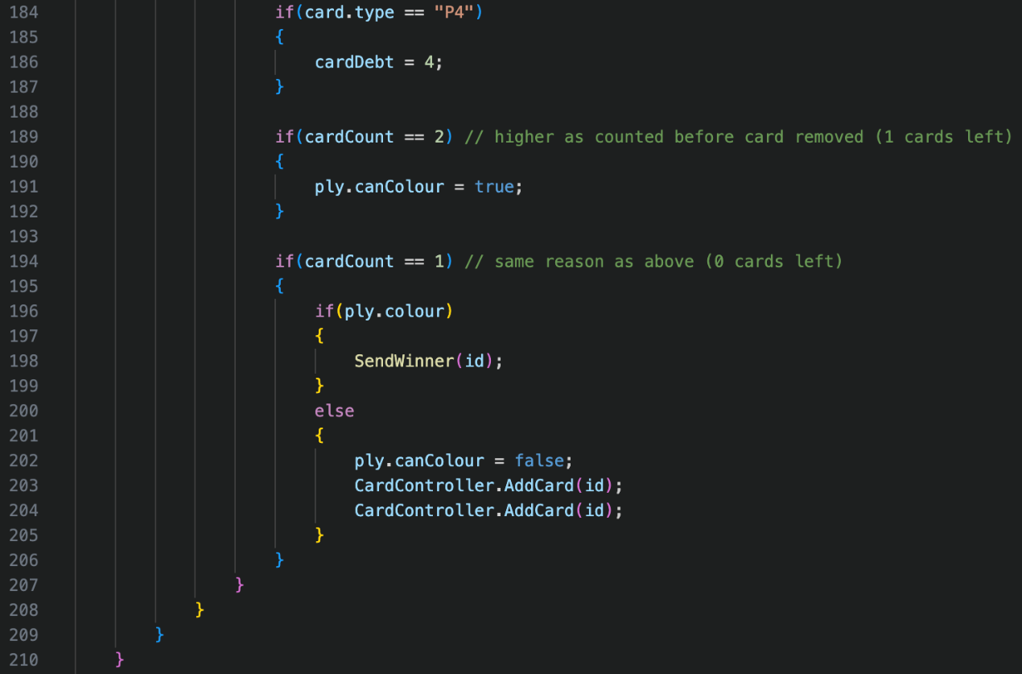

If the card is a pickup 4, then the cardDebt is set to 4. As started before, NextTurn is called when they pick their colour. If they now have 1 card remaining, the player’s canColour attribute is set to true. If they are trying to play their last card, then their colour attribute is checked to ensure they pressed the button in sufficient time. If they did, the SendWinner method is called with their id. If not, their canColour attribute it set to false, and they receive a 2-card penalty.

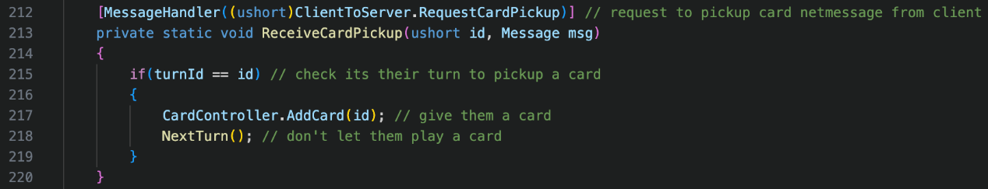

This message handler receives the ClientToServer.RequestCardPickup net message when a client requests to pick up a card from the deck. As the player can only pick up a card on their turn, it is checked to see if it is their turn. If it is, a card is added to their hand, and the NextTurn method is called, as picking up a card completes their turn.

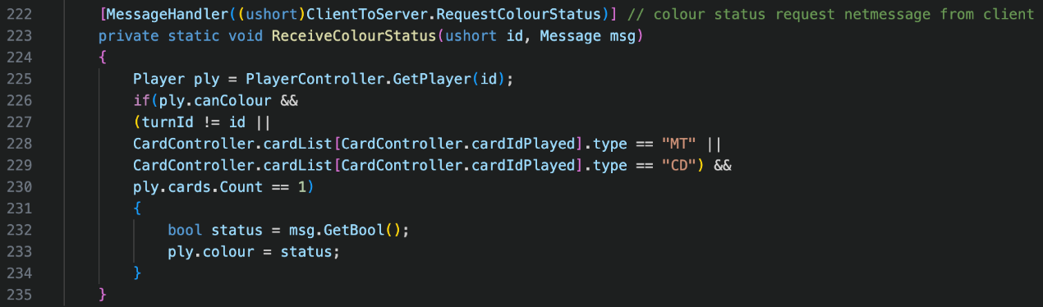

This message handler receives the ClientToServer.RequestColourStatus net message when the player presses the colour button. First, the id’s player class is fetched by the PlayerController.GetPlayer method. To change their status, they must meet 3 conditions. The first is their canColour attribute must be true. The second is that it must not be their turn except if they have played a miss a turn card or change direction card, as these could automatically revert to the player’s turn. The third condition is that the player must only have 1 card. If they meet all 3 conditions, their status is changed in their colour attribute. The client’s class differs to the server’s class.

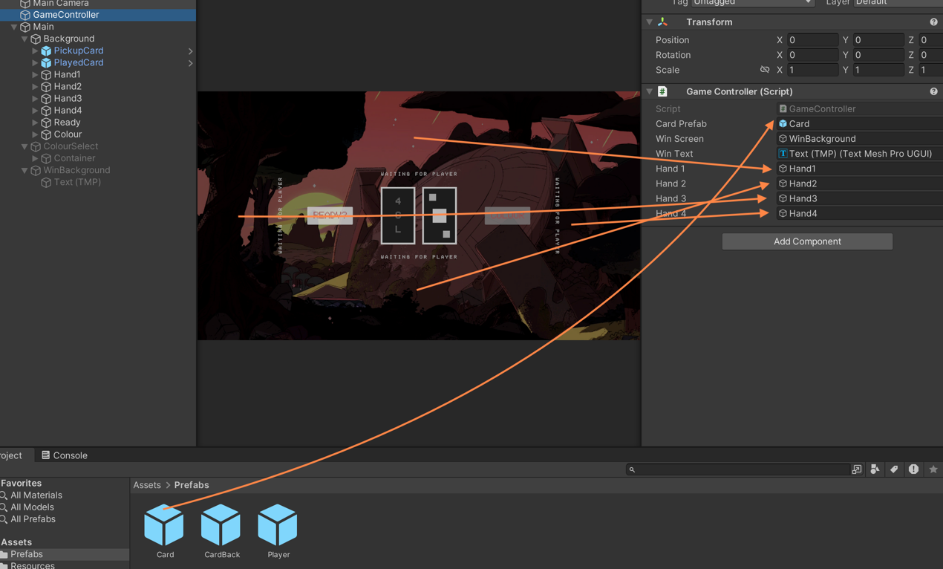

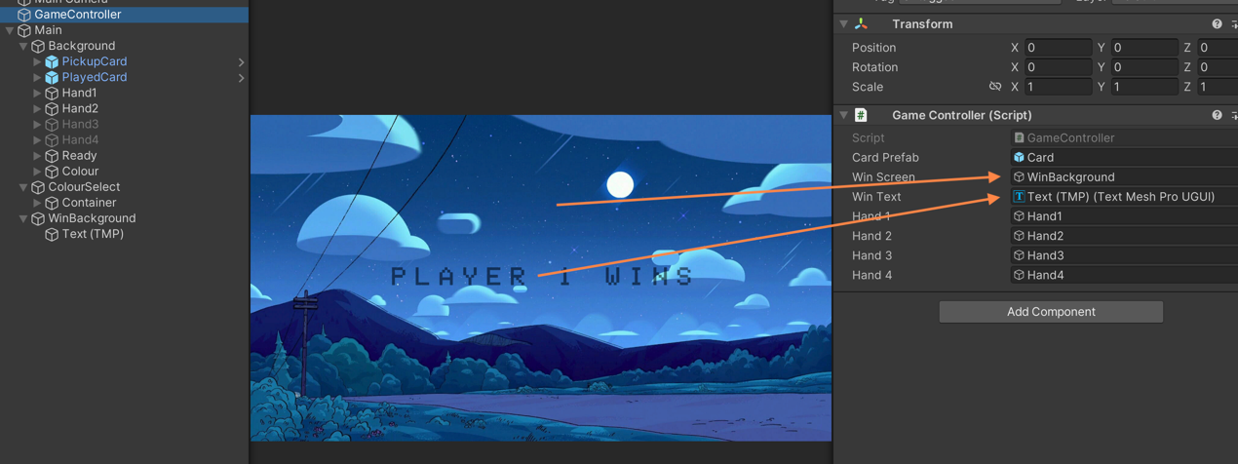

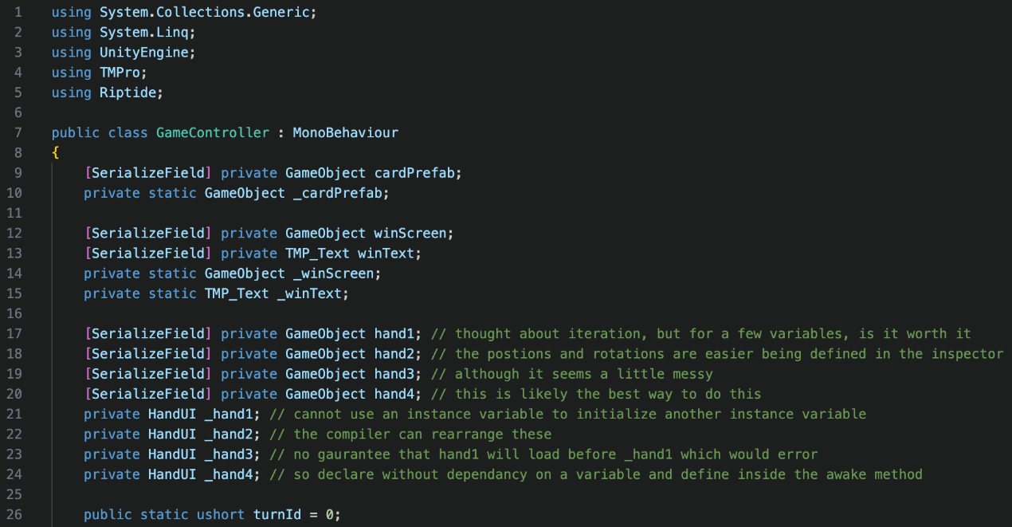

The script uses 5 different name spaces instead of 4 like the server. It uses all namespaces for the same reasons stated above, apart from the additional TMPro namespace which is used for the TMP_Text data type. Every variable except turnId, exists as a serialized variable and a static variable. Each variable can be seen where it correlates to in the screenshots of the Unity scene above. The messiest part of this code is the 4 different hands. I thought about creating these iteratively, but for 4 variables, was it worth it? The positions and rotations were far easier being defined in the inspector rather than by code, to save me time in my small-time frame to complete my project. As a result, I deemed this the best way forward. The last variable turnId holds the id of which client’s turn it is, just like on the server.

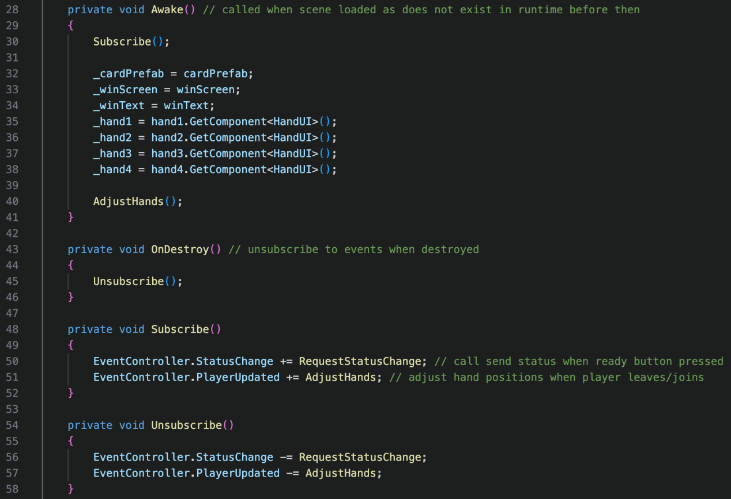

In the Awake method like before, the events are subscribed to, and each serialized variable is assigned to the static variable. This time, I assign the HandUI component to the static variable, to save rewriting it, as this is the only component used. The AdjustHands method is called for the initial placement of each player. When the method is destroyed and the OnDestroy method is called, the events are unsubscribed to. When the EventController.StatusChange event is called, the RequestStatusChange method is invoked to complete the ready status change. When the EventController.PlayerUpdated event is called, the AdjustHands method is called to move the player hand positions.

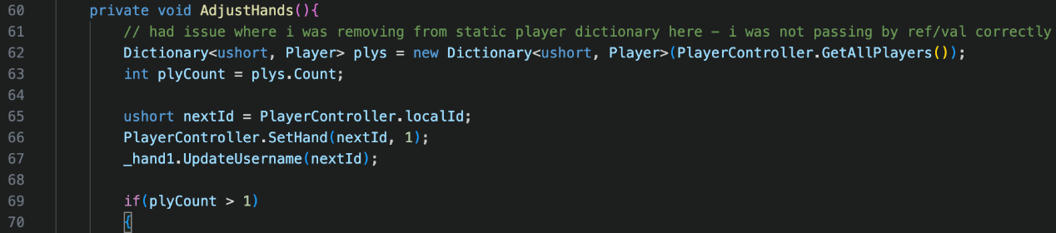

The AdjustHands method is where I had my biggest issue that I didn’t quite understand what was going wrong logically. What I had not considered at this time, was passing by reference and by value. When passed by value, a copy is created. When passed by reference, the memory location of the variable is accessed. Later in the method when I remove players from the plys dictionary, as I was passing by reference, I was removing them directly, which caused errors. When I realised that I was passing by reference, I created a new dictionary was has the contents of the PlayerController.players dictionary. This meant I could continue removing players without causing errors elsewhere in the code. Next, I get the player count by counting the keys in the dictionary. I set the nextId to the local player’s id, as they will always be in position 1 on their screen for a clear flow of game play to meet my clear UI success criteria. I then use the PlayerController.SentHand method to make this change. I update the username of the hand, as the hand owner has changed. If the player counter is greater than 1, then more hand positions need to be setup, and the code continues.

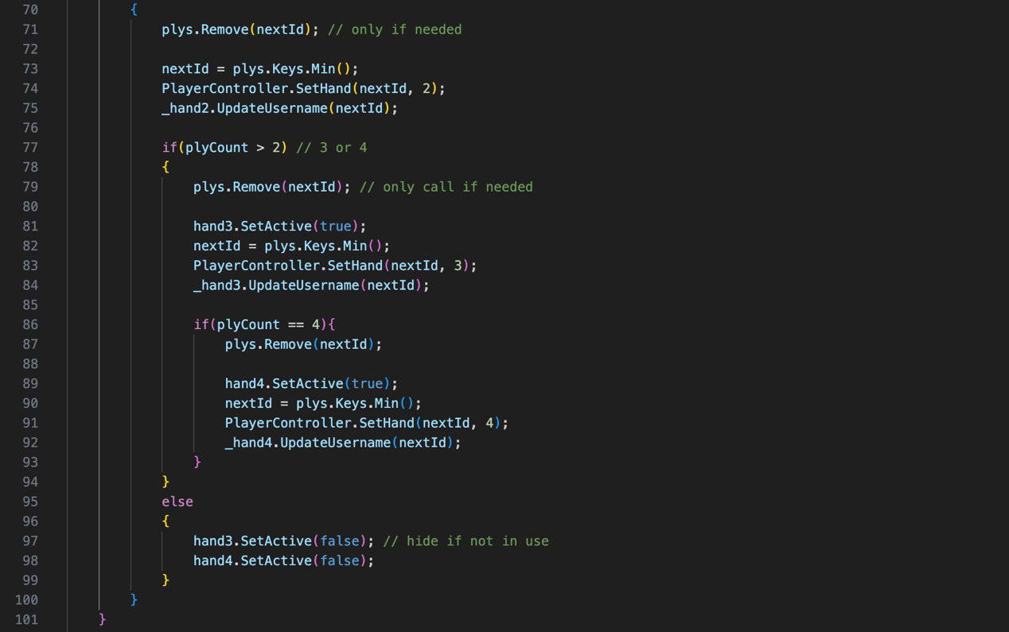

As it is now needed, the owner of hand 1’s id is removed from the copied dictionary. To get the nextId, the minimum key of the dictionary is found. The hand is set with the PlayerController.SetHand method again and the username for the hand is updated again. This happens for hand 3 if the player count is greater than 2, and hand 4 if the player count is equal to 4. For hand 3 and 4, if in use, they are to set to active, so they are visible. If the player count was not greater than 2, then hand 3 and 4 are set to inactive so they are invisible.

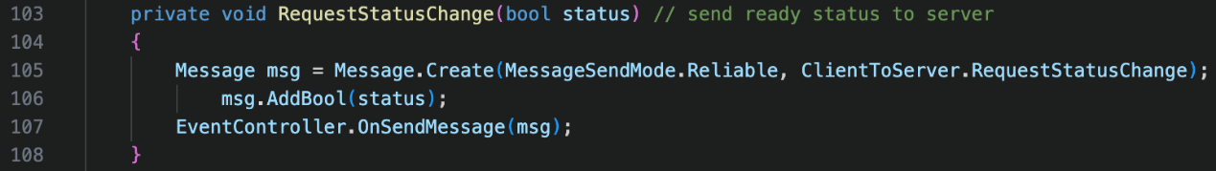

The RequestStatusChange method is used to send the ClientToServer.RequestStatusChange net message to the server, with their ready status added a Boolean data value. This is invoked by the EventController.StatusChange event.

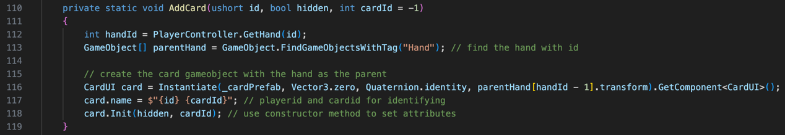

The AddCard method is used to a card to any of the player’s hands. There are 3 parameters, the id of the player to add a card to, whether the card should be hidden, and the cardId if not hidden. To start off with, I find the handId of the player’s id by using the PlayerController.GetHand method. I then get all hand game objects, which are added to the table in alphanumerical order. I create the card by instantiating the card prefab and assigning it as a child to the hand in parentHand at index handId minus one, as the index is 0 to 3, but the hand ids start from 1 to 4. I set the card game object’s name to the owner id and the card id and call the Init constructor method of the CardUI class, to display the card.

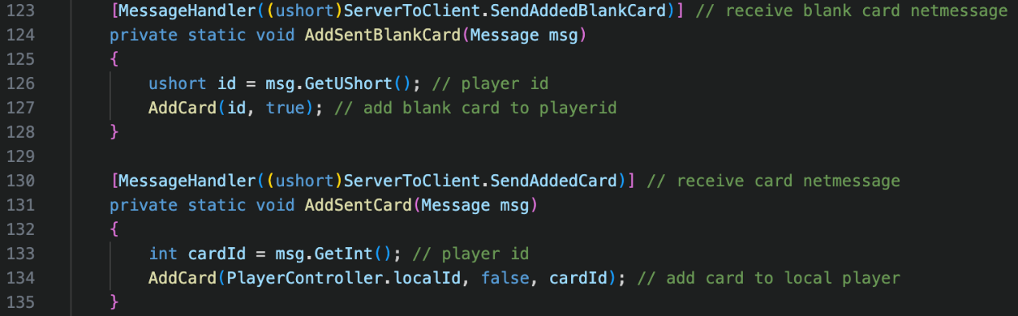

Both the ServerToClient.SendAddedBlankCard and the ServerToClient.SendAddedCard net messages serve similar functions. The AddSentBlankCad method gets the id of who to add a blank card to and calls the AddCard method with the id and true to show it should be a hidden card. The AddSentCard method gets the cardId, which has been incorrectly commented as player id and fixed in the appendix. The AddCard method is then called with the local id, that is should not be hidden, and the cardId. It will always be added to the local player, as these are they only cards that won’t be blank to the local client.

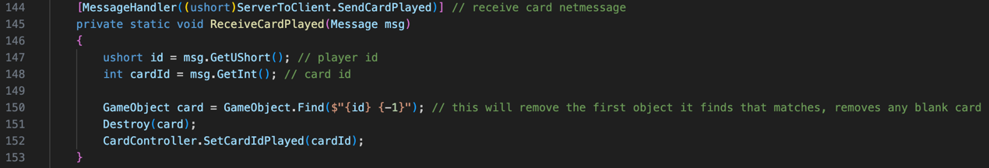

This message handler receives the ServerToClient.SendCardPlayed net message which is sent when another player plays a card. The id of the player who played the card is read from the message, as well as the card id that they played. I use GameObject.Find to find any game objects that belong to the id with cardId as -1. This will obtain the first blank card it finds. I then destroy that card and set the cardIdPlayed to the cardId through the CardController.SetCardIdPlayed method.

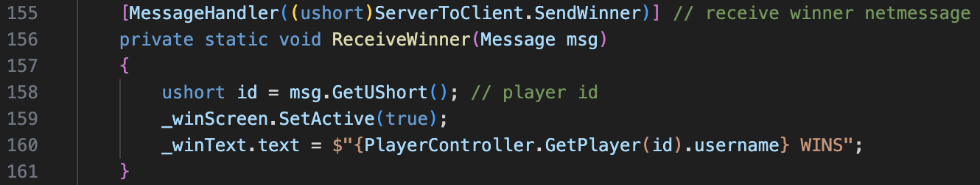

This messages handler receives the ServerToClient.SendWinner net message to receive the winning player. The id is read from the net message, the win screen is set to active so it can be seen, and the win screen text is set to the winning id’s username.

Combing all these classes above, I believe I have successfully completed the success criterion 3 being the original rules. I managed to implement all aspects of the original rules of UNO successfully, which has maintained the feeling of the game for Mr Dorrell and his fans.

## Success Criteria 4 – No Advertisements

At no point in my game, are adverts every displayed. This focuses the player’s attention to the game, with no distraction, for their best play session possible. It was my stakeholder’s request for the game to contain no adverts. This maintains the classic feel to the card main. As a result, I successfully met this success criterion.



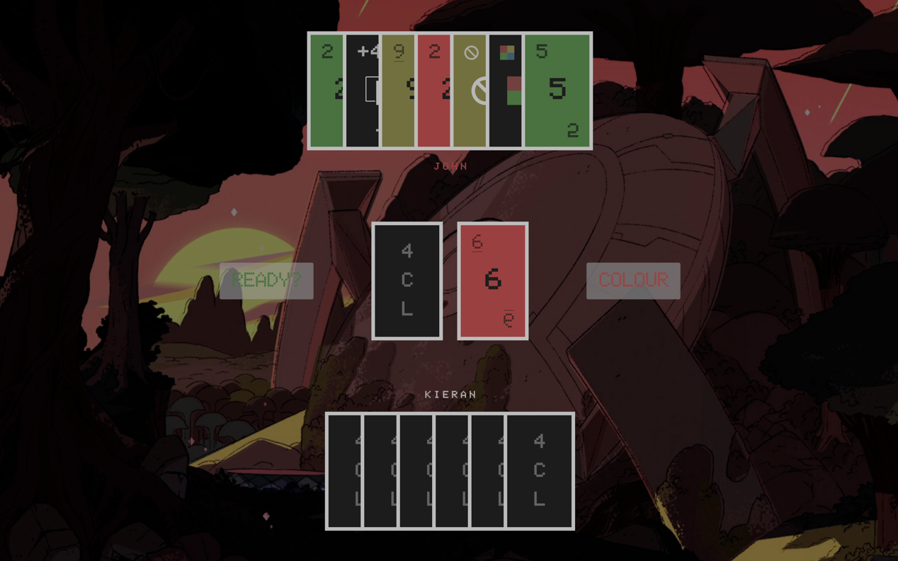



Within any scene, there are no adverts displayed to any player.

## Success Criteria 5 – Free to Play

As per my stakeholder’s request, the game will be free to play and there will be no payable DLCs. This allows for more fans to play and does not restrict those younger players who cannot afford expensive games, as this game is family friendly. Fans of any age will be able to join Mr Dorrell in this simple card game. No proof of this is required.

## Further Test Data for Post Development

A possibility for future development, could include any of my additional objectives that I did not complete. An example of this would be building on the username system, adding a password too. This would allow for unique usernames to identify fans for Mr Dorrell. The GUI on the login page would have to be modified to allow for password input, and a create account scene would be required. The username and password would need to be verified in a database. The password should be hashed ideally to keep it secure. The password would also need to be checked for its security, checking whether it was between 8 and 32 characters, contains uppercase and lowercases characters, contains symbols, and contains numbers.

# Evaluation

The tests below and additional tests were carried out during unit and integration testing during development. The tests outlined below were key aspects to be tested post development too, which are mainly integration tests. My test plan had to change from my design due to a different approach taken. I carefully planned each test that I created and used my original test plan as a base. Combining all tests, the success criterions 1-5 were successfully met, as they function as planned. The stakeholder and I believe the project was a success.

## Post Development Testing

|  |  |  |  |  |
| --- | --- | --- | --- | --- |
| **No.** | **Test Information** | **Type** | **Criteria Link** | **Page** |
| **1** | Check username cannot exceed 12 characters | Boundary | 1, 2, 4, 5 | 104 |
| **2** | Check username can be entered as 1 character | Boundary | 1, 2, 4, 5 | 104 |
| **3** | Check username only accepts alphanumeric characters | Erroneous | 1, 2, 4, 5 | 105 |
| **4** | Check alphanumeric username between 1-12 characters | Normal | 1, 2, 4, 5 | 105 |
| **5** | Check server is full error message | Normal | 1, 2, 4, 5 | 105 |
| **6** | Check server is offline error message | Normal | 1, 2, 4, 5 | 105 |
| **7** | Check game has started error message | Normal | 1, 2, 4, 5 | 106 |
| **8** | Check username is set to guest if not entered | Erroneous | 1, 2, 4, 5 | 106 |
| **9** | Check hand positions for 1/4 player count | Normal | 1, 2, 4, 5 | 106 |
| **10** | Check hand positions for 2/4 player count | Normal | 1, 2, 4, 5 | 107 |
| **11** | Check hand positions for 3/4 player count | Normal | 1, 2, 4, 5 | 107 |
| **12** | Check hand positions for 4/4 player count | Normal | 1, 2, 4, 5 | 107 |
| **13** | Check if ready buttons toggles to false from true on click | Normal | 1, 2, 4, 5 | 108 |
| **14** | Check if ready buttons toggles to true from false on click | Normal | 1, 2, 4, 5 | 108 |
| **15** | Check ready button is not interactable once the game begins | Normal | 1, 2, 4, 5 | 108 |
| **16** | Press ready on 1 client (1/4 player count) | Normal | 1, 2, 4, 5 | 109 |
| **17** | Press ready on 1 client (2/4 player count) | Boundary | 1, 2, 4, 5 | 109 |
| **18** | Press ready on 2 clients (2/4 player count) | Normal | 1, 2, 4, 5 | 110 |
| **19** | Press ready on 2 clients (3/4 player count) | Boundary | 1, 2, 4, 5 | 111 |
| **20** | Press ready on 3 clients (3/4 player count) | Normal | 1, 2, 4, 5 | 112 |
| **21** | Press ready on 3 clients (4/4 player count) | Boundary | 1, 2, 4, 5 | 113 |
| **22** | Press ready on 4 clients (4/4 player count) | Normal | 1, 2, 4, 5 | 114 |
| **23** | Display number card (0, 1, 2, 3, 4, 5, 7, 8) | Normal | 1, 3, 4, 5 | 115 |
| **24** | Display number card with underline (6, 9) | Normal | 1, 3, 4, 5 | 116 |
| **25** | Display miss a turn card | Normal | 1, 3, 4, 5 | 116 |
| **26** | Display change direction card | Normal | 1, 3, 4, 5 | 116 |
| **27** | Display pickup 2 card | Normal | 1, 3, 4, 5 | 117 |
| **28** | Display pickup 4 card | Normal | 1, 3, 4, 5 | 117 |
| **29** | Display change colour card | Normal | 1, 3, 4, 5 | 117 |
| **30** | Check card can be clicked, placed and removed across clients | Normal | 1, 2, 3, 4, 5 | 118 |
| **31** | Check can play card if no card has been previously played | Normal | 1, 2, 3, 4, 5 | 118 |
| **32** | Check can play same colour cards | Normal | 1, 2, 3, 4, 5 | 119 |
| **33** | Check can play same type cards | Normal | 1, 2, 3, 4, 5 | 119 |
| **34** | Check can play wild cards at anytime | Normal | 1, 2, 3, 4, 5 | 119 |
| **35** | Check can play card if it matches the wild colour | Normal | 1, 2, 3, 4, 5 | 120 |
| **36** | Check cannot play card if it does not meet any criteria | Erroneous | 1, 2, 3, 4, 5 | 120 |
| **37** | Check wild colour changes on all clients | Normal | 1, 2, 3, 4, 5 | 121 |
| **38** | Check player can pick up card | Normal | 1, 2, 3, 4, 5 | 121 |
| **39** | Check if colour buttons toggles to false from true on click | Normal | 1 ,3, 4, 5 | 122 |
| **40** | Check if colour buttons toggles to true from false on click | Normal | 1, 3, 4, 5 | 122 |
| **41** | Check colour button is only interactable before turn & 1 card | Normal | 1, 3, 4, 5 | 123 |
| **42** | Check turn moves on after card is played | Normal | 1, 2, 3, 4, 5 | 123 |
| **43** | Check turn moves on after card is picked up | Normal | 1, 2, 3, 4, 5 | 124 |
| **44** | Check miss a turn skips next turn | Normal | 1, 2, 3, 4, 5 | 124 |
| **45** | Check change direction changes the play direction | Normal | 1 ,2, 3, 4, 5 | 125 |
| **46** | Check +2 card adds 2 cards to next player | Normal | 1, 2, 3, 4, 5 | 125 |
| **47** | Check +4 card adds 4 cards to next player | Normal | 1, 2, 3, 4, 5 | 126 |
| **48** | Check hands adjust on disconnect | Normal | 1, 2, 4, 5 | 126 |
| **49** | Check player wins if all other players disconnect | Normal | 1, 2, 4, 5 | 130 |
| **50** | Check win screen is displayed if player wins | Normal | 1, 2, 4, 5 | 131 |

Green = Pass/Met | Orange = Failed but fixed (Pass) | Red = Fail

Test 1 (robustness)

* Test type: boundary
* Attempted input: 111111111111
* Status: passed – username is accepted and passed into the next scene
* Purpose: check username does not exceed 12 characters to prevent characters overflowing on UI display

 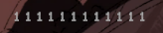

Test 2 (robustness)

* Test type: boundary
* Attempted input: 1
* Status: passed – username is accepted and passed into the next scene
* Purpose: check username still enters with an input of a singular character to prevent a blank username, which could confuse other players

 

Test 3 (robustness)

* Test type: erroneous
* Attempted input: !?_ABCDEFG12345
* Status: passed – non-alphanumeric characters are not accepted into input
* Purpose: to make sure only alphanumeric characters can be inputted as some symbols may not be supported by the font, which would go against clear UI

 

Test 4 (robustness)

* Test type: normal
* Attempted input: Kieran123
* Status: passed – alphanumeric username within 1-12 characters is accepted
* Purpose: to make valid alphanumeric input can be entered for clear UI

 

Test 5 (usability)

* Test type: normal
* Attempted input: connect when server is full
* Status: passed – the message “Server is full” is displayed
* Purpose: ensure the user knows why they cannot connect to the server

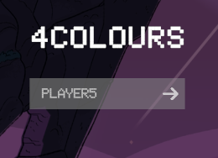 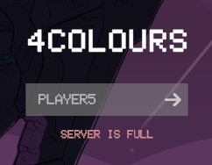

Test 6 (usability)

* Test type: normal
* Attempted input: connect when server is offline
* Status: passed – the message “Server is offline” is displayed
* Purpose: ensure the user knows why they cannot connect to the server

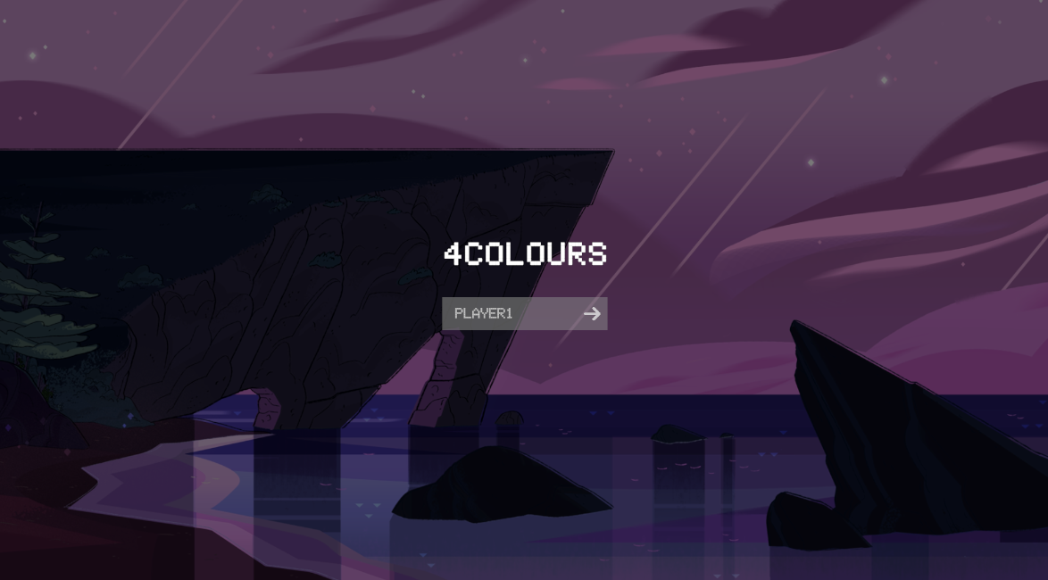 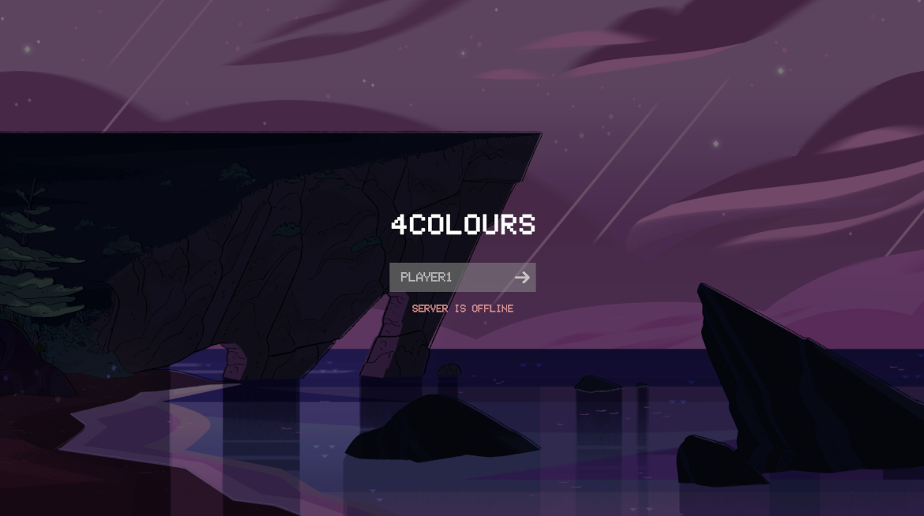

Test 7 (usability)

* Test type: normal
* Attempted input: connect when server is game has already started
* Status: passed – the message “Game has started” is displayed
* Purpose: ensure the user knows why they cannot connect to the server

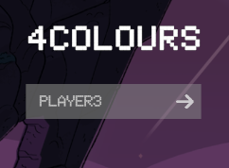 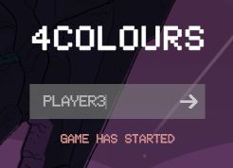

Test 8 (robustness/usability)

* Test type: erroneous
* Attempted input: no username input
* Status: passed – the username is set to Guest
* Purpose: ensure the user has a username to display to other players to prevent confusion for clear UI

 

Test 9 (usability)

* Test type: normal
* Attempted input: client 1 connects to empty server
* Status: passed – local client is hand 1, waiting text in hand 2, and hands 3 and 4 are disabled
* Purpose: ensure the clients own the correct hands to ensure a clear game flow

 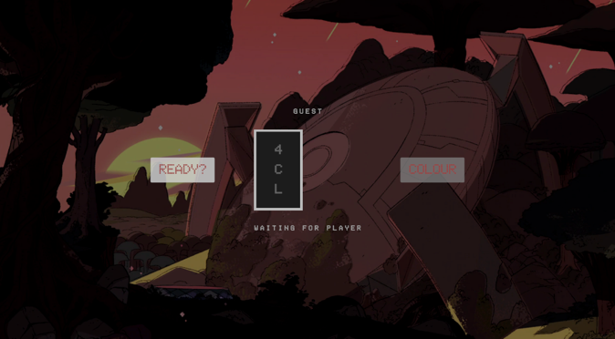

Test 10 (usability)

* Test type: normal
* Attempted input: client 2 connects to server with 1 client connected
* Status: passed – local client is hand 1, other client in hand 2, and hands 3 and 4 are disabled
* Purpose: ensure the clients own the correct hands to ensure a clear game flow

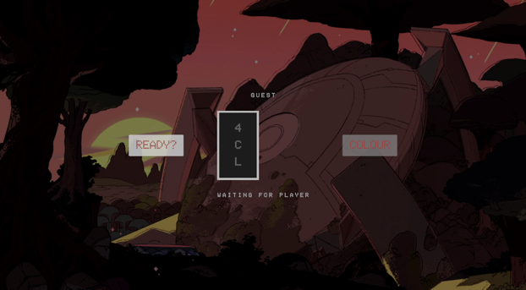 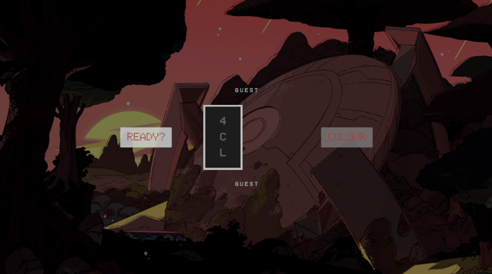

Test 11 (usability)

* Test type: normal
* Attempted input: client 3 connects to server with 2 clients connected
* Status: passed – local client is hand 1, other clients are hand 2 and 3 (assigned hand id based on ascending client id), and hand 4 is disabled
* Purpose: ensure the clients own the correct hands to ensure a clear game flow

 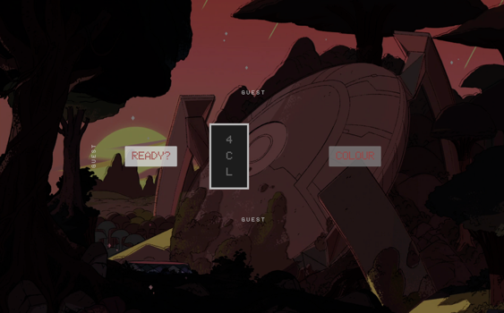

Test 12 (usability)

* Test type: normal
* Attempted input: client 4 connects to server with 3 clients connected
* Status: passed – local client is hand 1, other clients are hand 2, 3 or 4 (assigned hand id based on ascending client id)
* Purpose: ensure the clients own the correct hands to ensure a clear game flow

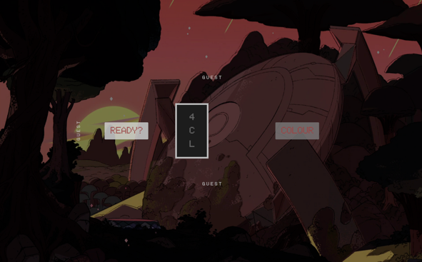 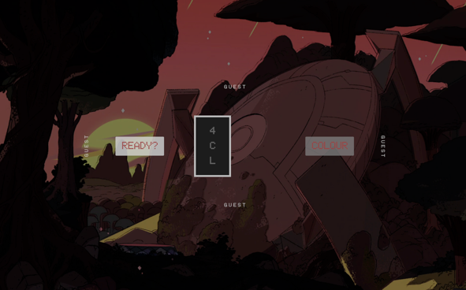

Test 13 (usability)

* Test type: normal
* Attempted input: toggle to false
* Status: passed
* Purpose: ensure button changes to false and message is passed to server, so the local client knows whether they have their status set to ready

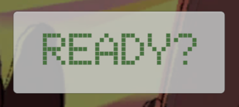 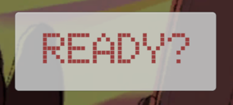

Test 14 (usability)

* Test type: normal
* Attempted input: toggle to true
* Status: passed
* Purpose: ensure button changes to true and message is passed to server, so the local client knows whether they have their status set to ready

 

Test 15 (usability/robustness)

* Test type: erroneous
* Attempted input: toggle to false when game has started
* Status: passed
* Purpose: ensure button is not interactable once game has started to prevent unnecessary data transfer, and make it clear to the user it does not need to be used

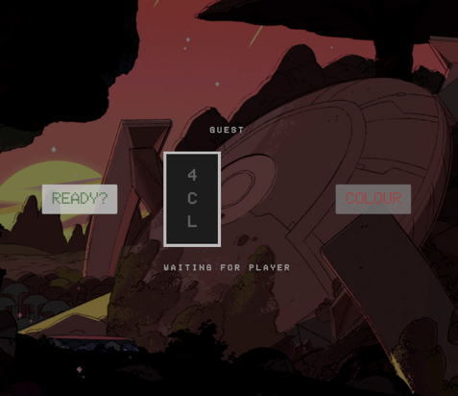 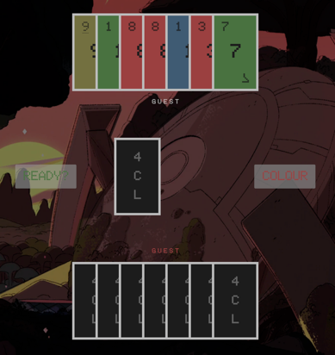

Test 16 (robustness)

* Test type: normal
* Attempted input: press ready on 1 client – 1 client connected
* Status: passed – game does not begin
* Purpose: ensure game only begins when there are 2 or more players that are ready as you cannot play the game with one player

 

Test 17 (robustness)

* Test type: erroneous
* Attempted input: press ready on 1 client – 2 clients connected
* Status: passed – game does not begin
* Purpose: ensure game only begins when there are 2 or more players that are ready, as all players must be ready to be a fair game

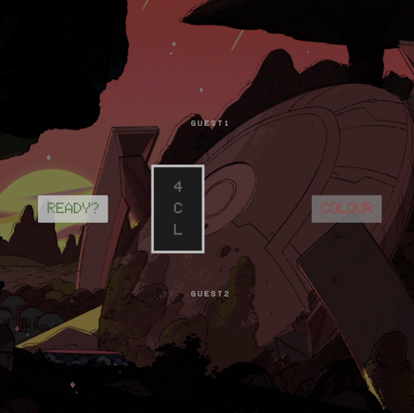 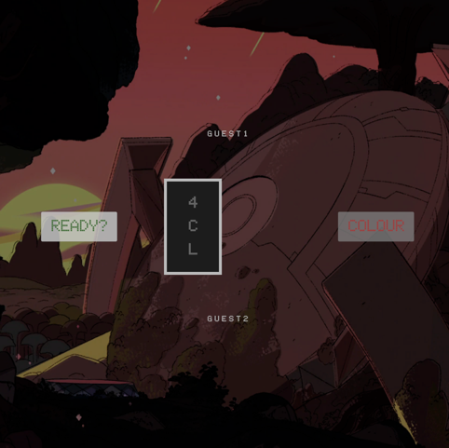

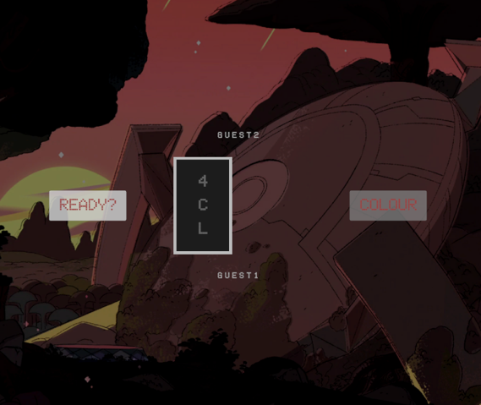 

Test 18 (robustness)

* Test type: normal
* Attempted input: press ready on 2 clients – 2 clients connected
* Status: passed – game begins
* Purpose: ensure game only begins when there are 2 or more players that are ready, as all players must be ready to be a fair game

 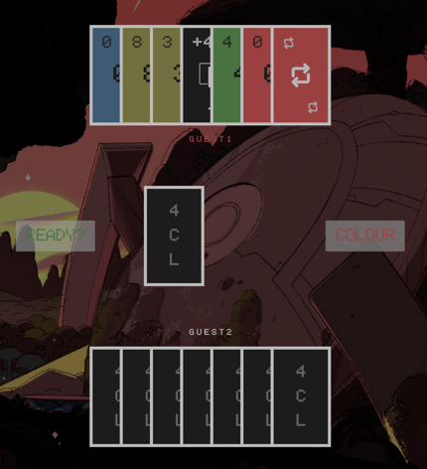

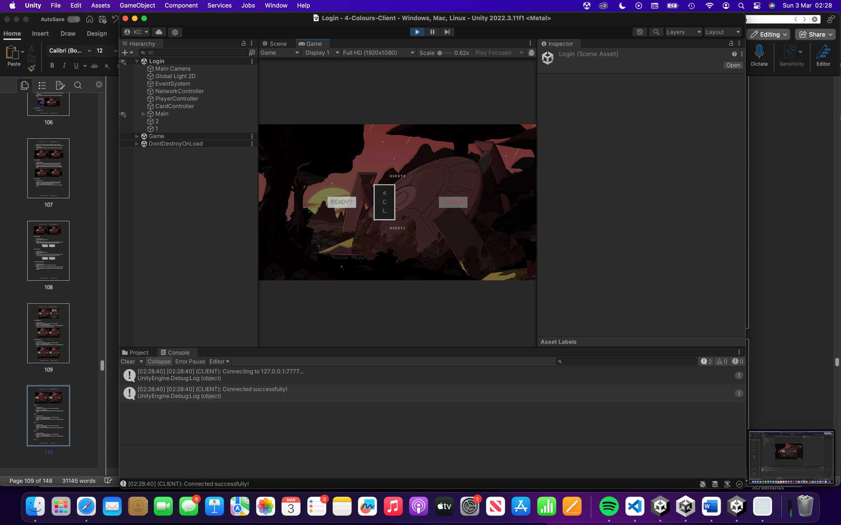 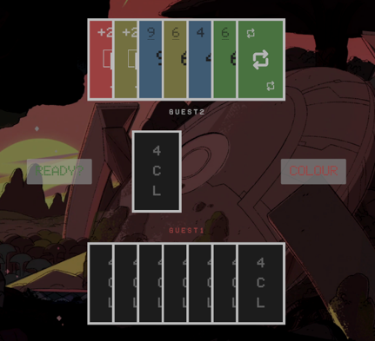

Test 19 (robustness)

* Test type: erroneous
* Attempted input: press ready on 2 clients – 3 clients connected
* Status: passed – game does not begin
* Purpose: ensure game only begins when there are 2 or more players that are ready, as all players must be ready to be a fair game

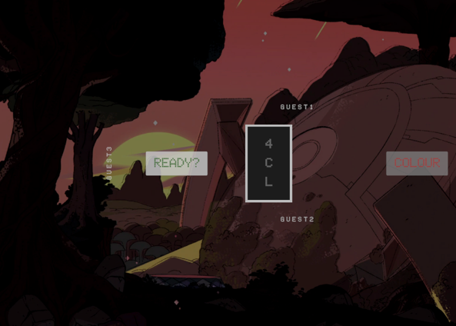 

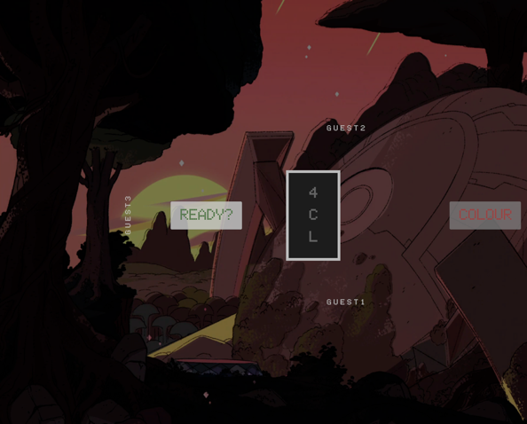 

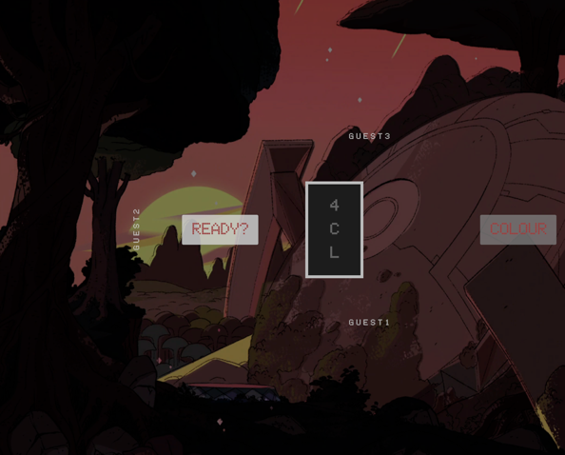 

Test 20 (robustness)

* Test type: normal
* Attempted input: press ready on 3 clients – 3 clients connected
* Status: passed – game begins
* Purpose: ensure game only begins when there are 2 or more players that are ready, as all players must be ready to be a fair game

 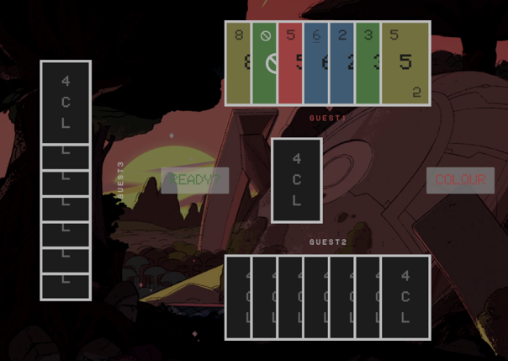

 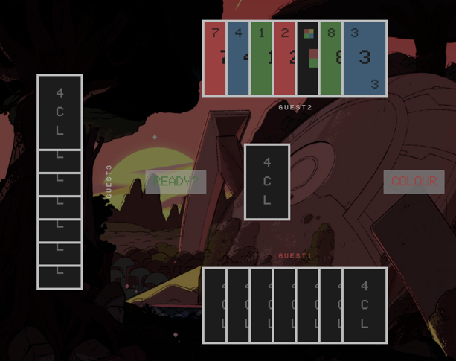

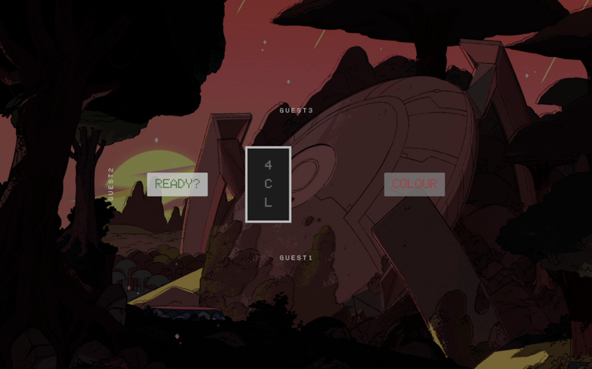 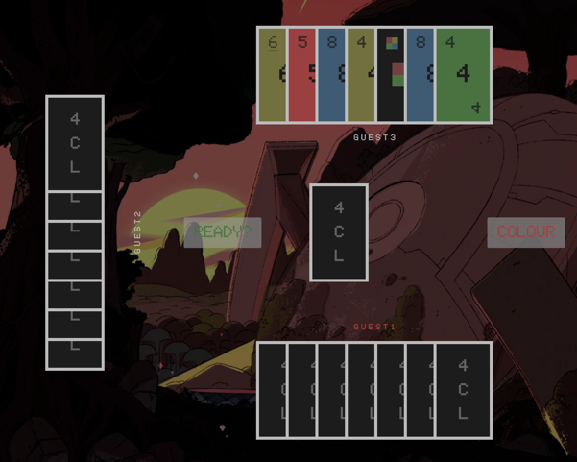

Test 21 (robustness)

* Test type: erroneous
* Attempted input: press ready on 3 clients – 4 clients connected
* Status: passed – game does not begin
* Purpose: ensure game only begins when there are 2 or more players that are ready, as all players must be ready to be a fair game

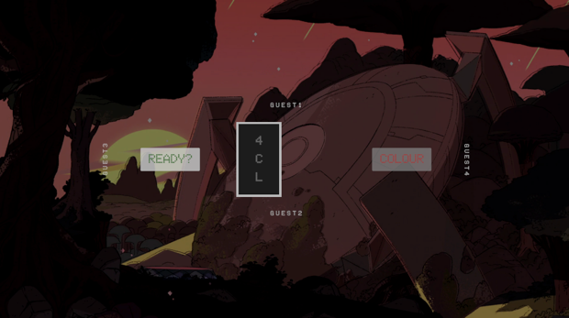 

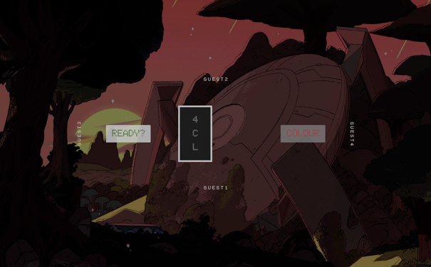 

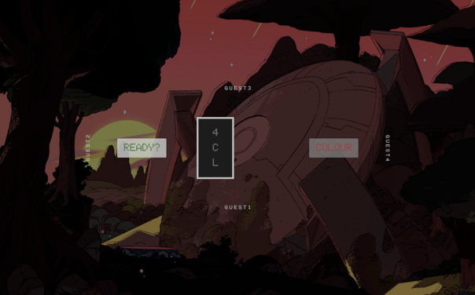 

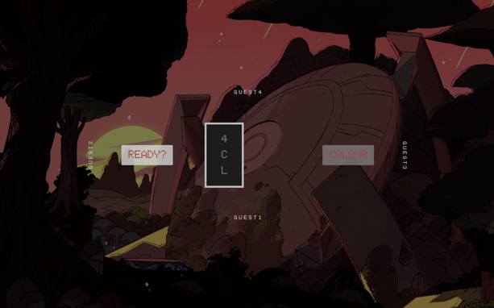 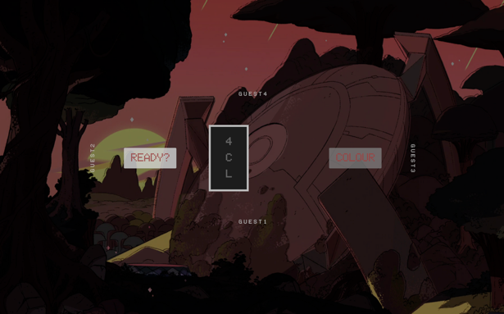

Test 22 (robustness)

* Test type: normal
* Attempted input: press ready on 4 clients – 4 clients connected
* Status: passed – game begins
* Purpose: ensure game only begins when there are 2 or more players that are ready, as all players must be ready to be a fair game

 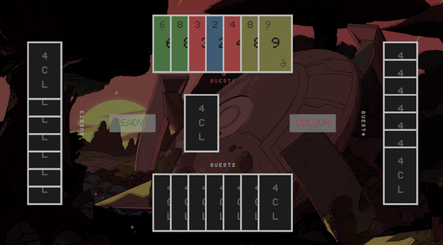

 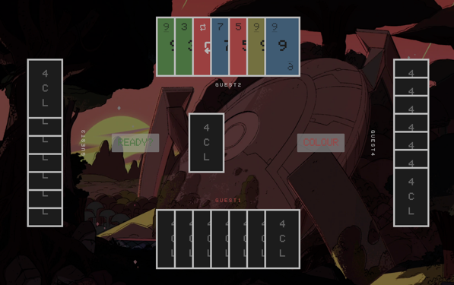

 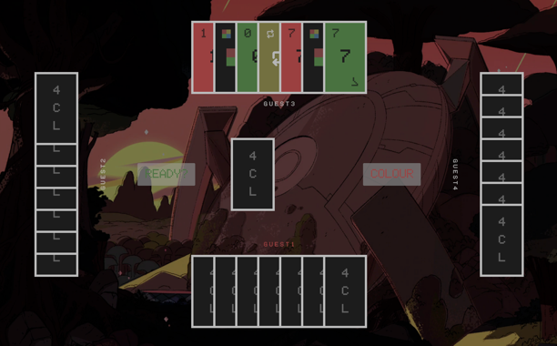

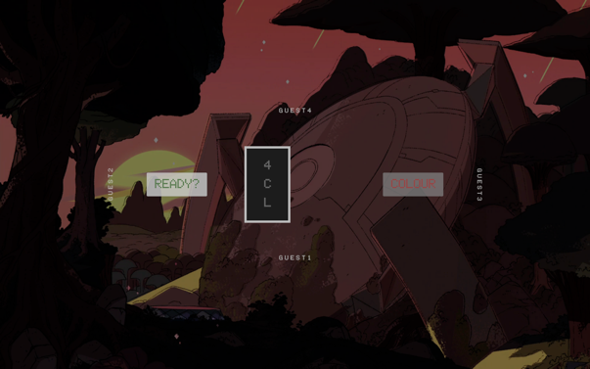 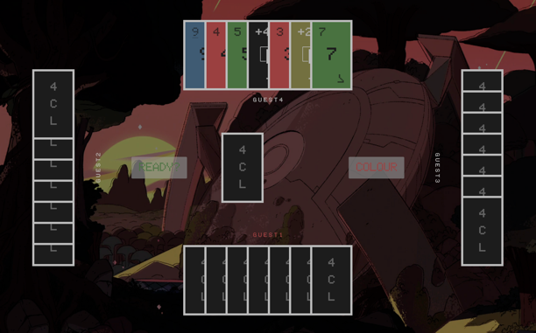

Test 23 (usability/function)

* Test type: normal
* Attempted input: display number card
* Status: failed but fixed - previous components displayed are not required when card updated, like the 8 being underlined (top left and bottom right of card)
* Purpose: ensure correct formatting for the card type so the user knows what card has been played to meet the stakeholder’s request of original UNO rules

 

* Remedial action: implement method in CardUI class to reset components and call when updating the card when already displayed

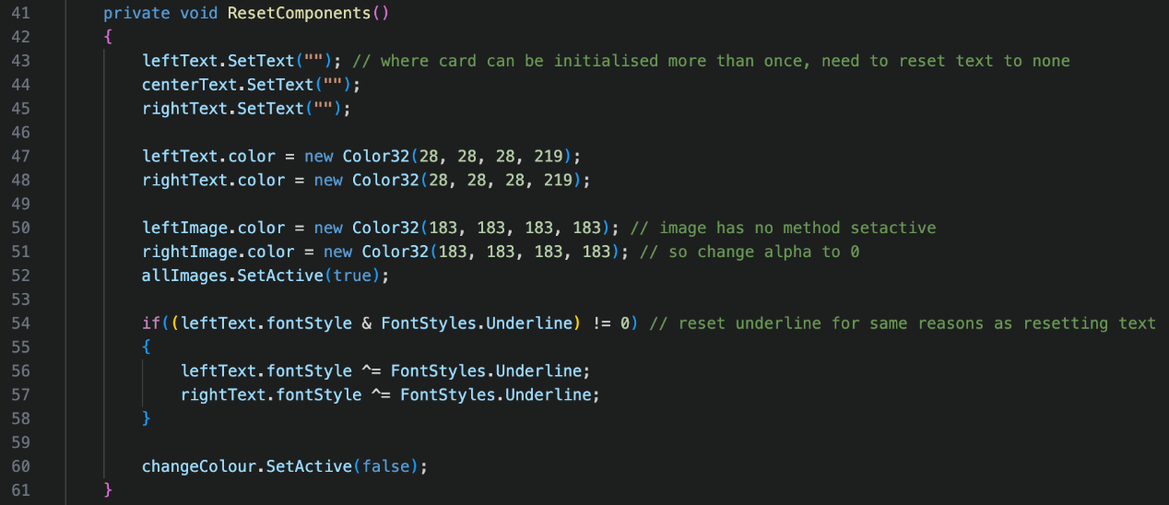

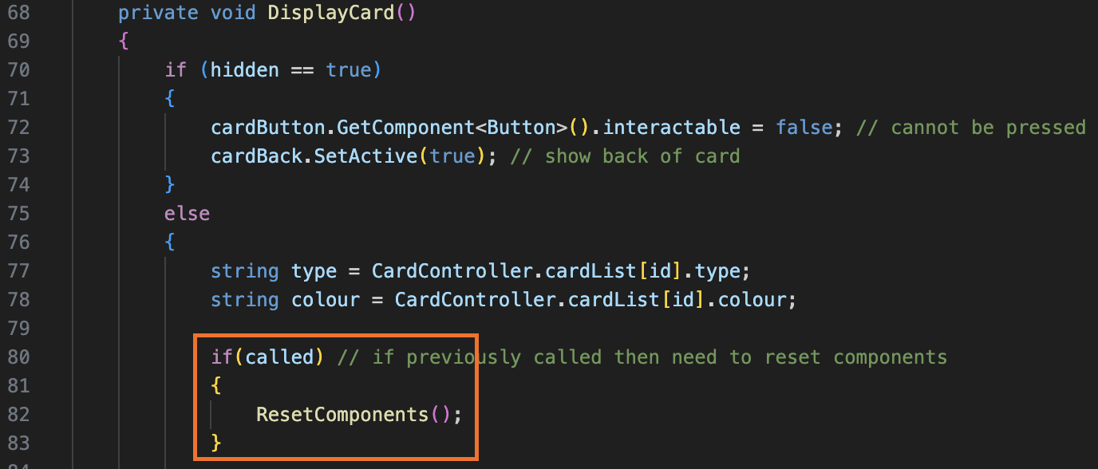

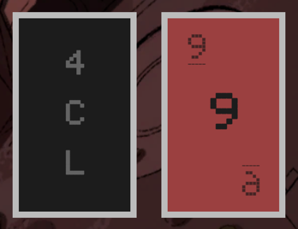 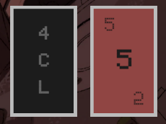

Test 24 (usability/function)

* Test type: normal
* Attempted input: display number card with underline
* Status: passed – card displayed correctly on play
* Purpose: ensure correct formatting for the card type so the user knows what card has been played to meet the stakeholder’s request of original UNO rules

 

Test 25 (usability/function)

* Test type: normal
* Attempted input: display miss a turn card
* Status: passed – card displayed correctly on play
* Purpose: ensure correct formatting for the card type so the user knows what card has been played to meet the stakeholder’s request of original UNO rules

 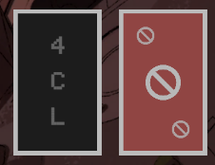

Test 26 (usability/function)

* Test type: normal
* Attempted input: display change direction card
* Status: passed – card displayed correctly on play
* Purpose: ensure correct formatting for the card type so the user knows what card has been played to meet the stakeholder’s request of original UNO rules

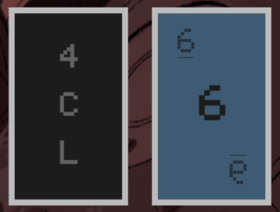 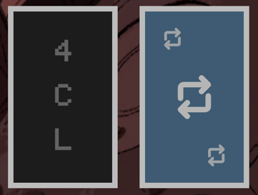

Test 27 (usability/function)

* Test type: normal
* Attempted input: display pickup 2 card
* Status: passed – card displayed correctly on play
* Purpose: ensure correct formatting for the card type so the user knows what card has been played to meet the stakeholder’s request of original UNO rules

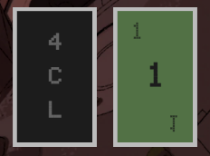 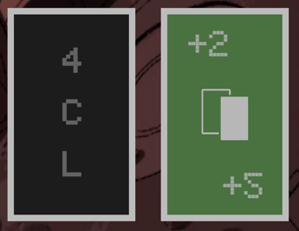

Test 28 (usability/function)

* Test type: normal
* Attempted input: display pickup 4 card
* Status: passed – card displayed correctly on play
* Purpose: ensure correct formatting for the card type so the user knows what card has been played to meet the stakeholder’s request of original UNO rules

 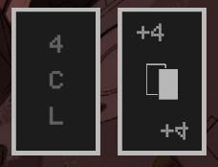

Test 29 (usability/function)

* Test type: normal
* Attempted input: display change colour card
* Status: passed – card displayed correctly on play
* Purpose: ensure correct formatting for the card type so the user knows what card has been played to meet the stakeholder’s request of original UNO rules

 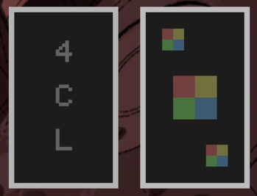

Test 30 (usability/function)

* Test type: normal
* Attempted input: play card
* Status: passed – card played and removed on all clients connected
* Purpose: check if card can be clicked to be played and removed and placed on other client’s games which allows for the players to know what’s happening in the game and is a main feature

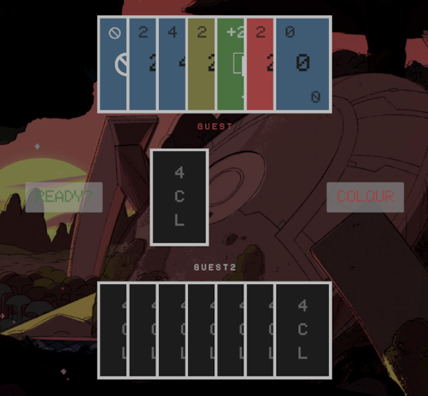 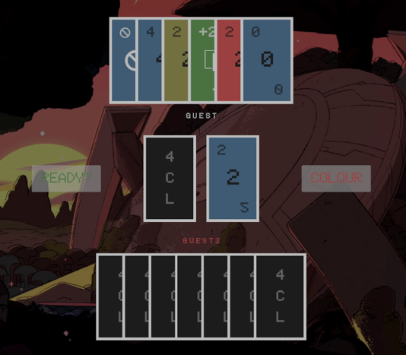

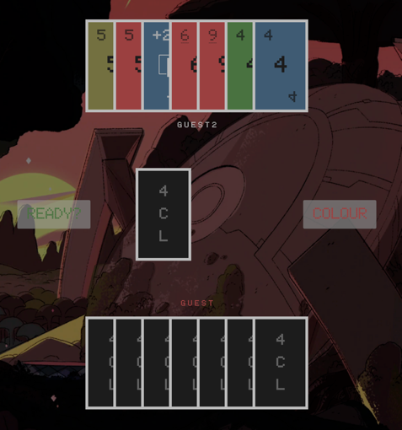 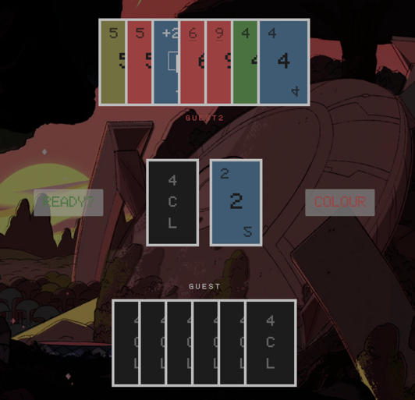

Test 31 (function)

* Test type: normal
* Attempted input: can play any card if no card has been previously played
* Status: passed – any card can be played
* Purpose: ensure cards can be played correctly for the stakeholder’s request of the original rules of UNO

 

Test 32 (function)

* Test type: normal
* Attempted input: can play card if matching colours
* Status: passed – any card can be played
* Purpose: ensure cards can be played correctly for the stakeholder’s request of the original rules of UNO

 

Test 33 (function)

* Test type: normal
* Attempted input: can play card if matching type
* Status: passed – any card can be played
* Purpose: ensure cards can be played correctly for the stakeholder’s request of the original rules of UNO

 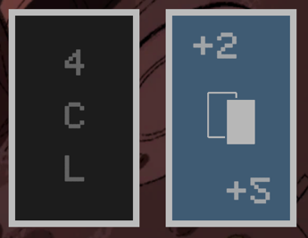

Test 34 (function)

* Test type: normal
* Attempted input: can play card wild card at any time
* Status: passed – any card can be played
* Purpose: ensure cards can be played correctly for the stakeholder’s request of the original rules of UNO

 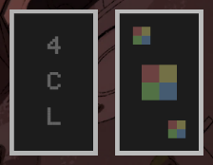

Test 35 (function)

* Test type: normal
* Attempted input: can play card if colour matches the wild colour
* Status: passed – any card can be played
* Purpose: ensure cards can be played correctly for the stakeholder’s request of the original rules of UNO

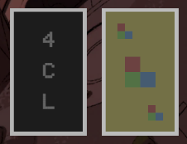 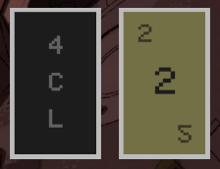

Test 36 (usability/robustness)

* Test type: erroneous
* Attempted input: can play card if it meets a criteria
* Status: passed – incorrect cards cannot be played
* Purpose: ensure cards can be played correctly for the stakeholder’s request of the original rules of UNO. If cards could be played that shouldn’t be able to, players would have unfair advantages

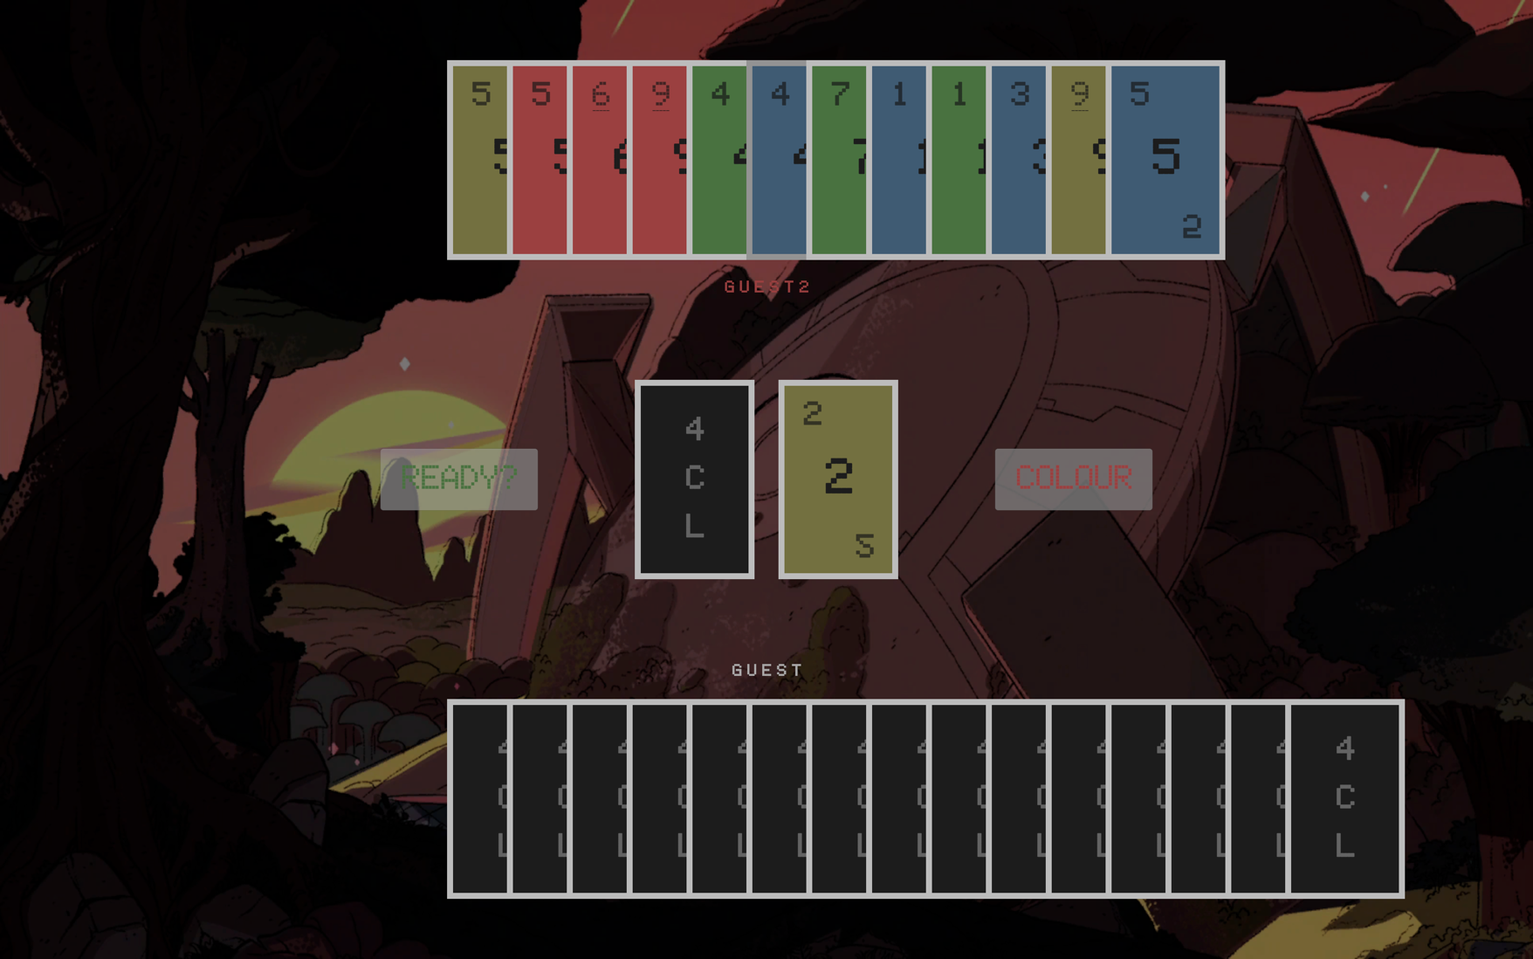 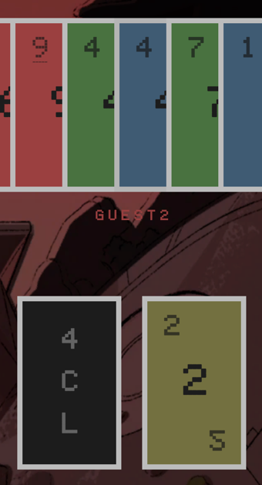

Test 37 (usability)

* Test type: normal
* Attempted input: play wild card and change colour
* Status: passed – wild colour changed on all clients
* Purpose: ensure the player knows what the colour has been changed to, so they know what cards they can play

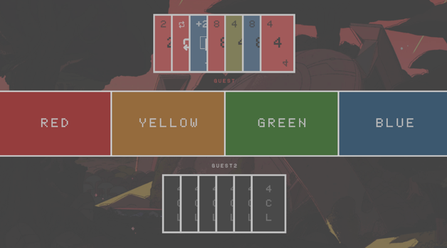 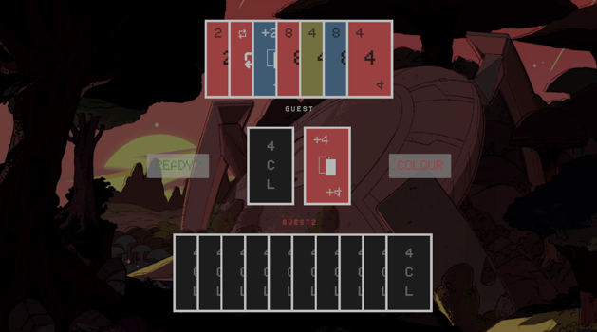

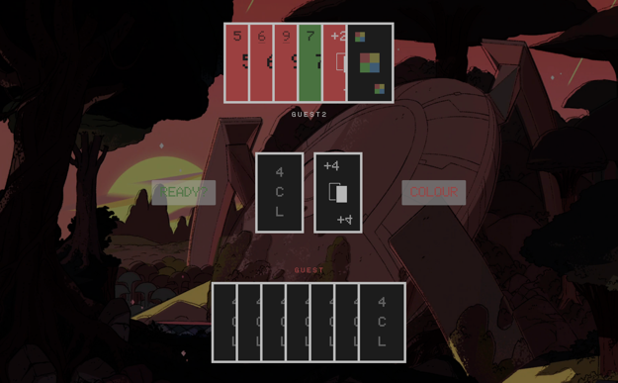 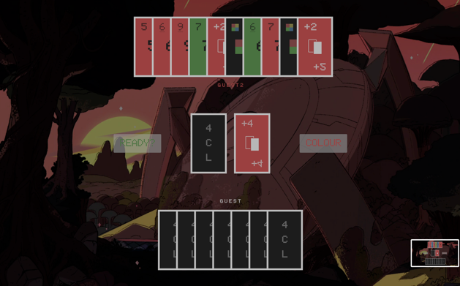

Test 38 (function)

* Test type: normal
* Attempted input: pick up a card from clicking centre-left 4CL card
* Status: failed but fixed – although cards are picked up successfully, there should only be 1 card added, and not 2
* Purpose: ability to pick up a card when the player cannot play any cards to complete their turn, just like the original rules of UNO for my stakeholder

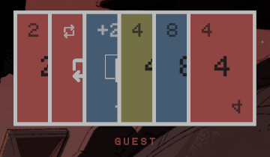 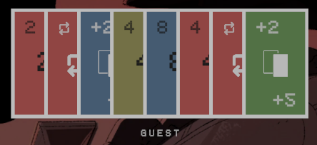

* Remedial action: where there were 2 players connected, and the card was being added inside the for loop, the number of cards added were equal to the player count. I moved the add card method outside of the for loop.





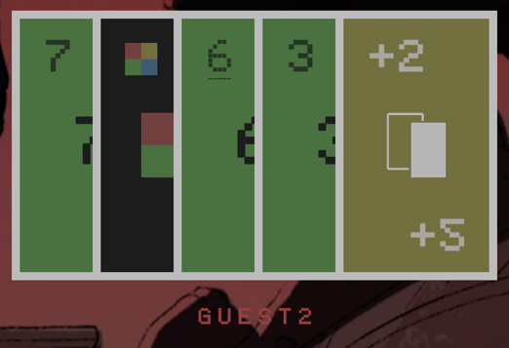 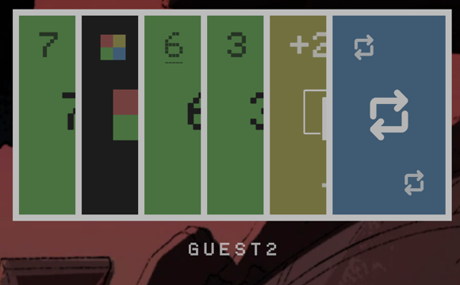

Test 39 (usability)

* Test type: normal
* Attempted input: toggle to false
* Status: passed
* Purpose: ensure button changes to false and message is passed to server, so the local client knows whether they have their colour status set

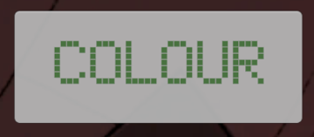 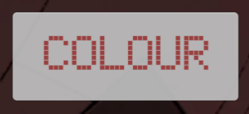

Test 40 (usability)

* Test type: normal
* Attempted input: toggle to true
* Status: passed
* Purpose: ensure button changes to true and message is passed to server, so the local client knows whether they have their colour status set

 

Test 41 (robustness/function)

* Test type: normal
* Attempted input: toggle colour to true on turn when playing last card
* Status: passed – the button is toggled, but they receive a late 2 card penalty
* Purpose: they must press the colour button before their turn to play their last card like the original rules of UNO for a fair game

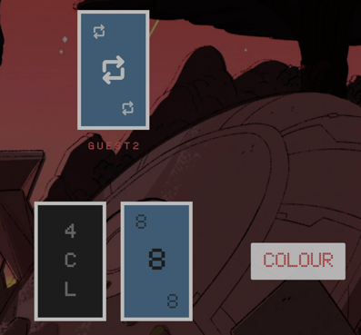 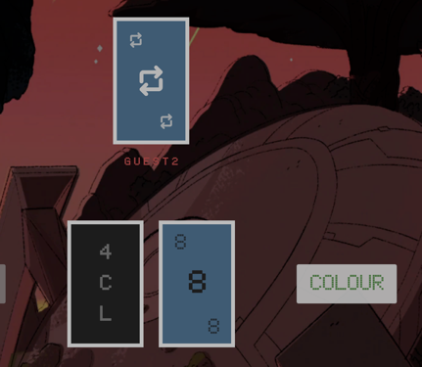 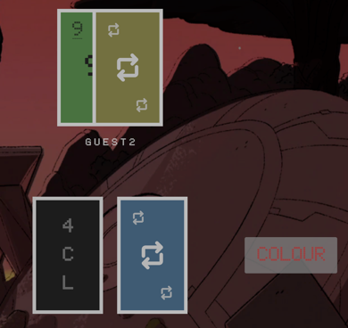

Test 42 (function)

* Test type: normal
* Attempted input: turn moves on after card is played
* Status: failed but fixed – turn could not move onto other players as they did not exist in the dictionary
* Purpose: turn should move on after card is played to the next player like in the original rules of UNO

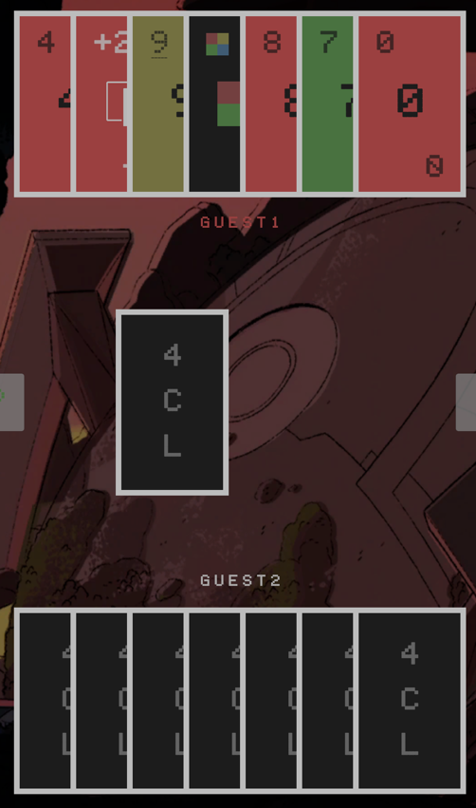 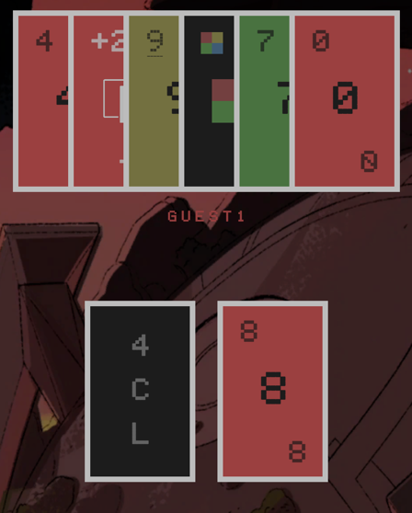



* Remedial action: when adjusting hand positions, I was removing the player from the dictionary. I thought I was accessing the dictionary by value, instead of reference. As a result, I was removing players from the main dictionary, instead of the copy I thought I was accessing





Test 43 (function)

* Test type: normal
* Attempted input: pick up a card to move the turn on
* Status: passed – the turn moves onto the next player
* Purpose: in the original rules of UNO, if you cannot play a card, you pick up a card to complete your turn

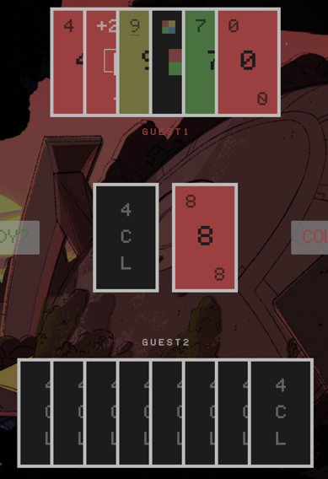 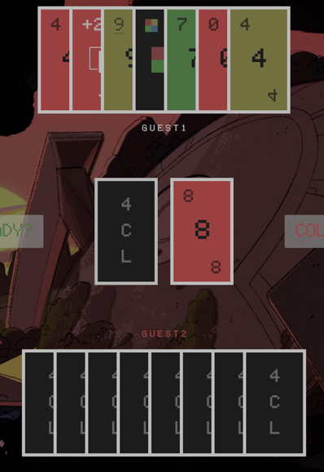

Test 44 (function)

* Test type: normal
* Attempted input: place a miss a turn card, so the next player does not play
* Status: passed – a turn is skipped
* Purpose: in the original rules of UNO, when a miss a turn card is placed, the next player misses their turn

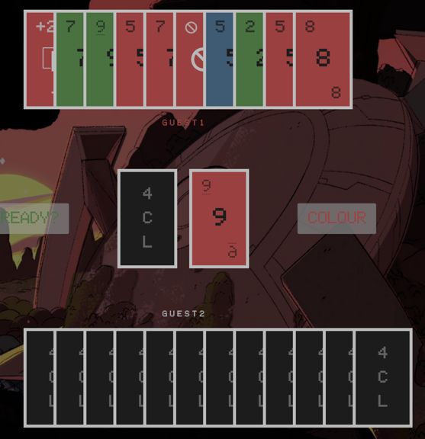 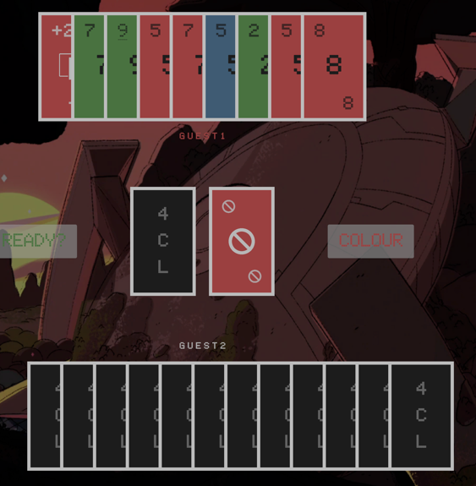

Test 45 (function)

* Test type: normal
* Attempted input: place a change direction card, so play reverses
* Status: passed – the play direction is switched
* Purpose: in the original rules of UNO, when a change direction card is placed, the play direction switches, and with 2 players, they get a second turn

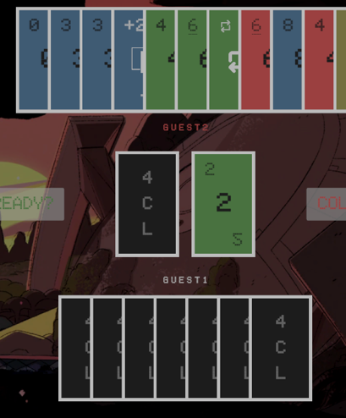 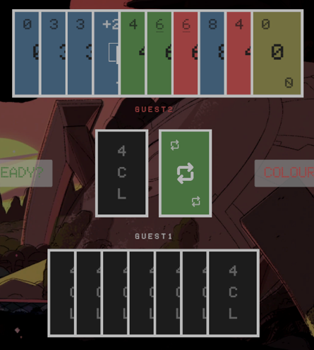

Test 46 (function)

* Test type: normal
* Attempted input: place a +2 card, so the next player picks up 2 cards
* Status: passed – the next player receives 2 cards
* Purpose: in the original rules of UNO, when a +2 card is placed, the next player must pick up 2 cards

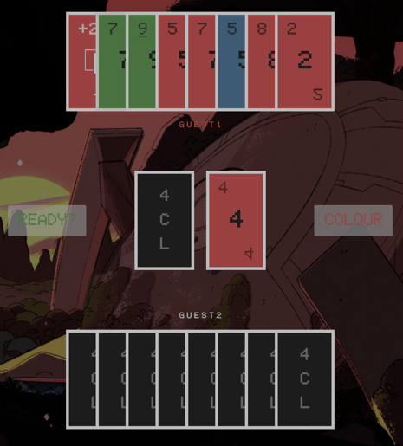 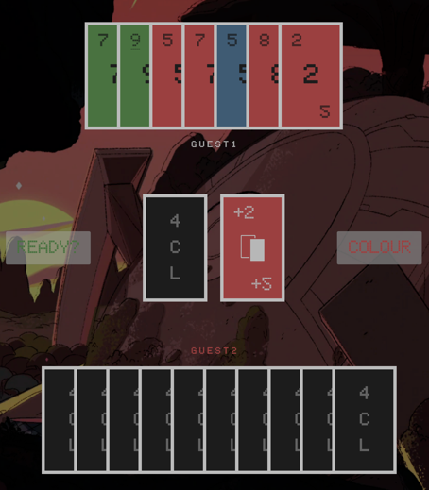

Test 47 (function)

* Test type: normal
* Attempted input: place a +4 card, so the next player picks up 4 cards
* Status: passed – the next player receives 4 cards
* Purpose: in the original rules of UNO, when a +4 card is placed, the next player must pick up 4 cards and the card player chooses the colour

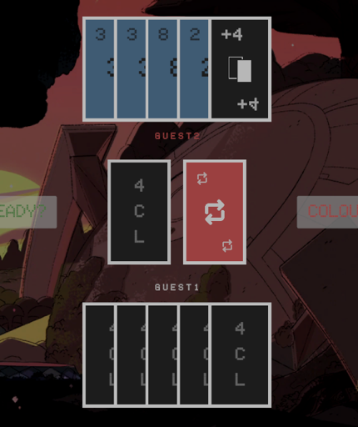 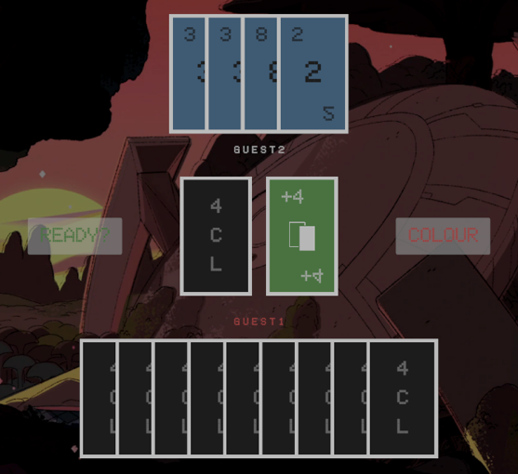

Test 48 (usability)

* Test type: normal
* Attempted input: disconnect player to adjust hand positions
* Status: failed but fixed – the hand positions did not update correctly, and the turn moved on to the next player, even if it wasn’t their turn
* Purpose: for a clear game flow, the disconnected players are removed, and their cards are returned into the deck

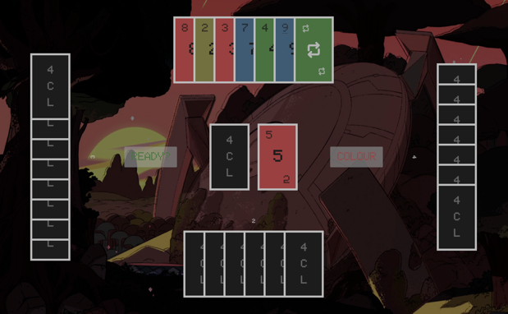 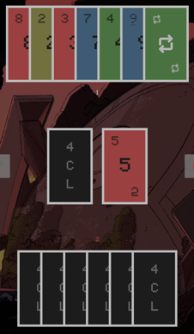

* Remedial action: on the server, I was always calling the next turn. However, it should only be called if it was their turn

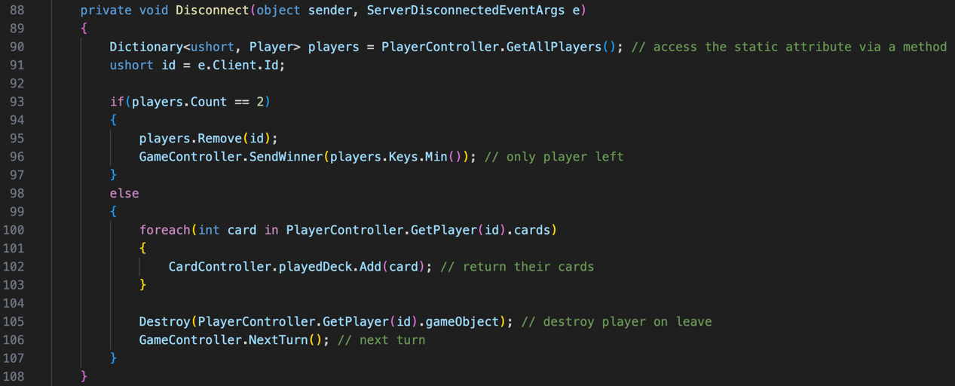

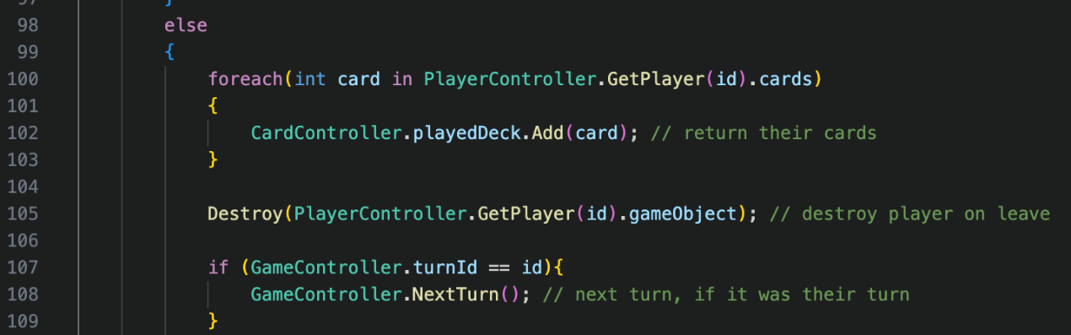

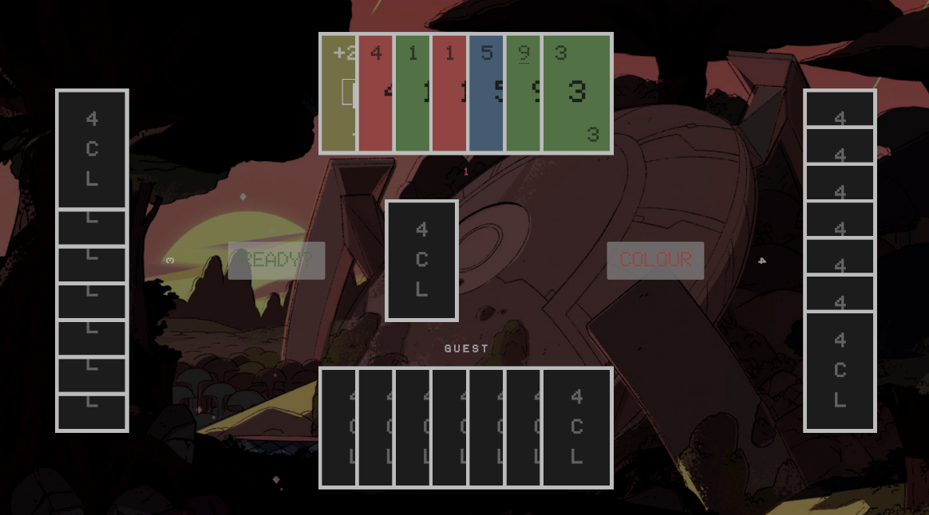

* Remedial action: the turn now stayed on the correct player when another play disconnected, but their hand was not removed still. I realised I was not checking for when the player count was greater than 2 but not equal to 4.

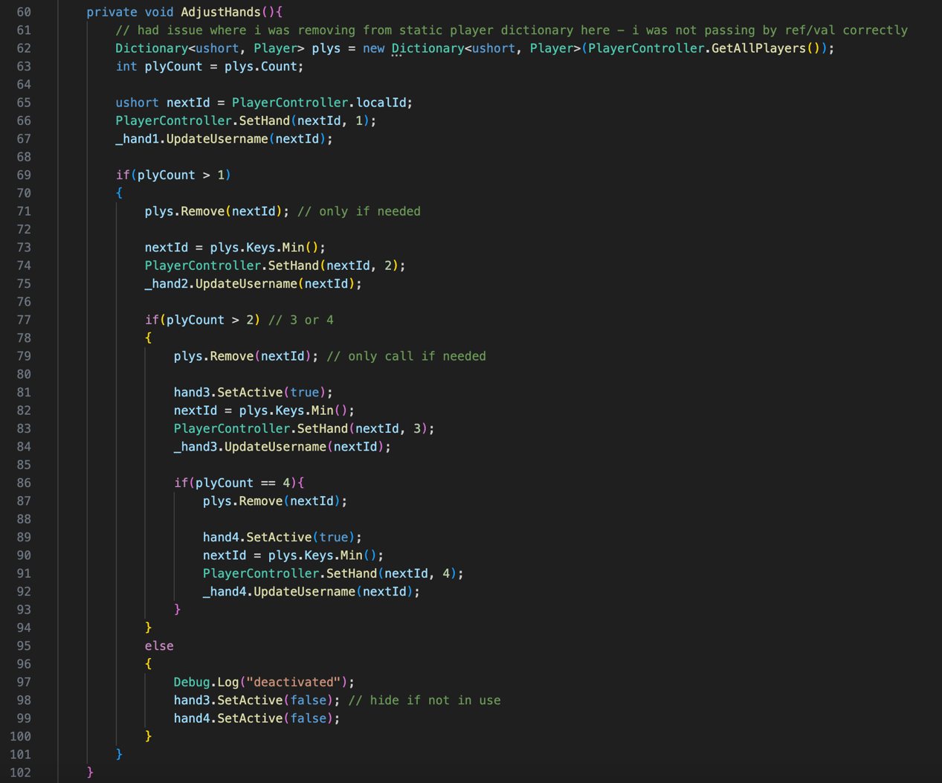

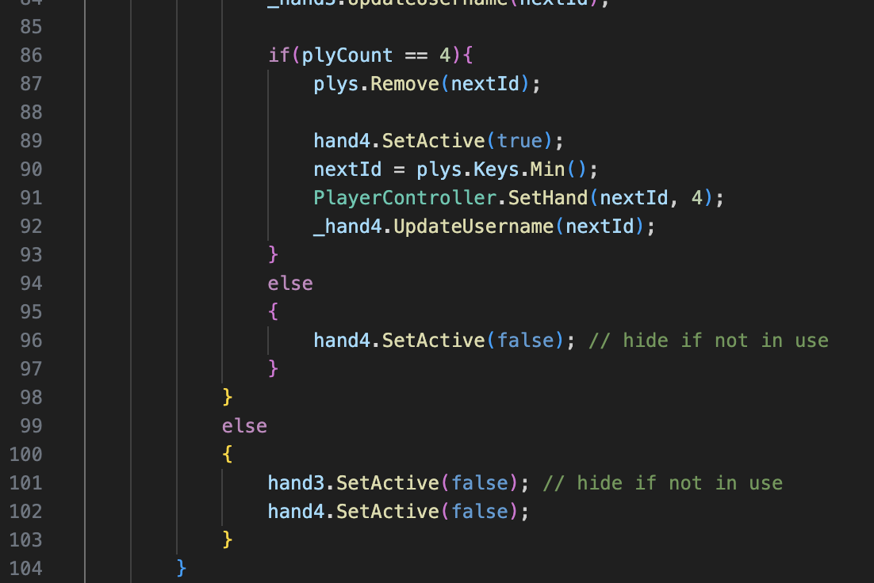

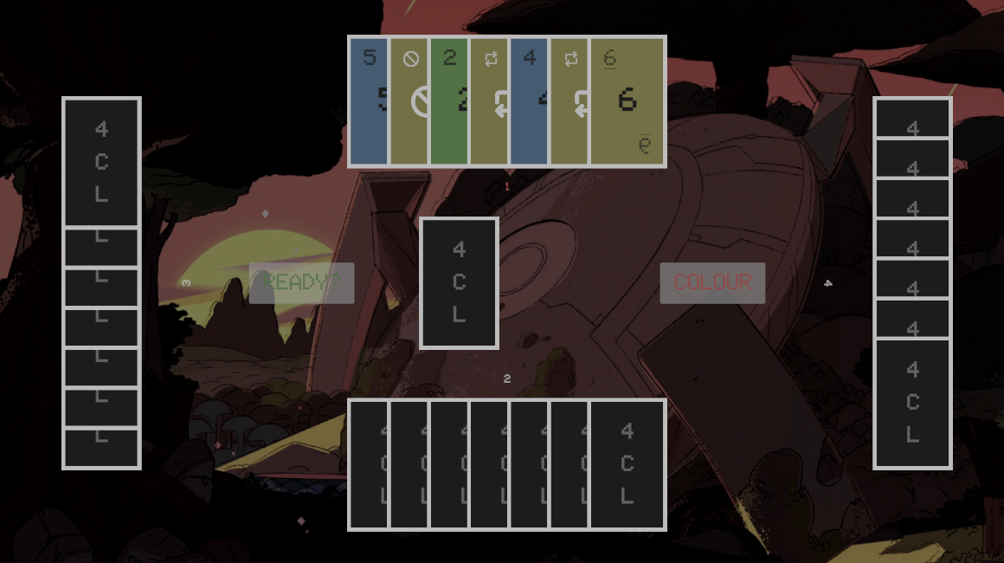

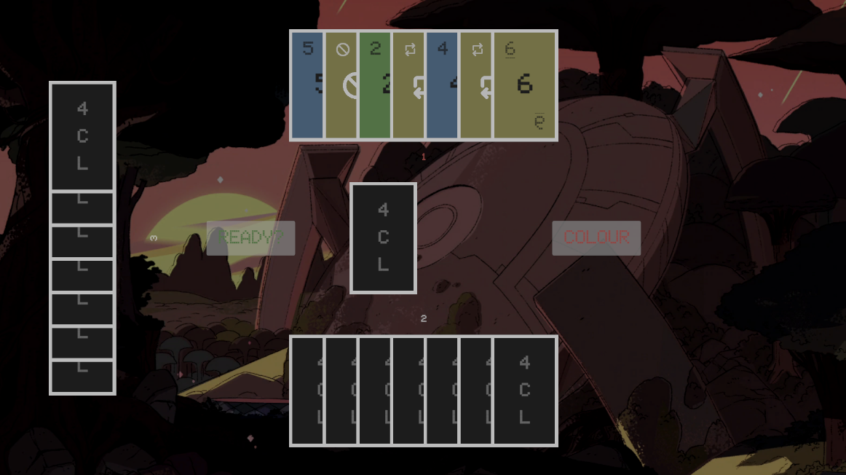

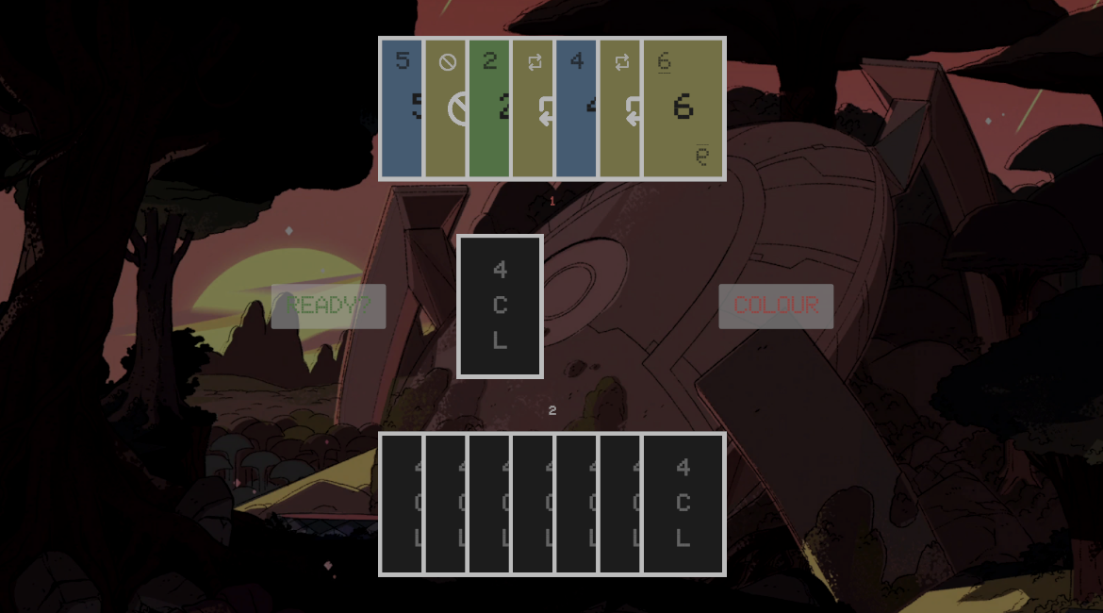

Test 49 (function)

* Test type: normal
* Attempted input: disconnect last player to display win screen
* Status: passed – the win screen displays on last player disconnection
* Purpose: the player must know who has won the game

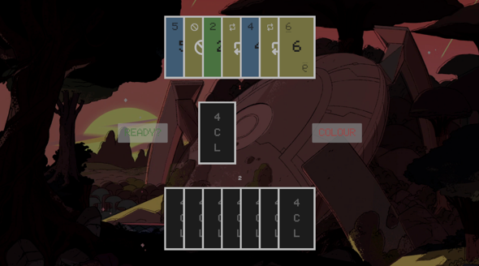 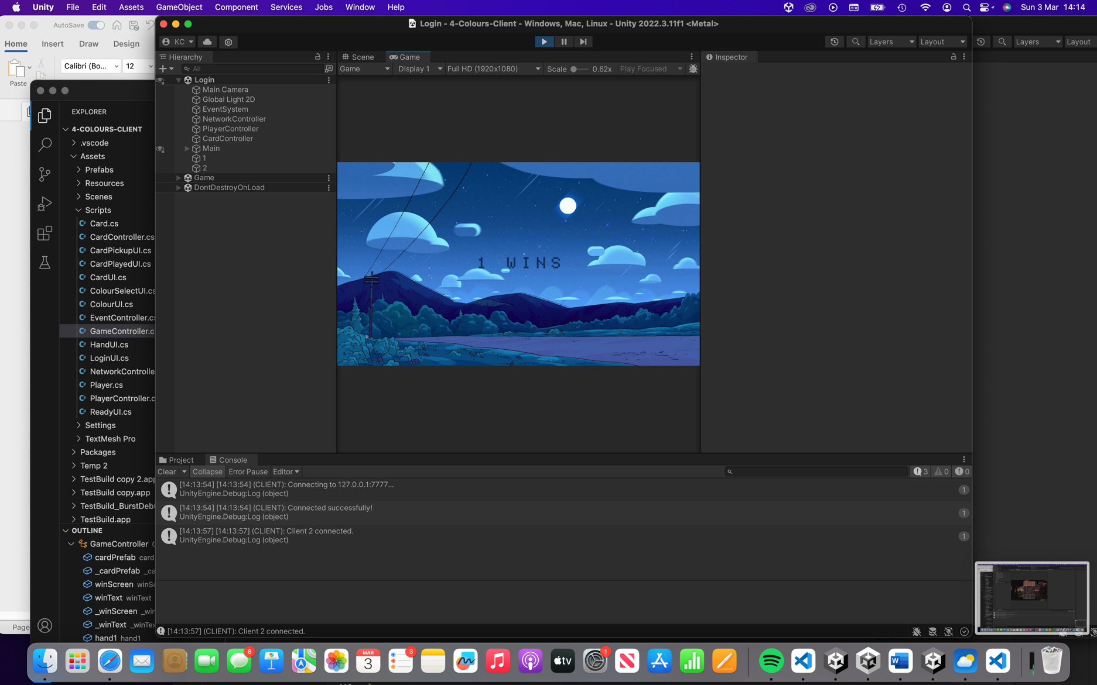

Test 50 (function/usability)

* Test type: normal
* Attempted input: play last card with colour button pressed to win
* Status: passed – the win screen displays when last card is played correctly
* Purpose: the players must know who has won the game to match the rules of UNO for the stakeholder

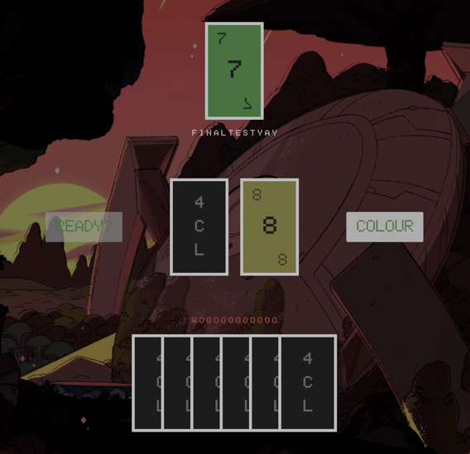 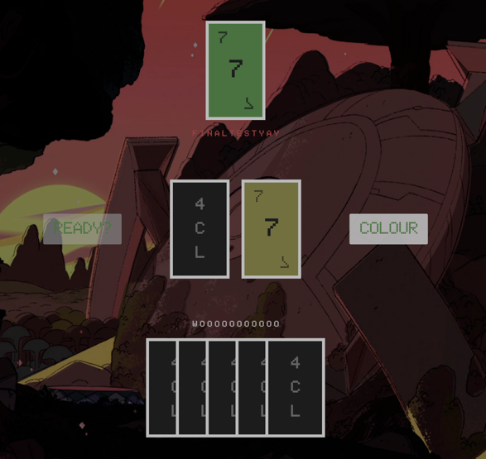



## Success Criteria 6 – Tutorial

The aim of this criterion was to provide a simple tutorial system that tells the user how to play the game. Additionally, this could have been extended into a playable tutorial. Unfortunately, I did not have enough time to complete a simple tutorial, let alone a playable tutorial. However, the rules of UNO are well known, and can easily be explain by Mr Dorrell in a video for his fans if they do not understand. In the future, this problem can be solved by adding a button on the Login scene to take the player to a Tutorial scene. The existing CardUI class can be used to display the cards, and extra information can be written about the game using text mesh pro elements. This would allow fans to have a good visual expiation of the game for usability.

## Maintenance

I think it’s unlikely that there will be many issues faced for maintenance, as the game has been made modularly to switch out and add features and has been well-programmed. However, I have identified some points that may become issues.

1. **External Libraries -** Within my game, I rely on a lot of external libraries. Although most of them are maintained by large corporations, Riptide is not. Riptide is made by a small developer named Tom Weiland. He recently announced that although he will not be adding any additional features to the library, he will still be completing bug and security fixes when appropriate. However, one day he may stop completing bug fixes if he abandons the project. If this happens, it will be unsupported, and may not be updated to support newer versions of Unity. This could impact the stakeholder, as the game may no longer be supported, and could encounter issues such as crashing. To reduce workload of maintenance, the library could be changed to a maintained one.
2. **Unity Version -** The game is built on Unity version 2022.3.11f1 which was the most up to date build at the time of starting development. Unity often releases new updates which include security fixes. If the game could not be updated to newer versions with the required libraries, it may leave security vulnerabilities for Mr Dorrell and his fans. To reduce workload, the reliance on external libraries could be removed, or switched to highly maintained libraries, which was made in point 1. This should be monitored ideally to prevent security breaches.
3. **UNO Rules -** Although unlikely to, the rules of UNO may change, or the rules Mr Dorrell and his fans would like may change. As the program is modular, it would be fairly easy to update the rules in future versions. To reduce workload, they could just keep the original rules as per the stakeholder’s request. However, if they did wish to change the rules to suit different versions of games, it would require a change of the tutorial system too if it was added. Throughout the programme, there is well commented code, and appropriate sub-routine and variable names. There shouldn’t be many issues understanding and contributing to the code as a result.

## Limitations

1. **Hosting -** For one server, there can only be 4 players connected currently. This is a small amount for the number of fans Mr Dorrell has. There are 2 options for Mr Dorrell. The current option is to have multiple servers and restart the server each time a game is completed. The ideal option is to introduce a room system, so players connect to a room, instead of a server. Each room would have a maximum of 4 players, instead of the server having a maximum of 4 players. This would mean Mr Dorrell would not have to host so many servers and save some money on hosting.
2. **Internet -** The next limitation is that the game requires internet. As there is currently no single player mode, the only mode available is the online multiplayer. For the online multiplayer, you need to connect to the server to receive and send data about other players. This may restrict the number of fans who can play the game, as not everyone may have access to internet access, or internet access at all times. Mr Dorrell may enjoy playing the game by himself without his fans occasionally.
3. **Statistics -** As there is no account creation feature yet, and simply a username input system, there is no way to save statistics for users. The username system allows for easy usability as they do not need to create an account to start playing and is simple to understand. By introducing accounts, each account could be assigned a unique ID. This ID would allow for statics such as games won and games played to be stored into a database, as planned in my design.

## Conclusion

I successfully analysed and designed my projected. However, when it came to development, the reality of time constraints came into play. I realised that I would not have enough time to implement my additional objectives and write them into my project log. I felt it would be better for my stakeholder to produce higher quality system, rather than rush for quantity as these can always be implemented into the modular program in the future. I successfully carried out unit tests and integration tests during development, and post development. Combing all factors, I completed all major aspects of my success criteria. In conclusion, Mr Dorrell and I believe the project to be a success.

# Appendix

Sorted into server and client files in alphabetical order.

## Server

**Card.cs**

[System.Serializable] // allows for multiple classes with the same name

public class Card

{

public int id { get; private set; } // encapsulation

public string type { get; private set; }

public string colour { get; private set; }

public Card(int Id, string Type, string Colour) // constructor, same name as class as serialized

{

id = Id;

type = Type;

colour = Colour;

}

}

**CardController.cs**

using System.Collections.Generic;

using UnityEngine;

using Riptide;

public class CardController : MonoBehaviour

{

public static List<Card> cardList = new List<Card>(); // all the cards available

// pickup deck can just be a list of ids that link to cardList, no need to copy all data, shuffle ids into it

public static List<int> pickupDeck = new List<int>(); // cards in the deck to be picked up

public static List<int> playedDeck = new List<int>(); // cards in the deck that have been played

public static int cardIdPlayed = -1; // cannot be 0 as 0 is a card id

public static string wildColour; // colour that has been set by a wild card

private void Awake()

{

ColourSet("R"); // red set

ColourSet("Y"); // yellow set

ColourSet("G"); // green set

ColourSet("B"); // blue set

pickupDeck.Clear(); // full of zeros due to being a set size (via unity editor)

playedDeck.Clear();

foreach(Card card in cardList)

{

pickupDeck.Add(card.id);

}

}

private void Start()

{

ShuffleList(pickupDeck); // cannot have in awake, shuffles before cards added to pickup

}

private static void ShuffleList<T>(List<T> list) // Fisher-Yates algorithm

{

System.Random rng = new System.Random(); // differentiate from unity random

int n = list.Count;

while (n > 1) // iterate through the list in reverse order

{

n--;

int k = rng.Next(n + 1); // generate a random index between 0 and n

// Swap the elements at indices k and n

T value = list[k];

list[k] = list[n];

list[n] = value;

}

}

private void ColourSet(string colour)

{

cardList.Add(new Card(cardList.Count, "0", colour)); // 0 card

for(int count = 1; count <= 2; count++) // x2 sets of 1-9 cards

{

for(int type = 1; type <= 9; type++)

{

cardList.Add(new Card(cardList.Count, type.ToString(), colour));

}

cardList.Add(new Card(cardList.Count, "MT", colour)); // miss turn card

cardList.Add(new Card(cardList.Count, "CD", colour)); // change direction card

cardList.Add(new Card(cardList.Count, "P2", colour)); // pickup 2 card

}

cardList.Add(new Card(cardList.Count, "CC", "W")); // change colour card

cardList.Add(new Card(cardList.Count, "P4", "W")); // pickup 4 card

}

public static void AddCard(ushort id){

if(pickupDeck.Count > 0)

{

int cardId;

cardId = pickupDeck[0]; // get 1st card from shuffled deck

pickupDeck.Remove(cardId);

PlayerController.AddCard(id, cardId);

}

else // if no cards left, add cards back and reshuffle

{

pickupDeck = playedDeck;

ShuffleList(pickupDeck);

AddCard(id); // retry

}

}

public static bool CanPlayCard(int requestId)

{

if((cardIdPlayed == -1 || // no card played yet, goes first as -1 is not an id

(cardList[requestId].colour == cardList[cardIdPlayed].colour) || // same colours

cardList[requestId].type == cardList[cardIdPlayed].type) || // same types

cardList[requestId].colour == "W" || // wild can be played on any card

(cardList[cardIdPlayed].colour == "W" && // if wild card been played

cardList[requestId].colour == wildColour)) // and cardplayed colour is equal to the wild set

{

return true;

}

return false; // no need for else as it would return true before

}

private static void SendColourChange(ushort id, string colour)

{

Dictionary<ushort, Player> players = PlayerController.GetAllPlayers(); // access the static attribute via a method

foreach(KeyValuePair<ushort, Player> ply in players)

{

if(id == ply.Key) // do not send to the client who sent it

{

continue;

}

Message msg = Message.Create(MessageSendMode.Reliable, ServerToClient.SendColourChange);

msg.AddString(colour);

EventController.Send(msg, ply.Key);

}

}

[MessageHandler((ushort)ClientToServer.RequestColourChange)] // colour change request from client

private static void SetColourChange(ushort id, Message msg)

{

if(GameController.turnId == id) // no need to check if W card played as val only checked if W card played

{

string colour = msg.GetString();

wildColour = colour;

SendColourChange(id, colour); // cannot send message in message handler

GameController.NextTurn();

}

}

}

**EventController.cs**

using UnityEngine.Events;

using Riptide;

public static class EventController

{

public static event UnityAction<Message> SendMessageToAll; // send message to all event

public static void Send(Message msg) => SendMessageToAll?.Invoke(msg); // when send is called, invoke all subscribers

public static event UnityAction<Message, ushort> SendMessageToPlayer; // send message to specific player

public static void Send(Message msg, ushort id) => SendMessageToPlayer?.Invoke(msg, id);

public static event UnityAction StopServer; // stop the server

public static void Stop() => StopServer?.Invoke();

}

**GameController.cs**

using System.Collections.Generic;

using System.Linq;

using UnityEngine;

using Riptide;

public class GameController : MonoBehaviour

{

public static ushort turnId = 0;

public static int playDirection = 1;

public static bool missTurn = false;

public static int cardDebt = 0;

public static bool gameStarted = false;

private void Start()

{

InvokeRepeating("CheckReadyStatus", 1.0f, 5.0f); // starting after 1 second, repeating every 5 seconds, time factor f

}

private void CheckReadyStatus()

{

Dictionary<ushort, Player> players = PlayerController.GetAllPlayers(); // access the static attribute via a method

if(players.Count > 1) // can't play with 1 player

{

bool allReady = true; // flag variable

foreach(KeyValuePair<ushort, Player> ply in players)

{

if(ply.Value.ready == false)

{

allReady = false; // flag that a player is not ready

return; // so no point continuing anything (had a break here originally)

}

}

if(allReady)

{

gameStarted = true;

Message msg = Message.Create(MessageSendMode.Reliable, ServerToClient.SendGameBegun);

EventController.Send(msg);

CancelInvoke("CheckReadyStatus"); // cancel the ready status check as game has started

foreach(KeyValuePair<ushort, Player> ply in players)

{

for(int count = 0; count <= 6; count++) // give starting 7 cards to each player

{

CardController.AddCard(ply.Key);

}

}

// had in next turn originally, checking if turnid==0 in if statement etc. (checking every call)

turnId = (ushort)players.Keys.Min(); // client 1 may leave, player key now starts at 2 etc.

SendNextTurn();

}

}

}

private static void SendNextTurn()

{

Message msg = Message.Create(MessageSendMode.Reliable, ServerToClient.SendTurnId);

msg.AddUShort(turnId);

EventController.Send(msg);

}

private static void CheckCardDebt() // check to see if cards need to be added

{

if(cardDebt > 0)

{

for(int i = 0; i < cardDebt; i++)

{

CardController.AddCard(turnId);

}

cardDebt = 0;

}

}

public static void NextTurn()

{

Dictionary<ushort, Player> players = PlayerController.GetAllPlayers(); // access the static attribute via a method

int maxKey = players.Keys.Max();

int minKey = players.Keys.Min();

bool flag = false; // flag variable

bool microFlag = false; // flag variable

int nextId;

while(flag == false)

{

nextId = (int)turnId + playDirection; // turn+1 clockwise, turn+-1=turn-1 anticlockwise

var ply = PlayerController.GetPlayer((ushort)nextId);

if(ply)

{

turnId = (ushort)nextId;

microFlag = true;

}

else if(nextId > maxKey && playDirection == 1) // max key means go back to min (clockwise)

{

turnId = (ushort)minKey;

microFlag = true;

}

else if(nextId < minKey && playDirection == -1) // and vise versa for anticlockwise

{

turnId = (ushort)maxKey;

microFlag = true;

}

if(microFlag) // saves repeating code in each if statement

{

if(missTurn){

missTurn = false;

continue; // go to next player

}

CheckCardDebt();

flag = true;

}

}

SendNextTurn();

}

public static void SendWinner(ushort id)

{

Message msg = Message.Create(MessageSendMode.Reliable, ServerToClient.SendWinner);

msg.AddUShort(id);

EventController.Send(msg);

EventController.Stop(); // you would restart server here

}

// Messages

[MessageHandler((ushort)ClientToServer.RequestStatusChange)] // ready status request netmessage from client

private static void ReceiveStatusChange(ushort id, Message msg)

{

bool status = msg.GetBool();

Player ply = PlayerController.GetPlayer(id);

ply.ready = status;

}

[MessageHandler((ushort)ClientToServer.RequestCardPlay)] // play card netmessage from client

private static void ReceiveCardPlay(ushort id, Message msg)

{

if(turnId == id){

int cardId = msg.GetInt();

if(PlayerController.HasCard(id, cardId))

{

if(CardController.CanPlayCard(cardId))

{

Player ply = PlayerController.GetPlayer(id);

int cardCount = ply.cards.Count;

CardController.cardIdPlayed = cardId;

PlayerController.RemoveCard(id, cardId);

Card card = CardController.cardList[cardId];

if(card.colour != "W") // nextturn is called upon colour change submital for wild cards

{

if(card.type == "MT")

{

missTurn = true;

NextTurn();

}

else if(card.type == "CD")

{

playDirection *= -1; // 1*-1 = clockwise to anticlockwise, -1*-1 = anticlockwise to clockwise

// no point storing as a varialbe in only used once

if(PlayerController.GetAllPlayers().Count == 2)

{

SendNextTurn(); // do not change and send the turnid again

return;

}

}

else if(card.type == "P2")

{

cardDebt = 2;

NextTurn();

}

else

{

NextTurn();

}

}

if(card.type == "P4")

{

cardDebt = 4;

}

if(cardCount == 2) // higher as counted before card removed (1 cards left)

{

ply.canColour = true;

}

if(cardCount == 1) // same reason as above (0 cards left)

{

if(ply.colour)

{

SendWinner(id);

}

else

{

ply.canColour = false;

CardController.AddCard(id);

CardController.AddCard(id);

}

}

}

}

}

}

[MessageHandler((ushort)ClientToServer.RequestCardPickup)] // request to pickup card netmessage from client

private static void ReceiveCardPickup(ushort id, Message msg)

{

if(turnId == id) // check its their turn to pickup a card

{

CardController.AddCard(id); // give them a card

NextTurn(); // don't let them play a card

}

}

[MessageHandler((ushort)ClientToServer.RequestColourStatus)] // colour status request netmessage from client

private static void ReceiveColourStatus(ushort id, Message msg)

{

Player ply = PlayerController.GetPlayer(id);

if(ply.canColour &&

(turnId != id ||

CardController.cardList[CardController.cardIdPlayed].type == "MT" ||

CardController.cardList[CardController.cardIdPlayed].type == "CD") &&

ply.cards.Count == 1)

{

bool status = msg.GetBool();

ply.colour = status;

}

}

}

**NetworkController.cs**

using UnityEngine;

using System.Collections.Generic;

using Riptide;

using Riptide.Utils;

using System.Linq;

// enum gives each string a numerical value that is converted for simplicity

public enum ServerToClient : ushort // server to client netmessages

{

SendConnectedPlayers,

SendNewPlayer,

SendDisconnectedPlayer,

SendAddedCard,

SendAddedBlankCard,

SendGameBegun,

SendTurnId,

SendCardPlayed,

SendColourChange,

SendWinner

}

public enum ClientToServer : ushort // client to server netmessages

{

RequestConnectedPlayers,

RequestStatusChange,

RequestCardPlay,

RequestColourChange,

RequestCardPickup,

RequestColourStatus,

}

public class NetworkController : MonoBehaviour

{

public Server server { get; private set; }

private void Awake()

{

RiptideLogger.Initialize(Debug.Log, Debug.Log, Debug.LogWarning, Debug.LogError, true); // init riptide

}

private void Start()

{

server = new Server();

server.Start(7777, 4); // port 7777 with maxplayers 4

Subscribe();

}

private void OnDestroy() // unsubscribe from events on destroy

{

Unsubscribe();

}

private void FixedUpdate() // handles delayed envents that need to be invoked

{

server.Update();

}

private void Subscribe()

{

server.ClientDisconnected += Disconnect;

server.HandleConnection += ConnectionHandler;

EventController.SendMessageToPlayer += SendToPlayer;

EventController.SendMessageToAll += SendToAll;

EventController.StopServer += Stop;

}

private void Unsubscribe()

{

server.ClientDisconnected -= Disconnect;

server.HandleConnection -= ConnectionHandler;

EventController.SendMessageToPlayer -= SendToPlayer;

EventController.SendMessageToAll -= SendToAll;

EventController.StopServer -= Stop;

}

private void ConnectionHandler(Connection conn, Message message)

{

if(GameController.gameStarted) // if game started then refuse connection

{

server.Reject(conn);

return;

}

server.Accept(conn);

}

private void Disconnect(object sender, ServerDisconnectedEventArgs e)

{

Dictionary<ushort, Player> players = PlayerController.GetAllPlayers(); // access the static attribute via a method

ushort id = e.Client.Id;

if(players.Count == 2)

{

players.Remove(id);

GameController.SendWinner(players.Keys.Min()); // only player left

}

else

{

foreach(int card in PlayerController.GetPlayer(id).cards)

{

CardController.playedDeck.Add(card); // return their cards

}

Destroy(PlayerController.GetPlayer(id).gameObject); // destroy player on leave

if (GameController.turnId == id){

GameController.NextTurn(); // next turn, if it was their turn

}

}

}

// NTS: https://medium.com/@javatechie/how-to-kill-the-process-currently-using-a-port-on-localhost-in-windows-31ccdea2a3ea

private void Stop()

{

server.Stop();

}

private void SendToPlayer(Message msg, ushort id) // send message to player with specific id

{

server.Send(msg, id);

}

private void SendToAll(Message msg) // send message to all players

{

server.SendToAll(msg);

}

}

**Player.cs**

using UnityEngine;

using System.Collections.Generic;

public class Player : MonoBehaviour // inherits MonoBehaviour

{

public ushort id { get; private set; } // id property to make use of encapsulation

public string username { get; private set; } // username property

public bool ready { get; set; } // public set to be changed by message handlers

public bool colour { get; set; } // public set to be changed by message handlers

public bool canColour { get; set; }

public List<int> cards = new List<int>();

public void Init(ushort Id, string Username) // seperate constructor method to allow for an object

{

id = Id;

username = Username;

ready = false;

colour = false;

canColour = true;

}

private void OnDestroy() // remove player if behaviour is destroyed

{

PlayerController.RemovePlayer(id);

}

}

**PlayerController.cs**

using System.Collections.Generic;

using UnityEngine;

using Riptide;

public class PlayerController : MonoBehaviour // inherits MonoBehaviour

{

[SerializeField] private GameObject playerPrefab;

private static GameObject staticPlayerPrefab; // only statics can access statics :(

[SerializeField] private static Dictionary<ushort, Player> players = new Dictionary<ushort, Player>();

private void Awake()

{

staticPlayerPrefab = playerPrefab; // cannot set an instance variables to eachother in initialization

}

public static Player GetPlayer(ushort id) // check if player exists in players

{

players.TryGetValue(id, out Player result);

return result;

}

public static Dictionary<ushort, Player> GetAllPlayers() // get all in players

{

return players;

}

public static void RemovePlayer(ushort id) // remove player from players if exists

{

if (players.TryGetValue(id, out Player result))

{

players.Remove(id);

Message msg = Message.Create(MessageSendMode.Reliable, ServerToClient.SendDisconnectedPlayer);

msg.AddUShort(id);

EventController.Send(msg);

}

}

private static void AddPlayer(ushort id, string username)

{

Player player = Instantiate(staticPlayerPrefab, Vector3.zero, Quaternion.identity).GetComponent<Player>(); // create game object

player.name = $"{id}"; // set display name of game object

player.Init(id, username);

players.Add(id, player);

}

// Messages

private static void SendConnectedPlayers(ushort id)

{

// reliable send mode to ensure the message is sent (TCP instead of UDP)

Message msg = Message.Create(MessageSendMode.Reliable, ServerToClient.SendConnectedPlayers);

int plyCount = players.Count;

msg.AddInt(plyCount);

// had a problem here where I forgot plycount is before added, I had set to 1 when should be 0

if(plyCount != 0) // this is the only player, do not add again

{

foreach (KeyValuePair<ushort, Player> ply in players)

{

if(id == ply.Key) // do not resend the same player

{

continue;

}

msg.AddUShort(ply.Key); // player id

msg.AddString(ply.Value.username); // player username

}

}

EventController.Send(msg, id); // send netmessage to the player requesting login

}

private static void SendNewPlayer(ushort id, string username){

foreach (KeyValuePair<ushort, Player> ply in players)

{

if(id == ply.Key) // do not send player player to the player

{

continue;

}

Message msg = Message.Create(MessageSendMode.Reliable, ServerToClient.SendNewPlayer);

msg.AddUShort(id);

msg.AddString(username);

EventController.Send(msg, ply.Key);

}

}

public static void AddCard(ushort id, int cardId){

players[id].cards.Add(cardId); // issue where I had inside of for loop, and card count was *playercount higher than should be

// could have sent as 1 netmessage and sent either the actual cardid or -1 to correct players

foreach (KeyValuePair<ushort, Player> ply in players){

if(id == ply.Key) // send the cardid to the player so they can see the card they got

{

Message msg = Message.Create(MessageSendMode.Reliable, ServerToClient.SendAddedCard);

msg.AddInt(cardId);

EventController.Send(msg, id); // send netmessage to id (quicker than accessing key)

continue;

}

// cannot have 2 local scope variables with the same name

Message _msg = Message.Create(MessageSendMode.Reliable, ServerToClient.SendAddedBlankCard);

_msg.AddUShort(id);

EventController.Send(_msg, ply.Key); // send netmessage for blank cards to other players

}

}

public static void RemoveCard(ushort id, int cardId){

players[id].cards.Remove(cardId);

foreach (KeyValuePair<ushort, Player> ply in players){

if(id == ply.Key) // do not send to the client who sent it

{

continue;

}

// cannot call in a message handler anyway

Message msg = Message.Create(MessageSendMode.Reliable, ServerToClient.SendCardPlayed);

msg.AddUShort(id);

msg.AddInt(cardId);

EventController.Send(msg, ply.Key); // send netmessage to each player, other than the player joining

}

}

public static bool HasCard(ushort id, int cardId) // check if player has a card

{

return players[id].cards.Contains(cardId);

}

[MessageHandler((ushort)ClientToServer.RequestConnectedPlayers)] // login request netmessage from client

private static void InitializeNewPlayer(ushort id, Message msg)

{

string username = msg.GetString();

SendConnectedPlayers(id); // send connected players if any

SendNewPlayer(id, username); // send new player to connected players if any

AddPlayer(id, username); // add the player on the server

}

}

## Client

**Card.cs**

[System.Serializable] // allows for multiple classes with the same name

public class Card

{

public int id { get; private set; } // encapsulation

public string type { get; private set; }

public string colour { get; private set; }

public Card(int Id, string Type, string Colour) // constructor, same name as class as serialized

{

id = Id;

type = Type;

colour = Colour;

}

}

**CardController.cs**

using System.Collections.Generic;

using UnityEngine;

public class CardController : MonoBehaviour

{

public static List<Card> cardList = new List<Card>(); // all the cards available

public static int cardIdPlayed = -1; // cannot be 0 as it is a cardid

public static string wildColour; // colour that has been set by a wild card

public static Sprite MTSprite;

public static Sprite CDSprite;

public static Sprite P2Sprite;

// saves creating inside of every cardui class

public static Dictionary<string, Color32> cardColours = new Dictionary<string, Color32>()

{

{"R", new Color32(155, 64, 64, 255)},

{"Y", new Color32(115, 112, 64, 255)},

{"G", new Color32(72, 115, 64, 255)},

{"B", new Color32(64, 91, 115, 255)},

{"W", new Color32(31, 31, 31, 255)}

};

private void Awake()

{

ColourSet("R"); // red set

ColourSet("Y"); // yellow set

ColourSet("G"); // green set

ColourSet("B"); // blue set

// unity caches, so cannot keep loading everytime, so cannot be in cardui as multiple instances exist

MTSprite = Resources.Load<Sprite>("MT");

CDSprite = Resources.Load<Sprite>("CD");

P2Sprite = Resources.Load<Sprite>("P2");

}

private void ColourSet(string colour)

{

cardList.Add(new Card(cardList.Count, "0", colour)); // 0 card

for (int count = 1; count <= 2; count++) // x2 sets of 1-9 cards

{

for (int type = 1; type <= 9; type++)

{

cardList.Add(new Card(cardList.Count, type.ToString(), colour));

}

cardList.Add(new Card(cardList.Count, "MT", colour)); // miss turn card

cardList.Add(new Card(cardList.Count, "CD", colour)); // change direction card

cardList.Add(new Card(cardList.Count, "P2", colour)); // pickup 2 card

}

cardList.Add(new Card(cardList.Count, "CC", "W")); // change colour card

cardList.Add(new Card(cardList.Count, "P4", "W")); // pickup 4 card

}

public static bool CanPlayCard(int requestId)

{

// can play same type, same colour or if -1 then there has been no card played yet

// -1 has to go first as -1 does not exist in cardList

if((cardIdPlayed == -1 || // no card played yet, goes first as -1 is not an id

(cardList[requestId].colour == cardList[cardIdPlayed].colour) || // same colours

cardList[requestId].type == cardList[cardIdPlayed].type) || // same types

cardList[requestId].colour == "W" || // wild can be played on any card

(cardList[cardIdPlayed].colour == "W" && // if wild card been played

cardList[requestId].colour == wildColour)) // and cardplayed colour is equal to the wild set

{

return true;

}

return false; // no need for else as it would return true before

}

public static void SetCardIdPlayed(int cardId) // saves rewriting code in cardui and gamecontroller

{

cardIdPlayed = cardId;

CardPlayedUI.UpdateCard(cardId);

}

}

**CardPickupUI.cs**

using UnityEngine;

using Riptide;

public class CardPickupUI : MonoBehaviour

{

// thought about adding validation to check whether they can play a card insead of picking up for their turn

// but even UNO/other card games in real life rely on some trust from the player, plus the goal is no cards

public void PickupCard() // add card to deck instead of turn

{

Message msg = Message.Create(MessageSendMode.Reliable, ClientToServer.RequestCardPickup); // request for card to be picked up

EventController.OnSendMessage(msg);

}

}

**CardPlayedUI.cs**

using UnityEngine;

using Riptide;

public class CardPlayedUI : MonoBehaviour

{

[SerializeField] private GameObject cardPlayed;

public static GameObject _cardPlayed;

private void Awake()

{

_cardPlayed = cardPlayed; // can't set instance to instance in initialization

_cardPlayed.SetActive(false); // set invisible as no cards played yet

}

public static void UpdateCard(int cardId) // saves running update each frame call (update method)

{

if(!_cardPlayed.activeSelf) // if not active, make active

{

_cardPlayed.SetActive(true);

}

_cardPlayed.GetComponent<CardUI>().Init(false, cardId); // redraw card

}

[MessageHandler((ushort)ServerToClient.SendColourChange)] // receive the wild colour

private static void SetColourChange(Message msg)

{

string colour = msg.GetString();

_cardPlayed.GetComponent<CardUI>().SetBackgroundColour(colour); // the the card background

CardController.wildColour = colour;

}

}

**CardUI.cs**

using UnityEngine;

using UnityEngine.UI;

using TMPro;

using Riptide;

[System.Serializable]

public class CardUI : MonoBehaviour

{

[SerializeField] private Button cardButton;

[SerializeField] private Image background;

[SerializeField] private GameObject allImages;

[SerializeField] private Image leftImage;

[SerializeField] private Image centerImage;

[SerializeField] private Image rightImage;

[SerializeField] private TMP_Text leftText;

[SerializeField] private TMP_Text centerText;

[SerializeField] private TMP_Text rightText;

[SerializeField] private GameObject changeColour;

[SerializeField] private GameObject cardBack;

private bool hidden;

private int id;

private Sprite typeImage;

private bool called = false;

public void Init(bool Hidden, int Id = -1) // if hidden, no ID needed (constructor)

{

hidden = Hidden;

id = Id;

DisplayCard();

}

private void SetAllImages(Sprite img)

{

leftImage.sprite = img;

centerImage.sprite = img;

rightImage.sprite = img;

}

private void ResetComponents() // had an issue where I wasn't resetting all components correctly

{

leftText.SetText(""); // where card can be initialised more than once, need to reset text to none

centerText.SetText("");

rightText.SetText("");

leftText.color = new Color32(28, 28, 28, 219);

rightText.color = new Color32(28, 28, 28, 219);

leftImage.color = new Color32(183, 183, 183, 183); // image has no method setactive

rightImage.color = new Color32(183, 183, 183, 183); // so change alpha to 0

allImages.SetActive(true);

if((leftText.fontStyle & FontStyles.Underline) != 0) // reset underline for same reasons as resetting text

{

leftText.fontStyle ^= FontStyles.Underline;

rightText.fontStyle ^= FontStyles.Underline;

}

changeColour.SetActive(false);

}

public void SetBackgroundColour(string colour)

{

background.GetComponent<Image>().color = CardController.cardColours[colour];

}

private void DisplayCard()

{

if (hidden == true)

{

cardButton.GetComponent<Button>().interactable = false; // cannot be pressed

cardBack.SetActive(true); // show back of card

}

else

{

string type = CardController.cardList[id].type;

string colour = CardController.cardList[id].colour;

if(called) // if previously called then need to reset components

{

ResetComponents();

}

SetBackgroundColour(colour);

switch(type){

case "MT":

SetAllImages(CardController.MTSprite);

break;

case "CD":

SetAllImages(CardController.CDSprite);

break;

case "P2": case "P4":

typeImage = CardController.P2Sprite; // use the same sprite for both

centerImage.sprite = typeImage;

leftImage.color = new Color32(255, 255, 255, 0); // image has no method setactive

rightImage.color = new Color32(255, 255, 255, 0); // so change alpha to 0

leftText.color = new Color32(183, 183, 183, 183);

rightText.color = new Color32(183, 183, 183, 183);

string pickupText = $"+{type.Substring(1)}"; // 2 or 4

leftText.SetText(pickupText);

rightText.SetText(pickupText);

break;

case "CC":

allImages.SetActive(false);

changeColour.SetActive(true);

break;

default:

allImages.SetActive(false);

leftText.SetText(type);

centerText.SetText(type);

rightText.SetText(type);

if(type == "6" || type == "9") // underline 6 and 9

{

leftText.fontStyle = FontStyles.Underline;

rightText.fontStyle = FontStyles.Underline;

}

break;

}

}

called = true;

}

public void PlayCard() // validate on both client and server, never trust client

{

ushort localId = PlayerController.localId;

if(GameController.turnId == localId)

{

if(CardController.CanPlayCard(id))

{

CardController.SetCardIdPlayed(id);

Message msg = Message.Create(MessageSendMode.Reliable, ClientToServer.RequestCardPlay); // request for card to be played

msg.AddInt(id);

EventController.OnSendMessage(msg);

if(CardController.cardList[id].colour == "W") // open colour select for wild

{

ColourSelectUI.Open();

}

int handId = PlayerController.GetHand(localId);

GameObject[] hands = GameObject.FindGameObjectsWithTag("Hand"); // find the hand with id

int cardCount = hands[handId - 1].transform.childCount;

if(cardCount == 2) // have to include self, as count will be 2 as not destroyed yet

{

ColourUI.Available();

}

else

{

ColourUI.Unavailable();

}

Destroy(gameObject); // final call as rest of code wouldn't execute

}

}

}

}

**ColourSelectUI.cs**

using UnityEngine;

using Riptide;

public class ColourSelectUI : MonoBehaviour

{

[SerializeField] private GameObject colourSelect;

private static GameObject _colourSelect;

void Awake()

{

_colourSelect = colourSelect; // same again, no instance=instance in initialization

colourSelect.SetActive(false);

}

public static void Open()

{

_colourSelect.SetActive(true);

}

public void ChangeColour(string colour)

{

Message msg = Message.Create(MessageSendMode.Reliable, ClientToServer.RequestColourChange); // request for colour change upon wild card call

msg.AddString(colour);

EventController.OnSendMessage(msg);

CardPlayedUI._cardPlayed.GetComponent<CardUI>().SetBackgroundColour(colour); // set playedcard background

colourSelect.SetActive(false);

}

}

**ColourUI.cs**

using System.Collections;

using System.Collections.Generic;

using UnityEngine;

using UnityEngine.UI;

using TMPro;

using Riptide;

public class ColourUI : MonoBehaviour

{

[SerializeField] private Button button;

[SerializeField] private TMP_Text colour;

private static Button _button;

private static TMP_Text _colour;

private static bool status = false;

private void Awake()

{

_button = button; // cannot set instance var to instance in initialization

_colour = colour;

}

public static void Available()

{

_button.GetComponent<Button>().interactable = true;

}

public static void Unavailable()

{

_button.GetComponent<Button>().interactable = false;

status = false;

_colour.color = new Color32(155, 64, 64, 255);

}

public void Toggle() // visible from the connect feature

{

if(status == false)

{

status = true;

colour.color = new Color32(72, 115, 64, 255);

}

else if(status == true)

{

status = false;

colour.color = new Color32(155, 64, 64, 255);

}

Message msg = Message.Create(MessageSendMode.Reliable, ClientToServer.RequestColourStatus); // request for colour status to update

msg.AddBool(status);

EventController.OnSendMessage(msg);

}

}

**EventController.cs**

using Riptide;

using UnityEngine.Events;

public static class EventController

{

public static event UnityAction<Message> SendMessage; // when a message is sent to server

public static void OnSendMessage(Message msg) => SendMessage?.Invoke(msg);

public static event UnityAction<string> ConnectRequest; // request to connect to server

public static void OnConnectRequest(string username) => ConnectRequest?.Invoke(username);

public static event UnityAction<ushort, string> ConnectSuccess; // successfully connected ti server

public static void OnConnectSuccess(ushort id, string username) => ConnectSuccess?.Invoke(id, username);

public static event UnityAction<bool> StatusChange; // on change of their ready status

public static void OnStatusChange(bool status) => StatusChange?.Invoke(status);

public static event UnityAction PlayerUpdated; // on any player updated (conn/disconn)

public static void OnPlayerUpdated() => PlayerUpdated?.Invoke();

public static event UnityAction TurnChange; // on turn changes

public static void OnTurnChange() => TurnChange?.Invoke();

}

**GameController.cs**

using System.Collections.Generic;

using System.Linq;

using UnityEngine;

using TMPro;

using Riptide;

public class GameController : MonoBehaviour

{

[SerializeField] private GameObject cardPrefab;

private static GameObject _cardPrefab;

[SerializeField] private GameObject winScreen;

[SerializeField] private TMP_Text winText;

private static GameObject _winScreen;

private static TMP_Text _winText;

[SerializeField] private GameObject hand1; // thought about iteration, but for a few variables, is it worth it

[SerializeField] private GameObject hand2; // the postions and rotations are easier being defined in the inspector

[SerializeField] private GameObject hand3; // although it seems a little messy

[SerializeField] private GameObject hand4; // this is likely the best way to do this

private HandUI _hand1; // cannot use an instance variable to initialize another instance variable

private HandUI _hand2; // the compiler can rearrange these

private HandUI _hand3; // no gaurantee that hand1 will load before _hand1 which would error

private HandUI _hand4; // so declare without dependancy on a variable and define inside the awake method

public static ushort turnId = 0;

private void Awake() // called when scene loaded as does not exist in runtime before then

{

Subscribe();

_cardPrefab = cardPrefab;

_winScreen = winScreen;

_winText = winText;

_hand1 = hand1.GetComponent<HandUI>();

_hand2 = hand2.GetComponent<HandUI>();

_hand3 = hand3.GetComponent<HandUI>();

_hand4 = hand4.GetComponent<HandUI>();

AdjustHands();

}

private void OnDestroy() // unsubscribe to events when destroyed

{

Unsubscribe();

}

private void Subscribe()

{

EventController.StatusChange += RequestStatusChange; // call send status when ready button pressed

EventController.PlayerUpdated += AdjustHands; // adjust hand positions when player leaves/joins

}

private void Unsubscribe()

{

EventController.StatusChange -= RequestStatusChange;

EventController.PlayerUpdated -= AdjustHands;

}

private void AdjustHands(){

// had issue where i was removing from static player dictionary here - i was not passing by ref/val correctly

Dictionary<ushort, Player> plys = new Dictionary<ushort, Player>(PlayerController.GetAllPlayers());

int plyCount = plys.Count;

ushort nextId = PlayerController.localId;

PlayerController.SetHand(nextId, 1);

_hand1.UpdateUsername(nextId);

if(plyCount > 1)

{

plys.Remove(nextId); // only if needed

nextId = plys.Keys.Min();

PlayerController.SetHand(nextId, 2);

_hand2.UpdateUsername(nextId);

if(plyCount > 2) // 3 or 4

{

plys.Remove(nextId); // only call if needed

hand3.SetActive(true);

nextId = plys.Keys.Min();

PlayerController.SetHand(nextId, 3);

_hand3.UpdateUsername(nextId);

if(plyCount == 4){

plys.Remove(nextId);

hand4.SetActive(true);

nextId = plys.Keys.Min();

PlayerController.SetHand(nextId, 4);

_hand4.UpdateUsername(nextId);

}

else

{

hand4.SetActive(false);

}

}

else

{

hand3.SetActive(false); // hide if not in use

hand4.SetActive(false);

}

}

}

private void RequestStatusChange(bool status) // send ready status to server

{

Message msg = Message.Create(MessageSendMode.Reliable, ClientToServer.RequestStatusChange);

msg.AddBool(status);

EventController.OnSendMessage(msg);

}

private static void AddCard(ushort id, bool hidden, int cardId = -1)

{

int handId = PlayerController.GetHand(id);

GameObject[] parentHand = GameObject.FindGameObjectsWithTag("Hand"); // find the hand with id

// create the card gameobject with the hand as the parent

CardUI card = Instantiate(_cardPrefab, Vector3.zero, Quaternion.identity, parentHand[handId - 1].transform).GetComponent<CardUI>();

card.name = $"{id} {cardId}"; // playerid and cardid for identifying

card.Init(hidden, cardId); // use constructor method to set attributes

}

// Messages

[MessageHandler((ushort)ServerToClient.SendAddedBlankCard)] // receive blank card netmessage

private static void AddSentBlankCard(Message msg)

{

ushort id = msg.GetUShort(); // player id

AddCard(id, true); // add blank card to playerid

}

[MessageHandler((ushort)ServerToClient.SendAddedCard)] // receive card netmessage

private static void AddSentCard(Message msg)

{

int cardId = msg.GetInt(); // card id

AddCard(PlayerController.localId, false, cardId); // add card to local player

}

[MessageHandler((ushort)ServerToClient.SendTurnId)] // receive card netmessage

private static void SetTurnId(Message msg)

{

turnId = msg.GetUShort(); // player id

EventController.OnTurnChange();

}

[MessageHandler((ushort)ServerToClient.SendCardPlayed)] // receive card netmessage

private static void ReceiveCardPlayed(Message msg)

{

ushort id = msg.GetUShort(); // player id

int cardId = msg.GetInt(); // card id

GameObject card = GameObject.Find($"{id} {-1}"); // this will remove the first object it finds that matches, removes any blank card

Destroy(card);

CardController.SetCardIdPlayed(cardId);

}

[MessageHandler((ushort)ServerToClient.SendWinner)] // receive winner netmessage

private static void ReceiveWinner(Message msg)

{

ushort id = msg.GetUShort(); // player id

_winScreen.SetActive(true);

_winText.text = $"{PlayerController.GetPlayer(id).username} WINS";

}

}

**HandUI.cs**

using TMPro;

using UnityEngine;

public class HandUI : MonoBehaviour

{

[SerializeField] private TMP_Text usernameText;

private ushort id;

private void Awake()

{

Subscribe();

}

private void Subscribe()

{

EventController.TurnChange += SetUsernameColour; // using events saves checking in an update method

}

private void Unsubscribe()

{

EventController.TurnChange -= SetUsernameColour;

}

private void OnDestroy()

{

Unsubscribe();

}

private void SetUsernameColour()

{

if(GameController.turnId == id){ // if turn active set to red

usernameText.color = CardController.cardColours["R"];

}

else // or set to white if inactive

{

usernameText.color = new Color32(255, 255, 255, 103);

}

}

public void UpdateUsername(ushort Id)

{

id = Id; // cache id for setusernamecolour

usernameText.SetText(PlayerController.GetPlayer(Id).username); // set hand username

}

}

**NetworkController.cs**

using System;

using UnityEngine;

using UnityEngine.SceneManagement;

using Riptide;

using Riptide.Utils;

using Unity.VisualScripting;

using TMPro;

public enum ServerToClient : ushort // server to client netmessages

{

SendConnectedPlayers,

SendNewPlayer,

SendDisconnectedPlayer,

SendAddedCard,

SendAddedBlankCard,

SendGameBegun,

SendTurnId,

SendCardPlayed,

SendColourChange,

SendWinner,

}

public enum ClientToServer : ushort // client to server netmessages

{

RequestConnectedPlayers,

RequestStatusChange,

RequestCardPlay,

RequestColourChange,

RequestCardPickup,

RequestColourStatus,

}

public class NetworkController : MonoBehaviour

{

public Client client { get; private set; }

public static string localUsername;

[SerializeField] private TMP_Text errorText;

private void Awake()

{

RiptideLogger.Initialize(Debug.Log, Debug.Log, Debug.LogWarning, Debug.LogError, true); // init riptide

}

private void Start()

{

client = new Client();

Subscribe();

}

private void OnDestroy()

{

Unsubscribe();

}

private void FixedUpdate()

{

client.Update();

}

private void Subscribe()

{

client.Connected += OnConnected;

client.Disconnected += OnDisconnected;

client.ConnectionFailed += ConnectionHandler;

EventController.ConnectRequest += Connect;

EventController.SendMessage += OnSendMessage;

}

private void Unsubscribe()

{

client.Connected -= OnConnected;

client.Disconnected -= OnDisconnected;

client.ConnectionFailed -= ConnectionHandler;

EventController.ConnectRequest -= Connect;

EventController.SendMessage -= OnSendMessage;

}

private void ConnectionHandler(object sender, ConnectionFailedEventArgs e)

{

// default error message

string msg = "Unknown error!";

RejectReason reason = e.Reason;

// custom error messages

if(reason == RejectReason.Rejected)

{

msg = "Game has started";

}

else if(reason == RejectReason.ServerFull)

{

msg = "Server is full";

}

else if(reason == RejectReason.NoConnection)

{

msg = "Server is offline";

}

errorText.text = msg;

}

public void Connect(string username)

{

localUsername = string.IsNullOrEmpty(username) ? $"Guest" : username;

client.Connect("127.0.0.1:7777");

}

private void OnSendMessage(Message msg)

{

client.Send(msg);

}

private void OnConnected(object sender, EventArgs e)

{

EventController.OnConnectSuccess(client.Id, localUsername);

}

private void OnDisconnected(object sender, EventArgs e)

{

SceneManager.LoadScene("Login"); // restart client

}

}

**Player.cs**

using UnityEngine;

public class Player : MonoBehaviour // inherits MonoBehaviour

{

public ushort id { get; private set; } // id property to make use of encapsulation

public string username { get; private set; } // username property

public bool isLocal { get; private set; } // local property

public int handId { get; set; }

public void Init(ushort Id, string Username, bool IsLocal) // constructor method

{

id = Id;

username = Username;

isLocal = IsLocal;

}

private void OnDestroy() // remove player if behaviour is destroyed

{

PlayerController.RemovePlayer(id);

}

}

**PlayerController.cs**

using System.Collections.Generic;

using UnityEngine;

using Riptide;

using UnityEngine.SceneManagement;

public class PlayerController : MonoBehaviour

{

// PlayerController exits as one object, use static method to share data

[SerializeField] private GameObject playerPrefab;

private static GameObject _playerPrefab;

public static Dictionary<ushort, Player> players = new Dictionary<ushort, Player>();

public static ushort localId;

private void Awake()

{

_playerPrefab = playerPrefab;

Subscribe(); // subscribe to events when loaded

}

private void OnDestroy()

{

Unsubscribe(); // unsubscribe to events when destroyed

}

private void Subscribe()

{

EventController.ConnectSuccess += AddLocalPlayer; // call addplayer method when server connected

}

private void Unsubscribe() // if disconnected remove subscribers from calling

{

EventController.ConnectSuccess -= AddLocalPlayer;

}

public static Player GetPlayer(ushort id) // check if player exists in players

{

players.TryGetValue(id, out Player result);

return result;

}

public static Dictionary<ushort, Player> GetAllPlayers()

{

return players;

}

public static void SetHand(ushort id, int hand){

players[id].handId = hand;

}

public static int GetHand(ushort id){

return players[id].handId;

}

public static bool RemovePlayer(ushort id) // remove player from players if exists

{

if (players.TryGetValue(id, out Player result))

{

players.Remove(id);

EventController.OnPlayerUpdated(); // adjust hand position

return true;

}

return false;

}

private static void AddLocalPlayer(ushort id, string username)

{

localId = id;

AddPlayer(id, username, true);

Message msg = Message.Create(MessageSendMode.Reliable, ClientToServer.RequestConnectedPlayers); // request the other players now we are connected

msg.AddString(username);

EventController.OnSendMessage(msg);

}

private static void AddPlayer(ushort id, string username, bool local)

{

// create game object in scene using the player prefab

Player player = Instantiate(_playerPrefab, Vector3.zero, Quaternion.identity).GetComponent<Player>();

player.name = $"{id}"; // set display name of game object

player.Init(id, username, local); // use constructor method to set attributes

players.Add(id, player); // add player into players dictionary

}

// Messages

[MessageHandler((ushort)ServerToClient.SendConnectedPlayers)] // connected players netmessage from server

private static void AddConnectedPlayers(Message msg)

{

int plyCount = msg.GetInt();

if(plyCount != 0)

{

for(int count = 0; count < plyCount; count++)

{

ushort id = msg.GetUShort(); // player id

string username = msg.GetString(); // player username

AddPlayer(id, username, false);

}

}

SceneManager.LoadScene("Game", LoadSceneMode.Additive); // additive mode keeps existing controller game objects

}

[MessageHandler((ushort)ServerToClient.SendNewPlayer)] // receive new client who has connected

private static void AddNewPlayer(Message msg)

{

ushort id = msg.GetUShort(); // player id

string username = msg.GetString(); // player username

AddPlayer(id, username, false);

EventController.OnPlayerUpdated(); // adjust hand position when added, already adjusted from scene change

}

[MessageHandler((ushort)ServerToClient.SendDisconnectedPlayer)] // receive client who has disconnected

private static void RemoveDisconnectedPlayer(Message msg)

{

ushort id = msg.GetUShort(); // player id

RemovePlayer(id); // onplayerupdated called within remove player method

}

}

**ReadyUI.cs**

using UnityEngine;

using UnityEngine.UI;

using TMPro;

using Riptide;

public class ReadyUI : MonoBehaviour

{

[SerializeField] private Button button;

private static Button _button;

[SerializeField] private TMP_Text ready;

private bool status = false;

void Awake()

{

_button = button;

}

public void Toggle() // visible from the connect feature

{

if(status == false)

{

status = true;

ready.color = CardController.cardColours["G"];

;

}

else

{

status = false;

ready.color = CardController.cardColours["R"];

}

EventController.OnStatusChange(status); // call event to send status change

}

// Messages

[MessageHandler((ushort)ServerToClient.SendGameBegun)] // receive game has begun net message from server

private static void ReceiveGameBegun(Message msg)

{

_button.GetComponent<Button>().interactable = false;

}

}